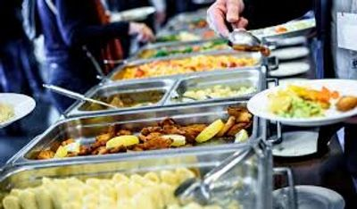

Dinner Buffet #1

CLASSIC COMPLETE DINNER BUFFET
ULTIMATE TOSSED SALAD
BEEF SIRLOIN TIP IN A SANGRIA WINE SAUCE
BONELESS BREAST OF CHICKEN WITH PENNE PASTA
(ALFREDO OR CLASSIC MARINARA AND CHOICE OF PASTA)
SOUTHERN YELLOW RICE
HERB BUTTER GREEN BEANS
FRESH BAKED DINNER ROLLS AND CORN BREAD W/ BUTTER
BEVERAGE STATION - SWEET TEA
$19.95 per guest drop off special.
$21.95 per guest, full service
(Plus Sales Tax & 18% Service Charge)
Includes all Support and Wait Staff, Setup, Service of Guest Tables
Service of Dinner Buffet, Stainless Chafing Dishes & More!
All disposable clear plastic dinnerware including plates
napkins, eating utensils and cups

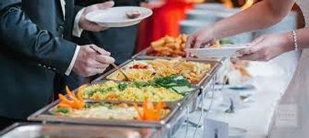

Dinner Buffet #2

CLASSIC COMPLETE DINNER BUFFET
ULTIMATE TOSSED SALAD
BEEF SIRLOIN TIP IN A BURGUNDY WINE SAUCE
BAKED BASA WHITE FISH WITH LEMON GARLIC AND HERBS
SOUTHERN YELLOW RICE
HERB BUTTER GREEN BEANS WITH ROASTED ALMONDS
FRESH BAKED DINNER ROLLS AND CORN BREAD W/ BUTTER
BEVERAGE STATION - SWEET TEA
$19.95 per guest drop off special.
$21.95 per guest
(Plus Sales Tax & 18% Service Charge)
Includes all Support and Wait Staff, Setup, Service of Guest Tables
Service of Dinner Buffet, Stainless Chafing Dishes & More!
All disposable clear plastic dinnerware including plates
napkins, eating utensils and cups

