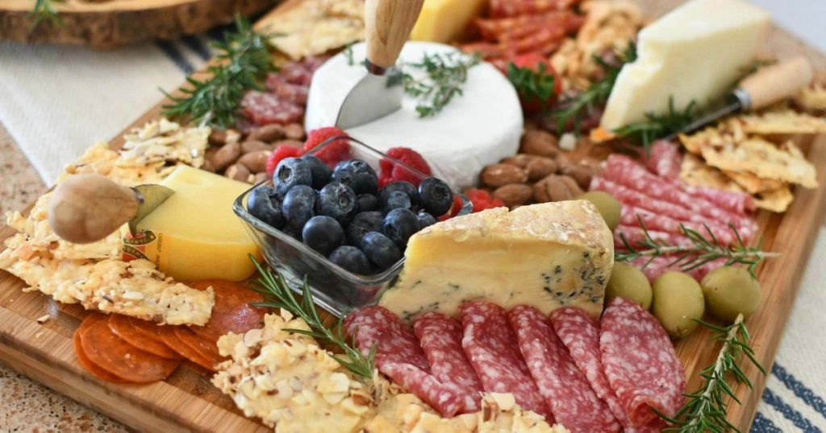

Italian Charcuterie Board #1
IMPORTED CURED SWEET ITALIAN HAM, IMPORTED SALAMI, CREAM CHEESE WITH OUR SWEET PEPPER JAM, ASSORTED SLICED AND CUBED CHEESE, FRENCH BRIE WHEEL, PEPPERONCINI PEPPERS, NUTS, STONE GROUND DIJON MUSTARD, OLIVES, PICKLES, FRESH BAKED FOCCACIA TOAST, SOUR DOUGH BREAD AND CRACKERS

Italian Charcuterie Board #2
IMPORTED CURED SWEET ITALIAN HAM, IMPORTED SALAMI, ITALIAN CAPOCOLLO, IMPORTED ITALIAN SAUSAGE, CREAM CHEESE WITH OUR SWEET PEPPER JAM, ASSORTED SLICED AND CUBED CHEESE, FRENCH BRIE WHEEL, FRESH MOZZARELLA & SWEET ROMA TOMATO CAPRESE SALAD, PEPPERONCINI PEPPERS, STONE GROUND DIJON MUSTARD, NUTS, OLIVES, PICKLES, FRESH BAKED FOCACCIA TOAST, SOUR DOUGH BREAD AND CRACKERS.

Italian Charcuterie Board #3
IMPORTED CURED SWEET ITALIAN HAM, IMPORTED SALAMI, ITALIAN PROSCIUTTO, ITALIAN CAPOCOLLO, IMPORTED ITALIAN SAUSAGE, ASSORTED SLICED AND CUBED CHEESE, CREAM CHEESE WITH OUR SWEET PEPPER JAM, FRENCH BRIE WHEEL, FRESH MOZZARELLA & SWEET ROMA TOMATO CAPRESE SALAD, PEPPERONCINI PEPPERS, NUTS, ROASTED RED PEPPER & TOMATO RAGU, DIJON MUSTARD, OLIVES, PICKLES, FRESH BAKED FOCCACIA TOAST, SOUR DOUGH BREAD AND CRACKERS.

Charcuterie Board # 1 $6.95 per guest
Charcuterie Board # 2 $8.95 per guest
Charcuterie Board # 3 $10.95 per guest
(Plus, Sales Tax & 18% Service Charge)
Disposable clear plastic dinnerware including plate
napkins, eating utensils.

