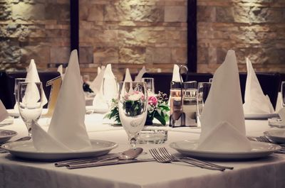

China Packages
Package #1
China Dinner Plate
Stainless Flatware (Fork & Knife)
$4.00 pp + China Service Charge
Package #2
China Dinner Plate
Stainless Flatware (Fork & Knife)
Cloth Dinner Napkin (White or Black)
$5.00 pp + China Service Charge
Package #3
China Dinner Plate
Stainless Flatware (Fork & Knife)
Cloth Dinner Napkin (White or Black)
Water/Drinking Goblet Glass
$6.00 pp + China Service Charge
Package #4
China Dinner Plate
Stainless Flatware (Fork & Knife)
Cloth Dinner Napkin (White or Black)
Water/Drinking Goblet Glass
Appetizer or Salad Plate
$7.00 pp + China Service Charge
Package #5
China Dinner Plate
Stainless Flatware (Fork & Knife)
Cloth Dinner Napkin (White or Black)
Water/Drinking Goblet Glass
Appetizer and Salad Plate
$8.00 pp + China Service Charge
EVERYTHING IS INCLUDED IN THE ABOVE CHINA PACKAGES:
DELIVERY, TABLE PICKUP, STAFFING, WASHING & RESTOCKING
WE STOCK IT ALL!
WE ALSO HAVE COCKTAIL, WINE AND CHAMPAGNE GLASSES!!

