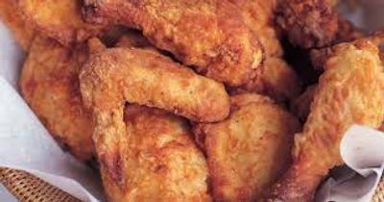
All Dinner Buffets Packages Include
All Support Staff, Setup, Service of Guest Tables, Service
of Buffet, Stainless Chafing Dishes and More!
All disposable clear plastic dinnerware including plates
napkins, eating utensils and cups
(SEE OUR SELECTION OF CHINA PACKAGES)

Package #3
1hr RECEPTION PARTY & COMPLETE DINNER BUFFET

1hr Hor d'oeuvre Reception
ASSORTED CHEESE TRAY ASSORTED CRACKER TRAY
FRESH ASSORTED VEGETABLE TRAY
RANCH DRESSING FOR DIPPING

Complete Dinner Buffet
HOMEMADE COLESLAW
SOUTHERN FRIED CHICKEN
ROASTED PULLED BBQ PORK
CREAMY MACARONI & CHEESE
GREEN BEANS W/ APPLE WOOD SMOKED BACON
FRESH BAKED DINNER ROLLS AND CORNBREAD W/ BUTTER
BEVERAGE STATION - LEMONADE AND SWEET TEA
$21.75 Dinner Buffet without Hor d' oeuvre
$23.95 Dinner Buffet with Hor d' oeuvres
Prices per guest
(Plus, Sales Tax & Full Service - 18% Service Charge)

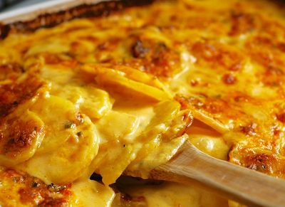

Package #4
1hr WEDDING RECEPTION &COMPLETE DINNER BUFFET
1hr Hor d'oeuvre Reception
ASSORTED CHEESE TRAY
ASSORTED CRACKER TRAY
FRESH ASSORTED VEGETABLE TRAY
RANCH DRESSING FOR DIPPING
Complete Dinner Buffet
ULTIMATE TOSSED SALAD
TOP SIRLOIN BEEF TIPS
(in a rich red wine brown sauce)
BONELESS BREAST OF CHICKEN PASTA
(bell peppers, onions, mushrooms marinara sauce)
AU GRATIN POTATOES
BUTTERED BABY CARROTS & GREEN BEANS
FRESH BAKED DINNER ROLLS AND CORN BREAD W BUTTER
BEVERAGE STATION-LEMONADE AND SWEET TEA
$23.50 Dinner Buffet without Hor d' oeuvre
$25.95 Dinner Buffet with Hor d' oeuvres
Prices per guest
(Plus, Sales Tax & Full Service - 18% Service Charge)
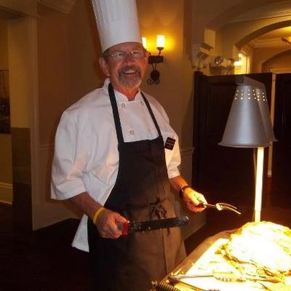

Package #5
1hr WEDDING RECEPTION & COMPLETE DINNER BUFFET
1hr Hor d'oeuvre Reception
HOR D' OEUVRES Table Display
ASSORTED CHEESE TRAYS
ASSORTED CRACKER TRAYS
ASSORTED FRESH GARDEN VEGETABLES
RANCH DRESSING FOR DIPPING
Passed Hor d' oeuvres
ASSORTED MINI QUICHE - PASSED
BURGUNDY BEEF MEATBALLS - PASSED​
Complete Dinner Buffet
ULTIMATE TOSSED SALAD
CHEF CARVING STATION - TOP SIRLOIN OF BEEF
"SICILIAN STYLE" CHICKEN BREAST W/ PENNE PASTA
(homemade marinara sauce w/ onion & bell pepper)
SOUTHERN STYLE YELLOW RICE
SAUTEED GARLIC BUTTER BROCCOLI
FRESH BAKED DINNER ROLLS AND CORN BREAD W/ BUTTER
BEVERAGE STATION - LEMONADE AND SWEET TEA
$25.25 Dinner Buffet without Hor d' oeuvres.
$28.95 Dinner Buffet with Hor d' oeuvres
Prices per guest
(Plus, Sales Tax & Full Service - 18% Service Charge)
(Chef Carving Fee Applies)
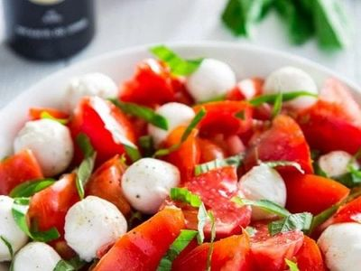

Package #6

1hr WEDDING RECEPTION &COMPLETE DINNER BUFFET
1hr Hor d'oeuvre Reception
ITALIAN CHARCUTURIE BOARD
IMPORTED CURED SWEET ITALIAN HAM, IMPORTED SALAMI,
IMPORTED ITALIAN SAUSAGE, ASSORTED CHEESE CUBES AND CRACKERS
FRESH MOZZARELLA & SWEET ROMA TOMATO CAPRESE SALAD,
PEPPERONCINI PEPPERS, ASSORTED OLIVES, ASSORTED FRESH VEGETABLES
RANCH DRESSING FOR DIPPING
FRESH BAKED FOCACIA TOAST
Complete Dinner Buffet
ULTIMATE TOSSED SALAD
CHEF CARVING STATION - ITALIAN TOP SIRLOIN OF BEEF
(Ask about your carving station options)
CHICKEN BREAST PREMAVERA PASTA
(assorted vegetables, alfredo sauce, corkscrew pasta)
PENNE PASTA ALA VODKA
ROASTED RED SKIN POTATOES
SAUTEED SPINACH AND GARLIC
FRESH BAKED DINNER ROLLS AND CORN BREAD W/ BUTTER
BEVERAGE STATION - LEMONADE AND SWEET TEA
$28.75 Dinner Buffet without Hor d' oeuvre
$32.95 Dinner Buffet with Hor d' oeuvres
Prices per guest
(Plus, Sales Tax & Full Service - 18% Service Charge
75 Guest Min, required for carving station)
(Chef Carving Fee Applies)
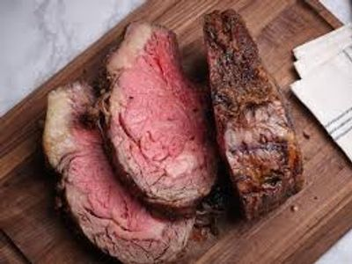

Package #7
1hr WEDDING RECEPTION & COMPLETE DINNER BUFFET
1hr Hor d'oeuvre Reception
HOR D' OEUVRES Table Display
ASSORTED CHEESE TRAYS
ASSORTED CRACKER TRAYS
ASSORTED FRESH GARDEN VEGETABLES
RANCH DRESSING FOR DIPPING
PASSED APPETIZERS
ASSORTED MINI QUICHE - PASSED
BURGUNDY MEATBALLS - PASSED
Complete Dinner Buffet
ULTIMATE TOSSED SALAD
CHEF CARVING STATION - PRIME RIB OF BEEF
(Ask about your carving station options)
BAKED BASA WHITE FISH WITH LEMON GARLIC HERBS
CORKSCREW PASTA MARINARA
BUTTERED ITALIAN GREEN BEANS
FRESH BAKED DINNER ROLLS AND CORN BREAD / BUTTER
BEVERAGE STATION - LEMONADE AND SWEET TEA
$35.25 Dinner Buffet without Hor d' oeuvre
$38.95 Dinner Buffet with Hor d' oeuvres
Prices per guest
(Plus, Sales Tax & Full Service - 18% Service Charge)
75 Guest Min, Required for carving station
(Plus Sales Tax & 18% Service Charge)
(Chef Carving Fee Applies)
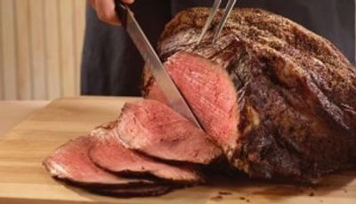

Package #8
1hr WEDDING RECEPTION & COMPLETE DINNER BUFFET
1hr Hor d'oeuvre Reception
ASSORTED CHEESE TRAY
ASSORTED CRACKER TRAY
FRESH ASSORTED VEGETABLE TRAY
RANCH DRESSING FOR DIPPING
Complete Dinner Buffet
ULTIMATE TOSSED SALAD
TOP SIRLOIN SLICED ROAST BEEF
(in a rich red wine brown sauce)
KICK'IN ASSORTED CHICKEN - PEPPERS ONIONS OLIVES
SOUTHERN YELLOW SAFFRON RICE
MIAMI STYLE BLACK BEANS
FRESH BAKED SLICED CUBAN BREAD W/ BUTTER
BEVERAGE STATION-LEMONADE AND SWEET TEA
$23.50 Dinner Buffet without Hor d' oeuvre
$25.95 Dinner Buffet with Hor d' oeuvres
Prices per guest
(Plus, Sales Tax & Full Service - 18% Service Charge)
$25.95 per guest (Plus Sales Tax & 18% Service Charge)

