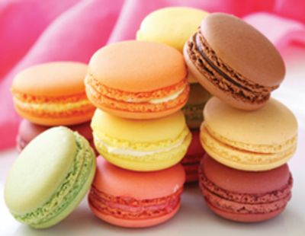

Desserts
SHEET CAKES
AVAILABLE IN WHITE, CHOCOLATE OR MARBLE CAKE
ICING - WHITE OR CHOCOLATE BUTTERCREAM
HALF SHEET CAKES (FEEDS 40) $69.00
FULL SHEET CAKES (FEEDS 80) $138.00

CUPCAKES
AVAILABLE IN WHITE OR CHOCOLATE CAKE
ICING - WHITE OR CHOCOLATE BUTTERCREAM
​24 CUPCAKES $49.00

ASSORTED FRENCH MACARONS
ASSORTED FLAVORS
30 COUNT $87.50
$2.85 EACH

SPECIALTY ITALIAN DESSERTS

SFOGLIATELLE’S $82.50 (30 Count)
ITALIAN RAINBOW CAKE $49.00
TIRAMISU $79.00 (24 Count Squares)
MINI CANNOLI $49.00 (24 Count)
GRANDMA’S ITALIAN KNOT COOKIES $69.00 (36 Count)
CAPPUCCINI HONEY GLAZED MINI DONUTS $35.00 (36 Count)

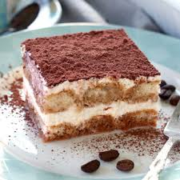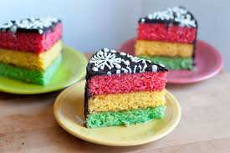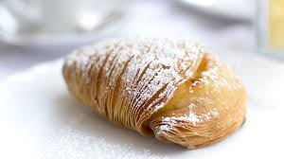

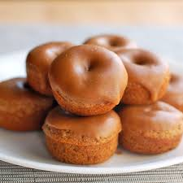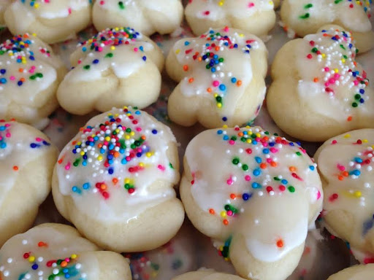

DESSERTS

TIRAMISU SHOTS $2.50 each
OREO MOUSSE CAKE $2.95 pp
SOUTHERN PECAN PIE $2.95 pp
CARROT CAKE / CREAM CHEESE BITES $21.00 dozen
CHEF PEPE'S HOMEMADE KEY LIME PIE $2.95 pp
MINI SPICED ESPRESSO CAKE SQUARES $21.00 dozen
CHOCOLATE CARAMEL CAKE $2.25 pp​
CHOCOLATE CARAMEL CAKE SHOTS $2.00 each
ASSORTED MINI DONUTS $8.25 dozen
ASSORTED FRESH BAKED COOKIES $6.95 dozen
ALL - AMERICAN APPLE PIE $2.75 pp
NEW YORK CHEESECAKE w/ FRESH STRAWBERRIES $ 3.95 pp
MINI ROUND CHEESECAKES $ 3.25 each
STRAWBERRY SHORTCAKE $2.75 pp
STRAWBERRY SHORTCAKE SHOTS $2.00 each
DONUT HOLE SKEWERS (3 on each) $19.00 dozen
FRESH BAKED FUDGE BROWNIES $21.00 dozen
INDIAN RAISIN BREAD PUDDING $2.75 pp
PUMPKIN PIE $2.25 pp
HOMEMADE PEACH COBBLER $2.95 pp
APPLE CARAMEL CRISP $2.95 pp
BROWNIE BITES $16.95 dozen
CHOCOLATE AND VANILLA PUDDING $1.95 PP
CHEF PEPE'S HOMEMADE KEY LIME PIE SQUARES $27.00 dozen
MINI ROUND KEY LIME PIES $3.25 each
CREAMY BANANA PUDDING $2.50 pp
MINI CREAM PUFFS W/ POWDERED SUGAR $9.95 dozen

