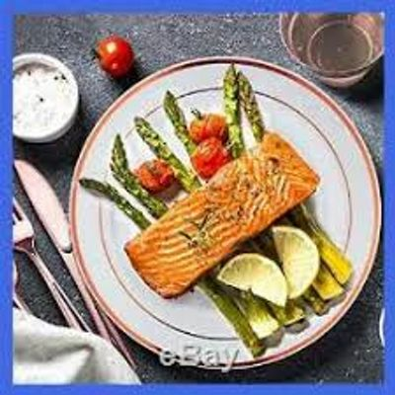

Additions to your Event
UPGRADED DISPOSABLE DINNERWARE
Elegant Heavyweight Plastic Plates by Masterpiece
7.5" Appetizer or Salad Plate w/ Silver Trim $1.35 per Guest
10.25" Dinner Plate w/ Silver Trim $2.95 per Guest
Appetizer and Dinner Plate Combo $4.00 per Guest
Also Includes Disposable White Fork, Knife and Napkin
(NO China Service Fee's Apply)
WEDDING CAKE CUTTING SERVICE
up to 50 guests fee $79.00, 51-100 guests $150.00,
101-150 guests $230.00, 151-200 $295.00
Over 200 guests $1.35 per guest.
(STAFF TO ASSIST IN CUTTING, PLATING AND SERVING)
(DISPOSABLE PLATE AND EATING UTENSIL INCLUDED)
COFFEE STATION
FRESH BREWED COFFEE
CREAM & CONDIMENTS
DISPOSABLE CUPS INCLUDED
$1.95 per guest

BEVERAGE STATIONS
CHOICE OF (2) $2.75 PER GUEST
SWEET TEA UNSWEETENED TEA
LEMONADE TROPICAL FRUIT PUNCH
FRESH BREWED COFFEE WITH CONDIMENTS
(DISPOSABLE CUPS INCLUDED)
INCLUDED IN YOU BUFFET PACKAGE
Your Clear Plastic Appetizer and Dinner Plate.
Matching Clear Fork, Knife and White Disposable Napkin

