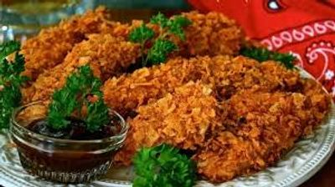

Heavy Hor d' oeuvres Party #1
CHEF PEPE'S
PREMIER WEDDING RECEPTION
WITH 1 1/2 HOUR HEAVY HOR D' OEUVRES
(HOR'S CHINA PACKAGE #1 INCLUDED)
ITALIAN ANTIPASTO TABLE DISPLAY
IMPORTED GENOA SALAMI, IMPORTED CURED SWEET
ITALIAN HAM, ASSORTED CHEESE CUBES.
FRESH SLICED MOZZARELLA & SWEET ROMA TOMATO CAPRESE SALAD
PEPPERONCINI PEPPERS, ASSORTED OLIVES, CORN RELISH
MARINATED BUTTON MUSHROOMS, PICKLES, SEASONED BEETS
ASSORTED FRESH VEGETABLES, RANCH DRESSING FOR DIPPING
FRESH BAKED SLICED ITALIAN BREAD TRAY
ASSORTED QUICHE
COCKTAIL MEATBALLS MARINARA
BREADED CHICKEN FRITTERS
GRATED IMPORTED PARMESAN CHEESE AND CRUSHED RED PEPPER.
BEVERAGE STATION - COFFEE, LEMONADE AND SWEET TEA
$25.95 per guest​
(Plus Sales Tax & 18% Service Charge)
(China Service Charge Applies)
ABOVE RECEPTION ADDING CHEF ATTENDED CARVING STATION
YOUR CHOICE OF
ROASTED TOP SIRLOIN OF BEEF
OR
ROASTED ROSEMARY PORK LOIN
Served with au jus, horseradish sauce and slider rolls included
​
$32.95 per guest
(75 Guest Min. Required for carving station)
(Plus Sales Tax & 18% Service Charge)
(China Service Charge Applies)
(Chef Carving Fee Applies)
Includes all Support Staff, Setup, Service of Guest Tables
Service of Buffet, Stainless Chafing Dishes & More!
Includes China & Silverware Package #1
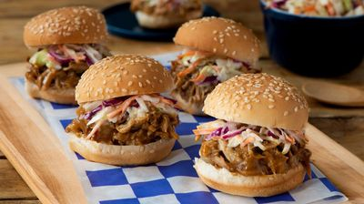

Heavy Hor d' oeuvres Party #2
CHEF PEPE'S
RIVER CITY WEDDING RECEPTION
WITH 1 1/2 HOUR HEAVY HOR D' OEUVRES
(HOR'S CHINA PACKAGE #1 INCLUDED)
MARKET FRESH VEGETABLE TRAY DISPLAY
FRESH SEASONAL FRUIT TRAY
ASSORTED CHEESE AND CRACKER TRAY
ROASTED SWEET BABY RAY'S PORK SLIDERS
COCKTAIL MEATBALLS MARINARA
ITALIAN SAUSAGE - FRESH ROASTED BELL PEPPERS AND ONIONS
FRESH BAKED SLICED ITALIAN BREAD
BEVERAGE STATION - COFFEE, LEMONADE AND SWEET TEA
$22.95 per guest​
(Plus Sales Tax & 18% Service Charge)
(China Service Charge Applies)

ABOVE RECEPTION ADDING CHEF ATTENDED CARVING STATION
YOUR CHOICE OF
ROASTED TOP SIRLOIN OF BEEF
OR
ROASTED ROSEMARY PORK LOIN
Served with au jus, horseradish sauce and slider rolls included
​
$29.95 per guest
(75 Guest Min. Required for carving station)
(Plus Sales Tax & 18% Service Charge)
(China Service Charge Applies)
(Chef Carving Fee Applies)
Includes all Support Staff, Setup, Service of Guest Tables
Service of Buffet, Stainless Chafing Dishes & More!
Includes China & Silverware Package #1

