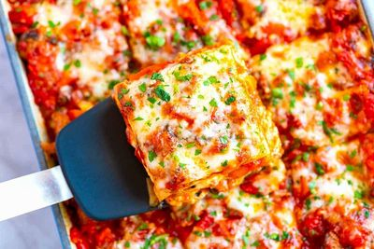

ITALIAN BUFFET
CREATE YOUR OWN ITALIAN MENU INCLUDES
All Support Staff, Setup, Service of Guest Tables, Service of Buffet,
Stainless Chafing Dishes & More! All disposable clear plastic dinnerware,
including plates, napkins, eating utensils and cups.
(SEE OUR SELECTION OF CHINA PACKAGES)

Create Your Own Italian Menu
HOR D OEUVRES RECEPTION & COMPLETE DINNER BUFFET
1hr Hor d'oeuvre Reception Selections

CHOOSE 2 APPETIZERS
- CHEESE & CRACKER TRAY
- FRESH VEGETABLE TRAY WITH RANCH
- ITALIAN MARINARA MEATBALLS
- TOMATO BASIL GARLIC BRUSCHETTA STATION
- EGGPLANT PARMESAN SLIDERS
- FRESH CAPRESE SALAD - FRESH MOZZARELLA AND TOMATOES
- THREE CHEESE AND ROASTED RED PEPPER POLENTA
- SPICY TOMATO & ITALIAN SAUSAGE FARFALLE PASTA

CHOOSE 2 ENTREES
- SPAGHETTI W/ MEATBALLS MARINARA OR MEAT SAUCE
- ROTISSERIE ITALIAN CHICKEN
- STUFFED RICCATA SHELLS MARINARA
- CHICKEN MARSALA
- LEMON PINOT GRIGIO CHICKEN PICCATA
- BEEF LASAGNA
- VEGETABLE LASAGNA
- SWEET ITALIAN SAUAGE WITH PEPPERS AND ONIONS
- MANICOTTI MARINARA
- EGGPLANT LASAGNA
- SHRIMP WITH BOW TIES IN OUR ROSA SAUCE
- BAKED WHITEFISH BASA W/ ITALIAN SPICES & BREADCRUMBS
CHOICE OF 3 SIDES BELOW
- BUTTERED BROCCOLI
- PEAS AND ONIONS
- SPINACH WITH OLIVE OIL AND GARLIC
- GARLIC MASHED POTATOES
- SOUTHERN YELLOW RICE
- OVEN BROWNED POTATOES
- FETTUCCINI AL FREDO
- ITALIAN GREEN BEANS
- PARMESAN GREEN BEANS
- PASTA SALAD
- SAUTEED MIXED SUMMER SQUASH
- AU GRATIN POTATOES
- MACARONI & CHEESE
- BUTTERED SWEET CORN
- SEASONED CUT GREEN BEANS
INCLUDES FRESH SLICED ITALIAN BREAD W/ BUTTER
INCLUDED BEVERAGE STATION - CHOICE OF 2
SWEET TEA LEMONADE UNSWEETENED TEA
TROPICAL FRUIT PUNCH CHERRY LIMEADE
ITALIAN PACKAGE PRICE
$21.75 Dinner Buffet without Hor d' oeuvre
$24.95 Dinner Buffet with Hor d' oeuvres
Prices per guest
(Plus, Sales Tax & Full Service - 18% Service Charge)

