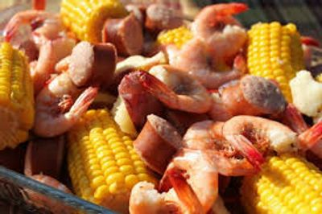

Low Country Boils
CLASSIC MAY PORT JUMBO SHRIMP
LOW COUNTRY BOIL DINNER BUFFET #1
CREAMY COLESLAW
POTATO SALAD
BOILED IN OUR CUSTOM BLENDED SEASONING
JUMBO FRESH MAY PORT SHRIMP
SMOKED SAUSAGE
CORN ON THE COB
RED SKIN POTATOES
SOUTHERN YELLOW RICE PANS
BUTTERED GREEN BEANS PANS
BAKED DINNER ROLLS AND CORN BREAD W/ BUTTER
COCKTAIL SAUCE
DRAWN BUTTER
BEVERAGE STATION - SWEET TEA
FRESH BAKED CHOCOLATE CHIP COOKIES
$24.95 per guest (Plus Sales Tax & 18% Service Charge)
Includes all Support and Wait Staff, Setup, Service of Guest Tables,
Service of Dinner Buffet, Stainless Chafing Dishes & More!
All disposable clear plastic dinnerware including plates napkins, eating utensils and cups
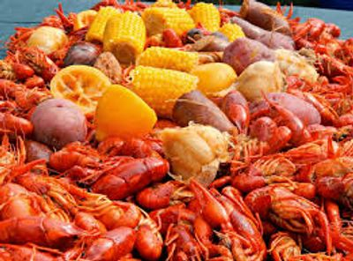

Low Country Boils
CLASSIC CRAYFISH & SHRIMP
LOW COUNTRY BOIL DINNER BUFFET #2
CREAMY COLESLAW
POTATO SALAD
BOILED IN OUR CUSTOM BLENDED SEASONING
LOUISIANA WHOLE CRAYFISH
JUMBO FRESH MAY PORT SHRIMP
SMOKED SAUSAGE
CORN ON THE COB
RED SKIN POTATOES
SOUTHERN YELLOW RICE PANS
BUTTERED GREEN BEANS PANS
BAKED DINNER ROLLS AND CORN BREAD W/ BUTTER
COCKTAIL SAUCE
DRAWN BUTTER
BEVERAGE STATION - SWEET TEA
FRESH BAKED CHOCOLATE CHIP COOKIES

$28.95 per guest (Plus Sales Tax & 18% Service Charge)
Includes all Support and Wait Staff, Setup, Service of Guest Tables,
Service of Dinner Buffet, Stainless Chafing Dishes & More!
All disposable clear plastic dinnerware including plates napkins, eating utensils and cups
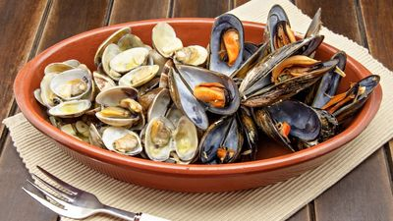

Low Country Boils
CLASSIC SHRIMP WITH CHOICE OF MUSSELS OR CLAMS
LOW COUNTRY BOIL DINNER BUFFET #3

CREAMY COLESLAW
POTATO SALAD

BOILED IN OUR CUSTOM BLENDED SEASONING
JUMBO FRESH MAY PORT SHRIMP
MUSSELS OR CLAMS
SMOKED SAUSAGE
CORN ON THE COB
RED SKIN POTATOES

SOUTHERN YELLOW RICE PANS
BUTTERED GREEN BEANS PANS
BAKED DINNER ROLLS AND CORN BREAD W/ BUTTER
COCKTAIL SAUCE
DRAWN BUTTER
BEVERAGE STATION - SWEET TEA
FRESH BAKED CHOCOLATE CHIP COOKIES

$28.95 per guest (Plus Sales Tax & 18% Service Charge)
Includes all Support and Wait Staff, Setup, Service of Guest Tables,
Service of Dinner Buffet, Stainless Chafing Dishes & More!
All disposable clear plastic dinnerware including plates napkins, eating utensils and cups

