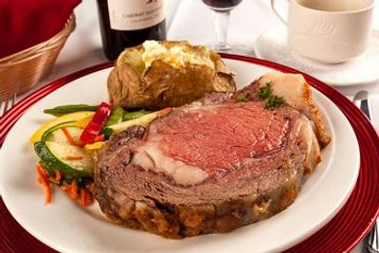

Plated Dinner #1

ALL CHINA INCLUDED
APPETIZER COURSE PLATED
CHICKEN CHARDONNAY
GARLIC MASHED POTATOES
CHARDONNAY WINE MUSHROOMS AND ARTICHOKE SAUCE
SALAD COURSE PLATED
CHEF PEPE'S ULTIMATE TOSSED SALAD
MAIN COURSE PLATED
CHEF PEPE'S PRIME RIB OF BEEF or SLICED TOP SIRLOIN
(in a Rich Burgundy Wine Sauce)
FRESH RED SKIN SMASHED POTATOES
GREEN BEANS & BABY CARROTS IN A BUTTER SAUCE
DINNER ROLLS AND CORN BREAD W/ BUTTER BASKET
PITCHERS OF SWEET TEA AND WATER ON TABLES
8 oz. Top Sirloin $42.95 per guest
8 oz. Prime Rib $46.95 per guest
(Plus Sales Tax & 18% Service Charge)
Includes all Support Staff
Service of Guest Tables
All CHINA INCLUDED
APPETIZER PLATE, SALAD PLATE AND DINNER PLATE,
APPETIZER FORK, SALAD FORK AND DINNER FORK WITH KNIFE.
INCLUDES WHITE OR BLACK CLOTH NAPKIN AND DRINKING GOBLET.
Some restrictions apply to venue accommodation
(China Service Charge Applies)

Reception and Plated Dinner #2
ALL CHINA INCLUDED
RECEPTION W/ PASSED HOR D' OEUVRE'S
CHEF PEPE’S
HOR D' OEUVRES TABLE DISPLAY
ASSORTED CHEESE TRAYS
ASSORTED CRACKER TRAYS
ASSORTED FRESH SEASONAL FRUIT TRAYS
ASSORTED FRESH GARDEN VEGETABLES
RANCH DRESSING FOR DIPPING
FRESH MOZZARELLA & SWEET ROMA TOMATO CAPRESE TRAY.
FRESH BAKED SLICED ITALIAN BREAD TRAY
1/2 HOUR PASSED HOR D' OEUVRE'S
ITALIAN PLUM TOMATO GARLIC BASIL BRUSCHETTA
ASSORTED PETITE QUICHE
SALAD COURSE PLATED
CHEF PEPE'S ULTIMATE TOSSED SALAD
MAIN COURSE PLATED
CHEF PEPE'S PRIME RIB OF BEEF OR SLICED TOP SIRLOIN
(in a Rich Burgundy Wine Sauce)
FRESH RED SKIN SMASHED POTATOES
GREEN BEANS & BABY CARROTS BUTTER SAUCE
DINNER ROLLS AND CORN BREAD W/ BUTTER BASKET
PITCHERS OF SWEET TEA AND WATER ON TABLES
8 oz. Top Sirloin $42.95 per guest
8 oz. Prime Rib $50.95 per guest
(Plus Sales Tax & 18% Service Charge)
Includes all Support Staff
Service of Guest Tables
All CHINA INCLUDED
APPETIZER PLATE, SALAD PLATE AND DINNER PLATE,
APPETIZER FORK, SALAD FORK AND DINNER FORK WITH KNIFE.
INCLUDES WHITE OR BLACK CLOTH NAPKIN AND DRINKING GOBLET.
Some restrictions apply to venue accommodation
(China Service Charge Applies)
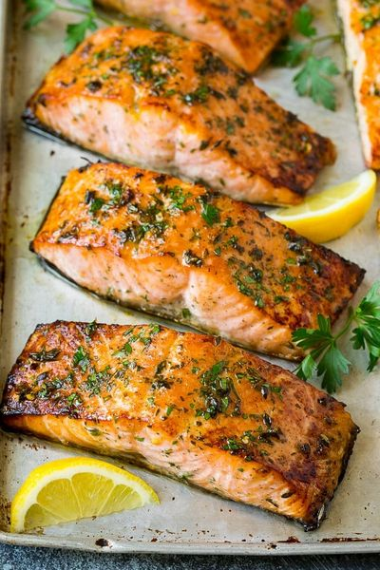

Plated Dinner #3
ALL CHINA INCLUDED
APPETIZER COURSE PLATED
CHICKEN CHARDONNAY
GARLIC MASHED POTATOES
CHARDONNAY WINE MUSHROOMS AND ARTICHOKE SAUCE
SALAD COURSE PLATED
CHEF PEPE'S ULTIMATE TOSSED SALAD
MAIN COURSE PLATED
CHEF PEPE'S SLICED BEEF SIRLOIN
(in a rich Burgundy Wine Sauce)
BREADED CHICKEN BREAST GARLIC HERB CREAM SAUCE
BAKED LEMON PEPPER BASA WHITE FISH
CLASSIC SAFFRON YELLOW RICE
FRESH RED SKIN SMASHED POTATOES
GREEN BEANS & BABY CARROTS IN A BUTTER SAUCE
DINNER ROLLS AND CORN BREAD W/ BUTTER BASKET
PITCHERS OF SWEET TEA AND WATER ON TABLES
$45.95 per guest
(Plus Sales Tax & 18% Service Charge)
Includes all Support Staff
Service of Guest Tables
All CHINA INCLUDED AND MEAL COUNT REQUIRED
APPETIZER PLATE, SALAD PLATE AND DINNER PLATE,
APPETIZER FORK SALAD FORK AND DINNER FORK WITH KNIFE.
INCLUDES WHITE OR BLACK CLOTH NAPKIN AND DRINKING GOBLET.
Some restrictions apply to venue accommodation
(China Service Charge Applies)

Reception and Plated Dinner #4
ALL CHINA INCLUDED
RECEPTION W/ PASSED HOR D' OEUVRE'S
CHEF PEPE’S
HOR D' OEUVRES TABLE DISPLAY
ASSORTED CHEESE TRAYS
ASSORTED CRACKER TRAYS
ASSORTED FRESH SEASONAL FRUIT TRAYS
ASSORTED FRESH GARDEN VEGETABLES
RANCH DRESSING FOR DIPPING
FRESH MOZZARELLA & SWEET ROMA TOMATO CAPRESE TRAY.
FRESH BAKED SLICED ITALIAN BREAD TRAY
1/2 HOUR PASSED HOR D' OEUVRE'S
ITALIAN PLUM TOMATO GARLIC BASIL BRUSCHETTA
ASSORTED PETITE QUICHE
SALAD COURSE PLATED
CHEF PEPE'S ULTIMATE TOSSED SALAD
MAIN COURSE PLATED
CHEF PEPE'S SLICED BEEF SIRLOIN
(in a rich Burgundy Wine Sauce)
BREADED CHICKEN BREAST GARLIC HERB CREAM SAUCE
BAKED LEMON PEPPER BASA WHITE FISH
CLASSIC SAFFRON YELLOW RICE
FRESH RED SKIN SMASHED POTATOES
GREEN BEANS & BABY CARROTS BUTTER SAUCE
DINNER ROLLS AND CORN BREAD W/ BUTTER BASKETS
PITCHERS OF SWEET TEA AND WATER ON TABLES
$45.95 per guest
(Plus Sales Tax & 18% Service Charge)
Includes all Support Staff
Service of Guest Tables
All CHINA INCLUDED AND GUEST COUNTS REQUIRED
APPETIZER PLATE, SALAD PLATE AND DINNER PLATE,
APPETIZER FORK, SALAD FORK AND DINNER FORK WITH KNIFE.
INCLUDES WHITE OR BLACK CLOTH NAPKIN AND DRINKING GOBLET.
Some restrictions apply to venue accommodation
(China Service Charge Applies)
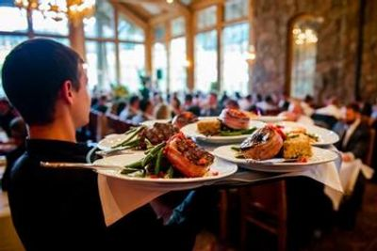

Plated Dinner #5
ALL CHINA INCLUDED
APPETIZER COURSE PLATED
CHICKEN CHARDONNAY
GARLIC MASH POTATOES
CHARDONNAY WINE MUSHROOMS AND ARTICHOKE SAUCE
SALAD COURSE PLATED
CHEF PEPE'S ULTIMATE TOSSED SALAD
MAIN COURSE PLATED
7 oz. FILET MIGNON
(in a Rich Burgundy Wine Sauce)
FRESH RED SKIN SMASHED POTATOES
GREEN BEANS & BABY CARROTS IN A BUTTER SAUCE
DINNER ROLLS AND CORN BREAD W/ BUTTER BASKET
PITCHERS OF SWEET TEA AND WATER ON TABLES
7 oz. Filet Mignon $49.95 per guest
(Plus Sales Tax & 18% Service Charge)
Includes all Support Staff
Service of Guest Tables
All CHINA INCLUDED
APPETIZER PLATE, SALAD PLATE AND DINNER PLATE, APPETIZER FORK
SALAD FORK AND DINNER FORK WITH KNIFE.
INCLUDES WHITE OR BLACK CLOTH NAPKIN AND DRINKING GOBLET.
Some restrictions apply to venue accommodation
(China Service Charge Applies)

Reception and Plated Dinner #6

ALL CHINA INCLUDED
RECEPTION W/ PASSED HOR D' OEUVRE'S
CHEF PEPE’S
HOR D' OEUVRES TABLE DISPLAY
ASSORTED CHEESE TRAYS
ASSORTED CRACKER TRAYS
ASSORTED FRESH SEASONAL FRUIT TRAYS
ASSORTED FRESH GARDEN VEGETABLES
RANCH DRESSING FOR DIPPING
FRESH MOZZARELLA & ROMA TOMATO CAPRESE TRAY.
FRESH BAKED SLICED ITALIAN BREAD TRAY
1/2 HOUR PASSED HOR D' OEUVRE'S
ITALIAN PLUM TOMATO GARLIC BASIL BRUSCHETTA
ASSORTED PETITE QUICHE
SALAD COURSE PLATED
CHEF PEPE'S ULTIMATE TOSSED SALAD
MAIN COURSE PLATED
BAKED 8 oz. FILLET OF SALMON
(in a Lemon-Lime Dill Butter)
SOUTHERN YELLOW SAFFRON RICE
GREEN BEANS & BABY CARROTS IN A BUTTER SAUCE
DINNER ROLLS AND CORN BREAD W/ BUTTER BASKET
PITCHERS OF SWEET TEA AND WATER ON TABLES
8 oz. Salmon Fillet $44.95 per guest
(Plus Sales Tax & 18% Service Charge)
Includes all Support Staff
Service of Guest Tables
All CHINA INCLUDED
APPETIZER PLATE, SALAD PLATE AND DINNER PLATE,
APPETIZER FORK, SALAD FORK AND DINNER FORK WITH KNIFE.
INCLUDES WHITE OR BLACK CLOTH NAPKIN AND DRINKING GOBLET.
Some restrictions apply to venue accommodation
(China Service Charge Applies)

