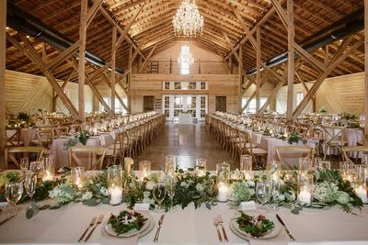

Venues

Jacksonville Public Library (Main)

904-630-1003

Aetna Riverfront – Jacksonville

904-591-9591  
Friday Musicale Auditorium – Jacksonville

904-355-7584  
Garden Center of St. Augustine

904-826-0242  
Garden Club – Jacksonville

904-355-4224  
German American Club – Jacksonville

904-389-2284  
Hilton Garden Inn – St. Augustine

904-824-4641  
Hampton Inn – St. Augustine

904-824-4641  
Jacksonville Beach Community Ctr

904-247-6236  
Jacksonville Zoo & Gardens

904-757-4463  
Laytn's Landing Yulee

904-225-5861  
Marine Land – St. Augustine

904-471-1111  
Nocatee Crosswater – Ponte Vedra

904-924-6851  
Morocco Shrine Auditorium – Jacksonville

904-642-5200  
Museum of Science/History – Jacksonville

904-396-7062  
Old Florida Museum Pioneer Barn -

904-824-8874  
Orange Park Lion’s Club – Jacksonville

904-264-5866  
Orange Park Woman’s Club – Jacksonville

904-264-8269  
Ramallah Club – Jacksonville

904-733-5211  
Ribault Club – Jacksonville

904-251-1050  
Wilson Center – Jacksonville

904-646-2222  
WJCT Downtown – Jacksonville

904-358-6311