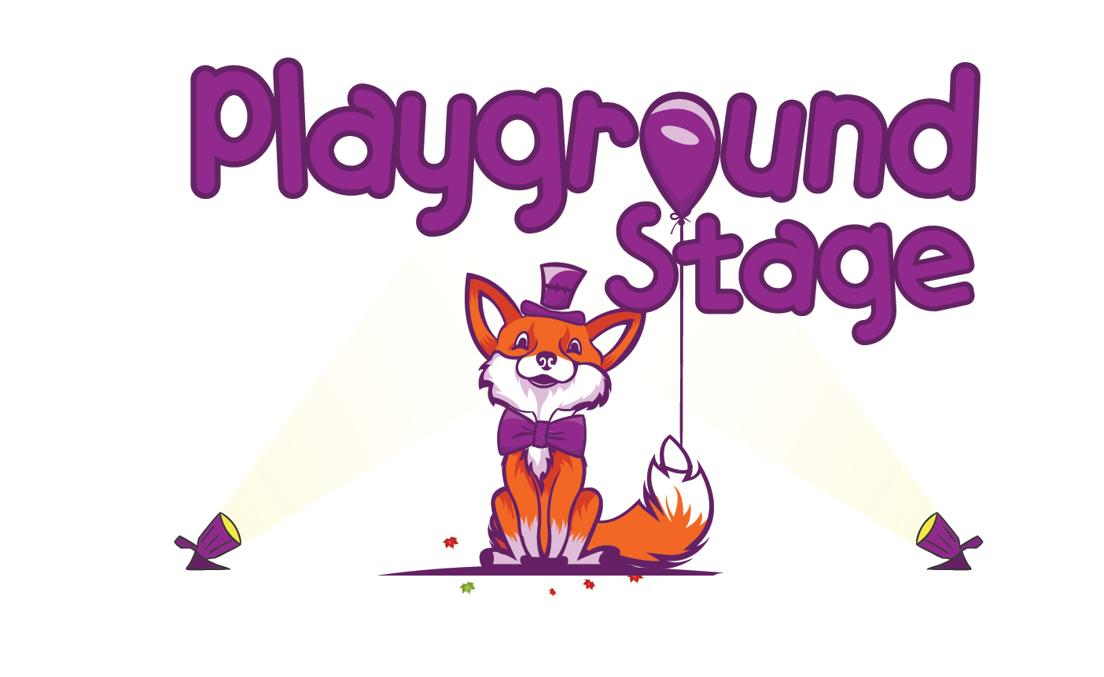
Playground Stage Class Application Form
2nd-4th Grade
Mini-Musical
March 25 – May 28, 2020

Please return this form to your child’s classroom teacher, the school office, or to education@playgroundstage.org by the end of the day on Friday February 28th 2020.

Parent/Guardian Email (This is how we communicate with you):

_________________________________________________________________

Child Information

Student Name: Gender:

Date of Birth:

School Name: Grade:

Normal Dismissal: Car rider Bus rider #__________ YMCA Afterschool Other

Playground Stage Dismissal: Pick Up Carpool YMCA Afterschool Other

Parent/Guardian Information

Adult Name: Email Address:

Phone Number: Relationship to Student:

Address:

Zip Code:

Authorized pick up information Person 1

Name: Phone:

Email: Relationship to student:

Is this person an emergency contact? Yes No

Authorized pick up information Person 2

Name: Phone:

Email: Relationship to student:

Is this person an emergency contact? Yes No

Emergency Contact

Name: Phone:

Alternate Phone:

Medical Information

Does this child have a medical condition or special needs? If so please explain

Allergies or dietary restrictions?

Self Administered Medication?

Nut Allergy?

Please initial after each paragraph indicating that you understand the expectations of the program

Pick Up
Class is held afterschool on Wednesdays until 4:15pm – pick up is promptly at 4:15pm unless your child is enrolled in YMCA after-care. Afterschool class days are 3/25, 4/1, 4/15, 4/22, 4/29, 5/6, 5/13, 5/20, 5/27, 5/28. A performance for the family and friends will be held on 5/28.

(Initial)

Attendance
In order to be successful all students need to attend class every week to learn their role, dance choreography, and music. If any student misses 3 or more classes their role or responsibilities may be reassigned to a student who is present or a student on the waitlist may fill their spot in class. If a student needs to miss class for any reason school administration needs to be informed before the absence.

(Initial)
Performance
There will be a performance for on the last day of class. Friends and family are invited to watch. The play will start promptly at 3:30pm on Thursday 5/28, 2020.
(Initial)
Casting
All students signed up for the class will have a role with at least three lines to be spoken solo by the student for the audience. Casting decisions happen after the first day of class. Casting will not be reconsidered after casting is announced. Casting will not be disclosed to anyone except staff before the class announcement.

(Initial)
Behavior
Playground Stage supports each school we serve in their behavior policies and school rules. Each instructor will set the rules and guidelines at the beginning of the first class in accordance to school behavior policy. Any behavior that conflicts with the harmony of class and the ability for the instructor to teach will be brought to the attention of the parent after a warning has been given to the student. Playground Stage reserves the right to dismiss a student from class for multiple infractions or any behavior that becomes a safety concern for students or instructors.

(Initial)

