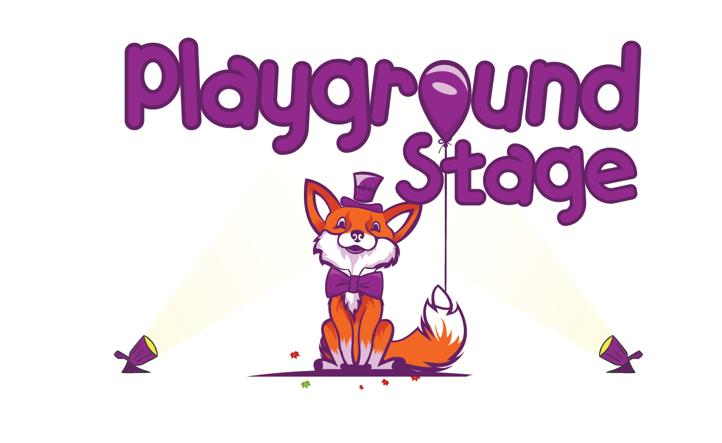
Playground Stage Class Application Form
K-2nd Grade
Musical Theatre Class
Feb. 5 – March 18, 2020

Please return this form to your child’s classroom teacher, the school office, or to education@playgroundstage.org by the end of the day on Friday January 31st.
Parent/Guardian Email (This is how we communicate with you):

________________________________________@_________________________

Child Information

Student Name: Gender:

Date of Birth:

School Name: Grade:

Normal Dismissal: Car rider Bus rider #__________ YMCA Afterschool Other

Playground Stage Dismissal: Pick Up Carpool YMCA Afterschool Other

Parent/Guardian Information

Adult Name: Email Address:

Phone Number: Relationship to Student:

Address:

Zip Code:

Authorized pick up information Person 1

Name: Phone:

Email: Relationship to student:
Is this person an emergency contact? Yes No

Authorized pick up information Person 2

Name: Phone:

Email: Relationship to student:

Is this person an emergency contact? Yes No

Emergency Contact

Name: Phone:

Alternate Phone:

Medical Information

Does this child have a medical condition or special needs? If so please explain

Allergies or dietary restrictions?

Self Administered Medication?

Nut Allergy?

Please initial after each paragraph indicating that you understand the expectations of the program

Pick Up
Class is held afterschool on Wednesdays until 3:45pm – pick up is promptly at 3:45pm unless your child is enrolled in YMCA after-care. Afterschool class days are 2/5, 2/12, 2/26, 3/4, 3/11, 3/18.

(Initial)

Attendance
In order to be successful all students need to attend class every week to learn their role, dance choreography, and music. If any student misses 2 or more classes a student on the waitlist may fill their spot in class. If a student needs to miss class for any reason school administration needs to be informed before the absence.

(Initial)
Performance
There will be a performance on the last day of class. Friends and family are invited to watch. The performance will start promptly at 3:00pm on Wednesday March 18th 2020.
(Initial)
Behavior
Playground Stage supports each school we serve in their behavior policies and school rules. Each instructor will set the rules and guidelines at the beginning of the first class. Any behavior that conflicts with the harmony of class and the ability for the instructor to teach will be brought to the attention of the parent after a warning has been given to the student. Playground Stage reserves the right to dismiss a student from class for multiple infractions or any behavior that becomes a safety concern for students or instructors.

(Initial)

Please return this form to your child’s classroom teacher, the school office, or to education@playgroundstage.org by the end of the day on Friday January 31st.

