POLICY:

It is the purpose of all Fire Departments in San Luis Obispo County to provide life safety and fire suppression services within their jurisdictions, and to provide for and utilize a standardized approach, designators, terminology, and expectations regarding tactical assignments when responding to structure fire incidents. This umbrella policy will bring all San Luis Obispo County structural fire incidents under one operational policy. By considering structural firefighting as one subject rather than a series of disciplines, a more consistent approach will be achieved.

AUTHORITY:

This SOP has been developed and adopted by the San Luis Obispo County Fire Chiefs Association. It is based upon Firescope ICS-500 Structure Fire Operations Command and Control Principles, NFPA 1710 (Standard for the Organization and Deployment of Fire Suppression Operations, Emergency Medical Operations, and Special Operations to the Public by Career Fire Departments), the SLO County Operational Area Fire & Rescue Mutual Aid Operations Plan, and recognized fire service industry best practices.

SCOPE:

This SOP applies to all San Luis Obispo County Fire Agencies. The expectation is that all Fire Departments in San Luis Obispo County who provide and receive automatic and mutual aid will abide by this policy and other subordinate County-wide Standard Operating Guidelines (SOGs):

- SOG # 301 - Structure Fires
- SOG # 202 - High-Rise
- SOG # 401 - Rapid Intervention Crew
- SOG # 201 - Incident Safety
- SOG # 205 - Staging
- SOG # 701 - Post Fire Decontamination
- Responsibilities of Command

  - Provide for life safety, accountability, and welfare of Fire Department Personnel and
the public.
  - Determine Strategy.
  - Establish Incident Objectives.
  - Develop and implement an Incident Action Plan (IAP).
  - Initiate relevant SOGs.
  - Incident stabilization.
  - Property conservation.
  - Environmental protection.

- Size-up

  - Size-Up is a continual mental process evaluating incident conditions which forms the
basis for the Incident Action Plan.
    - From Lloyd Layman’s FPODP, a size-up should take into consideration
      - Facts (Locate the Fire, Identify the Flow Path)
      - Probabilities
      - Own Situation
      - Decision
      - Plan of Operations

  - Size-Up is the responsibility of the Incident Commander as well as everyone else on the incident.
  - Size-Up serves as the basis for actions and resources required to manage/mitigate the incident.
  - Obtain a 360-degree view of the building as soon as possible.

Ill. Report on Conditions- the Initial Radio Report (aka Arrival Report)

- A clear, concise, and factual report of existing conditions and expected needs.
- First arriving unit activates the command process by providing an initial radio report of the current conditions on the assigned Command frequency.
- The Report on Conditions shall include:
  - Designator of the unit arriving on scene
  - Incident name
  - Confirmation of incident address/location
  - Brief description of the building (size, # floors, construction type, occupancy type)
  - Any observed smoke and fire conditions: Nothing Showing; Smoke Showing (amount/location/color/pressure); Fire Showing (amount/location)
  - Declaration of Mode (Command, Rescue, Investigation)
  - Status of water supply
  - Location of Accountability Board/Collection Point (typically the first on-scene apparatus)
- When applicable the Report on conditions will also include:
  - Life safety hazards or exposure problems
  - Action(s) taken
  - Location of ICP (Incident Command Post)
  - Identification of "A" side of building
  - Ordering of additional resources (e.g., Second alarm)

- Follow-up Radio Report (on assigned Command frequency)
This report will include any information that was garnered during the 360 assessment

(including whether the 360 assessment was completed or not):
1. Credible information given by occupants or bystanders
- 2. Confirm life safety status, and status of primary search
- 3. Update on fire/smoke location and conditions
- 4. What/if any utilities are secured
- 5. Subsequent actions taken
- 6. Other new information (specific hazards, exposure problems, best access) or resource requests.

- Conditions, Actions, Needs Report (CAN Report)

Progress reports will use the standard format of a CAN report. The CAN report must describe three things:
1. Conditions - An assessment of the current conditions
2. Actions - Specific activities being performed
3. Needs - includes additional personnel, apparatus, equipment, tactical support (such as
ventilation) or an exchange of personnel.

- Modes of Operation

  - The first unit at the scene will determine and announce the Mode of Operation.
  - Must be clearly communicated in the Report on Conditions.
  - There are three Modes of Operation:
    - Command Mode (Offensive or Defensive Strategy)
      - Company Officer or Chief Officer assumes command of the incident.
      - Based on incident complexity or size.
      - Potential for rapid expansion.
      - Command must be located exterior of the fire building.
      - Command is not transferred until the next arriving Company Officer/Chief Officer arrives on scene and assumes command.
      - Prior to entering the IDLH for interior attack operations beyond the incipient stage, the Two-Out OSHA requirement found in 29 CFR 1910.134(g)(4) MUST be satisfied. The only exception is Rescue Mode.
          - Back Up Crew (BUC) and “Two-Out” are to be considered synonymous and can be used interchangeably based upon individual agency guidelines or preference. The Back Up Crew (BUC) has the 2-Out OSHA responsibility.

    - Rescue Mode
      - A strong indication of known or imminent life threat.
      - Incident requires immediate action to prevent loss of life.
      - Requires Company Officer's direct involvement/supervision.
      - Next arriving Company Officer/Chief Officer will assume command upon

arrival (command may need to be passed).
      - Two-Out must be established as soon as possible.
      - Command is not transferred until the next arriving Company Officer/Chief
Officer arrives on scene and assumes command.
      - If Rescue Mode has been declared, the second arriving Company will proceed directly to the incident and assume command.
      - Utilization of the Rescue Exception and non-compliance with the OSHA Two In/Two Out mandate will require the responding Chief Officer to complete and submit an exception report (see Appendix #3) to the Fire Chief of the jurisdiction the incident occurred in describing the circumstances which required an exception/violation of the OSHA Two-in/Two-Out requirement for entry into the IDLH environment.

    - Investigation Mode
      - The initial arriving company will investigate.
      - The second arriving engine stages at a water supply. If the second company is a Truck or Quint, the Truck or Quint will spot for best tactical advantage.
      - Command is not transferred until the next arriving Company Officer/Chief Officer arrives on scene and assumes command.

  - The Fast Attack Mode is not endorsed as an option in this County due to its
potentially detrimental impact to incident command.

- Command Principles

  - The Incident Commander must develop and clearly communicate the Leader's Intent (a clear, concise statement about the mission's overall tasks, purpose, and expected results).
  - Chief Officers will not assume command, direct tactical operations, or cancel resource requests prior to their arrival at the incident.
  - Transfer of command should be conducted via face-to-face communications
  - Chief Officers should receive the following information for the transfer of command:
    - Incident situation status (CAN Report)
      - Conditions
      - Actions
      - Needs
    - Incident objectives and priorities (Incident Action Plan)
    - The effectiveness of initial actions
    - Current organization and resource assignments
    - Resources enroute and/or ordered
    - Communications plan

  - The transfer of command shall be announced on all Tactical and Command

frequencies.
  - The transfer of command is not assumed and should not be announced via radio
to operating companies until the transfer of command is complete.
  - Establishment of Division/Groups and functions (Lobby, Staging, Base, etc.) shall be
announced on all Tactical and Command frequencies.
  - All tactical/incident priorities and decisions will be based on S RECEO SV:
    - Size-Up
      - Obtain a 360-degree view of the building as soon as possible.
      - Locate the Fire
      - Identify Flow Path
    - Rescue
    - Exposures
    - Confinement
      - Control the Flow Path
    - Extinguishment
      - Cool the space from the safest location.
    - Overhaul
    - Salvage
    - Ventilation
      - Control the Flow Path

  - Divisions will be designated by the letter designation: A, B, C or D as described in Appendix #1 of this policy:
    - Division A will be the street/address side of the fire building unless otherwise identified and communicated by the Incident Commander.
    - Divisions B, C, and D are designated clockwise from Division A.

  - Divisions in multi-story buildings will be designated by floor number as described in Appendix #1.
  - Exposures, basements, and floors below grade will be designated as described in Appendix #1.

- Accountability

  - It shall be the responsibility of the Incident Commander to ensure the establishment and implementation of the accountability system per San Luis Obispo County
Fire Chiefs SOG# 201 – Incident Safety.
  - The use of an incident clock (aka PAR Timer) shall be established by the Agency Having Jurisdiction (AHJ). Either the Incident Commander or the AHJ Dispatch Center/ECC shall start an incident clock/PAR timer when the first arriving unit is on scene of a working structure fire. If the Incident clock/PAR timer responsibility lies with the Dispatch Center/ECC, the Dispatch Center/ECC

shall notify the IC at every 10-minute increment or until the fire is knocked down or the incident becomes static. The IC shall be permitted to cancel the incident clock/PAR timer notification through the Dispatch Center/ECC based on the incident conditions. Refer to ICS 910 – Firefighter Incident Safety and Accountability Guidelines, 2019 Edition and NFPA 1500 – Standard on Fire Department Occupational Safety, Health, and Wellness Program, 8.2.5, 2021 Edition. The AHJ may choose to use a different time interval (e.g., 15 minutes) than what is recommended here.

- Initial Apparatus Placement

  - The first arriving Engine Company will spot near the fire building for the best
tactical advantage leaving room for a Truck Company
  - The first arriving Truck Company will respond directly to the scene and spot near
the fire building for best tactical advantage.
  - The first arriving Ambulance/Patrol/Squad will respond directly to the scene and
spot in a location that provides for prompt medical treatment and transportation.

- Apparatus Staging (Levels I and II)

Refer to San Luis Obispo County Fire Chiefs SOG # 205 – Staging for additional information.

- Incident Parking

  - The Incident Commander should strongly consider shutting down roadways for
the safety of firefighters and request law enforcement for traffic control or road closures.
  - Apparatus should attempt to park in a manner that allows for easy arrival, departure, and organization of resources on scene.
  - Spotting of apparatus on the same side of the street or on a diagonal angle will help facilitate organized parking.

- Water Supply/Fire Flow Requirements

Water Supply/Fire Flow Requirements will be determined per a standardized fire flow calculation [(length x width)/3 x percent involved]. For multi-floor structures use {[(length x width)/3 x # of floors involved] x percent involved}.
- Fire Ground Search

  - Primary and Secondary Search will be performed in every involved and exposed

fire building.
  - When receiving reports of victims trapped, the Incident Commander shall attempt to
determine the number, location, and status of victims.
  - Primary Search - Rapid but thorough search to determine the location of victims; performed either before or during fire suppression operations. May be conducted with or
without a charged hose line.
  - Secondary Search - Slow, thorough search to ensure that no occupants were overlooked
during the primary search, conducted after the fire is under control by personnel who did
not conduct the primary search.
  - Assigned crews will relay to Operations/Incident Commander that a Primary or Secondary Search is complete and report their findings. A simple "Primary Search all clear" or "Secondary Search all clear" will indicate a successful search with no findings.
  - The Incident Commander will announce the "Primary Search all clear” on the assigned Command and Tactical frequencies.
  - Personnel will utilize the Standard Search Markings (see Appendix #2).

- Rapid Intervention Crew

Rapid Intervention Crews will be assigned and deployed per San Luis County Fire Chiefs SOG # 401 - Rapid Intervention Crew. Also refer to the San Luis Obispo County Fire Chiefs SOG # 402 - RIC Bag Inventory for the minimum list of equipment that will be carried in all RIC Bags within San Luis Obispo County.

- Evacuation Signal

Per FIRESCOPE FOG ICS 420-1 US&R 16-44, the standard operational Evacuation Signal is used exclusively to signal immediate area or building evacuation and consists of a series of three 10 second intermittent air horn blasts with a 10 second period of silence in between the blasts for a total of about 50 seconds. This should be followed by a radio announcement of "EMERGENCY TRAFFIC," with direction for Fire Department Personnel to evacuate the hazard area. A PAR should then be conducted.

- Post Fire Decontamination

Refer to San Luis Obispo County Fire Chiefs SOG # 701 – Post Fire Decontamination for guidelines and options related to post-fire decontamination of personnel and PPE.

XVII. Post Incident Review
A Post Incident Review provides an opportunity to review the effectiveness of the actions and procedures applied during actual incidents. This review is extremely valuable in improving the knowledge, skills, and abilities of our members on emergency incidents. To achieve continued service delivery improvement, a Post Incident Review (PIR) will be conducted after all working fires (see Appendix #4). Consideration shall be given to limit the review to Fire Department Personnel only.

Appendix #1- Fireground Geography

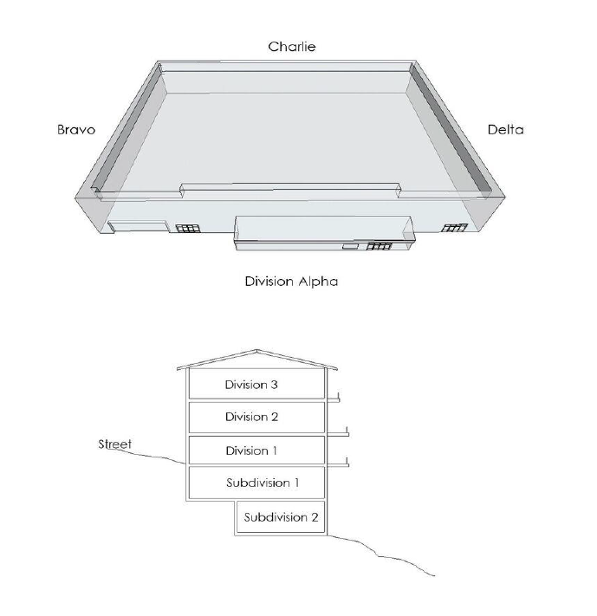
Unless otherwise specified, the address of the structure will be the Alpha side of the incident. The next following letters (B-D) will be applied in a clockwise rotation. To prevent confusion, verbalize the complete word, Alpha, Bravo, Charlie, Delta rather than the letter. On odd- shaped buildings it may be necessary to provide landmarks to help responding units understand the buildings orientation. A landmark such as a street name or geographical feature will help identify the Alpha Side. Example: The parking lot is the Alpha Side. Floors extending above street level will be identified in succession counting up. The street level is Division 1. Floors below street level will be identified as Sub-Level. Count from the street level down. Sub1, Sub2 etc.
Appendix #1- Fireground Geography

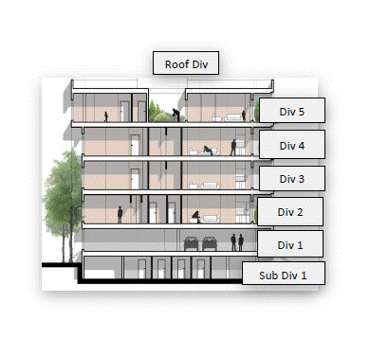
In multi-story, mid-rise, and high-rise occupancies, divisions will usually be indicated by floor number (Division 6 indicates sixth floor). When operating in levels below grade such as basements, the use of subdivisions is appropriate.

Appendix #1- Fireground Geography

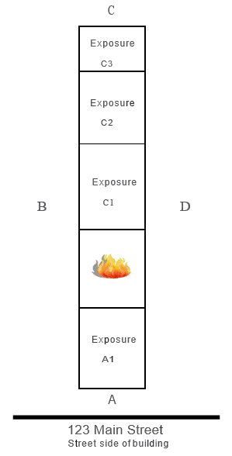

Appendix #1- Fireground Geography

In multi-unit occupancies, exposures can be indicated by alpha letter identifier for the side of the extension followed by a number that starts adjacent to the unit on fire. For a one-story strip mall where fire attack is being initiated on the Division A (Alpha) side, and fire is extending to the Division B (Bravo) side, the IC will start with Bravo 1, then Bravo 2 and so on to address units requiring assigned resources. If the fire extends to the Division D (Delta) side, the IC will start with Delta 1, then Delta 2. In a multi-story strip mall with a fire on the second floor and a Division 2 is established, similarly to the one-story structure, exposures to the Division Bravo side would be identified as Bravo 1, Bravo 2, and so on. Any exposure problems to the Division Delta side would be identified as Delta 1, Delta 2, and so on. The identifier for an exposure occupancy may be used for identification only and may not necessitate the assignment of an additional supervising Officer. The Incident Commander is responsible for clearly identifying areas of responsibility at multi-unit incidents.

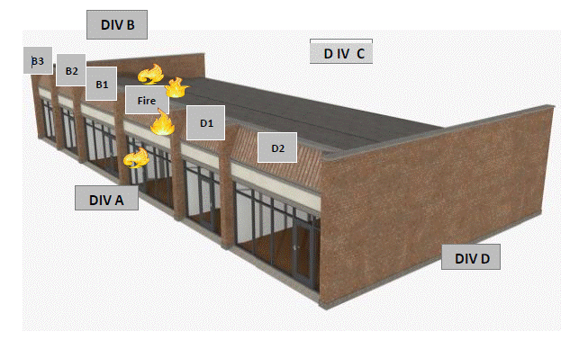

222 South Street
Street side of building

Appendix #2- Standard Search Markings

To be placed on the lower half of the door or on the wall adjacent to the doorway or opening to the space to be searched.

PRIMARY SEARCH INITIATED

PRIMARY SEARCH COMPLETED

Appendix #3- Two In/Two Out Exception Report

The incident described below required an exception to the OSHA Two In/Two Out requirement for the entry into the IDLH environment beyond incipient stage.

Incident Date: __________________________ AHJ Incident Number: _____________________

Incident Name: ____________________________________________________________________

Incident Address: __________________________________________________________________

Companies Involved: _______________________________________________________________

Company Officers: _________________________________________________________________

Report of victims trapped? Yes□ No□ When? __________________________

Number of Victims: ________ Number of Victims rescued ________ Number not rescued _________

Recue Mode Declared? Yes□ No□

Transporting ALS unit requested? Yes□ No□

Outcome of victims:

Summary of Actions:

Prepared by: ____________________________ Rank: ________________________________
(Incident Commander)

Fire Chief: ______________________________ Date: ________________________________
(Signature)

Appendix #4: Post Incident Review

The Post Incident Review (PIR) form provides a method, framework, and criteria for reviewing an incident. A review of performance is needed to improve and reinforce policies, SOG's and overall delivery of service to the public. The evaluation should be a positive and constructive learning tool.

Alarm and Size-Up:

- Was there adequate information from dispatch?
- Were communications effective with dispatch?
- Was the first in unit size up clear and accurate?
- What mode of operation was declared?
- Was a water supply obtained by the first arriving engine or another unit?
- What initial actions worked and what would you change?
Command and Fire Ground Operations:

- Was additional apparatus requested in a timely manner?
- Were the divisions/groups used appropriately for the incident's type and complexity?
- Were the SOP/SOG implemented and followed, if not why?
- Were assignments clear?
- Did personnel, units, and teams execute tactics effectively?
- Was apparatus properly positioned?
- What were the attack line selection and positioning?
- What type of ventilation was used and was it effective?

- What type of salvage was performed and when?
- What type of command decisions or fire ground operations worked (or didn’t), and would you change them?
Safety and Communications:

- How was risk analysis applied to the incident?
- Was a RIC established?
- Was Two- In / Two- out established?
- Were the utilities captured early in the incident?
- Were any Fire Department Personnel injured? Was it documented?
- Were crews relieved by fresh crews regularly and frequently?
- Was accountability controlled throughout the incident?
- Were PARs conducted during the incident?
- Did units, divisions/groups/branches communicate effectively?
- What communication or safety procedures can be improved?
Conclusion:
- What operations would you change?
- What operations worked well?
- What type of training would help to improve our performance?

