Subject: Change in Greater Alarm Plan

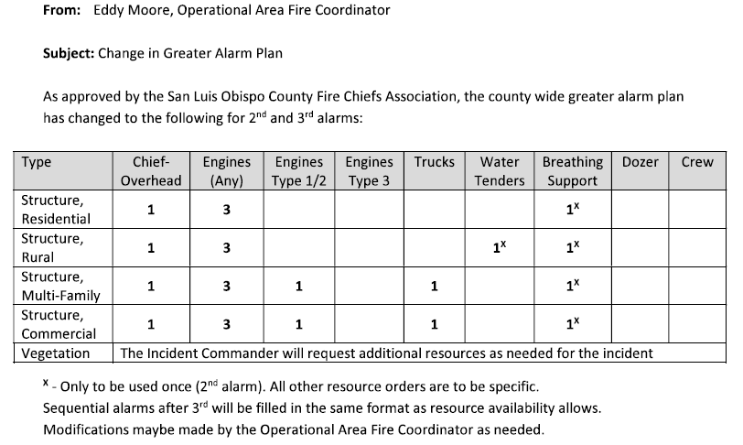

Date | Revision | SLO T/O Pres. | SLO Co. Chief Pres.
June 2, 2021 | Update sent to SL ECC, XSL Chiefs, SLU

