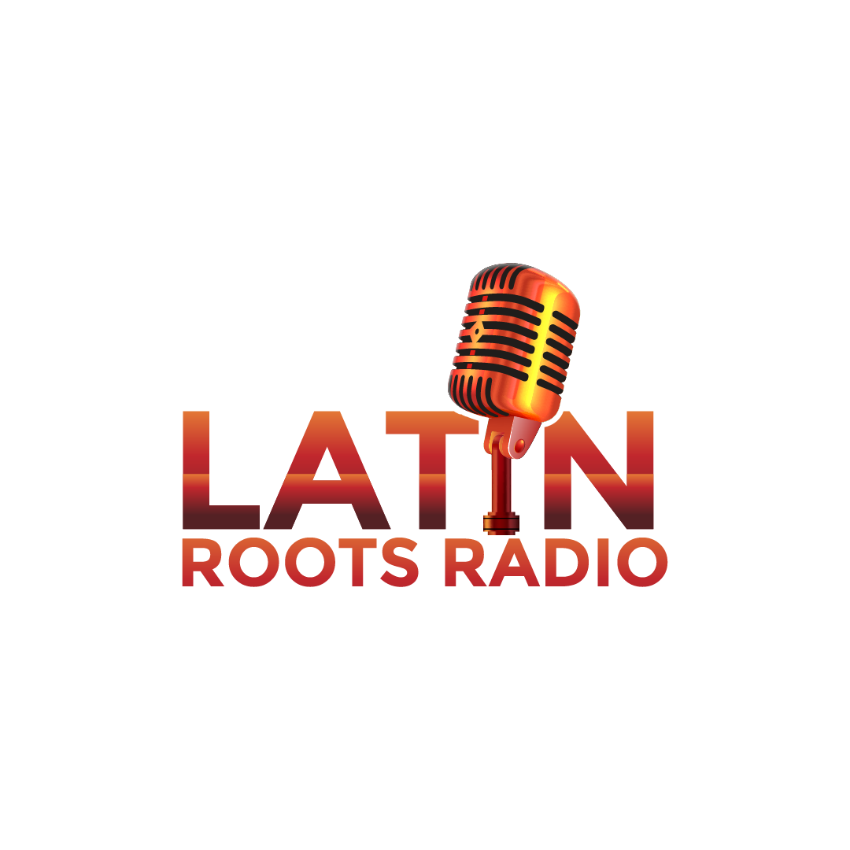
Latin Roots Radio DJ Services

Event Information Worksheet
Please fill out and return the following information to help us prepare for your event:

Client Information
Name: Click or tap here to enter text._______________
Email: __Click or tap here to enter text._____________
Phone Number: __Click or tap here to enter text.__
Today’s Date: _Click or tap to enter a date._________

Event Details
1. Event Type:
- ☐ Wedding - ☐ Birthday Party - ☐ Corporate Event - ☐ Private Party
- ☐ Other (Please specify): _Click or tap here to enter text._
- ☐ Name of person being celebrated if applicable : _Click or tap here to enter text._
2. Event Date: Click or tap to enter a date.______
3. Event Start Time: _Click or tap here to enter text._
4. Event End Time: _Click or tap here to enter text.___
5. Event Location:
- Venue Name: _Click or tap here to enter text._
- Address: _Click or tap here to enter text._
- City: Click or tap here to enter text.__
- State: _Click or tap here to enter text._
- Zip Code: _Click or tap here to enter text.__
6. Number of Guests: _Click or tap here to enter text.__
7. Age Range of Guests: _Click or tap here to enter text.__

Music Preferences
8. Preferred Music Genres:
- ☐ Salsa - ☐ Merengue - ☐ Bachata - ☐ Reggaeton - ☐ Soca - ☐ Reggae
- ☐ Cumbia - ☐ Dembo - ☐ Hip Hop - ☐ 80s-90s - ☐ Rock - ☐ TOP 40
- ☐ Other (Please specify): _Click or tap here to enter text._
9. Specific Songs or Artists You Want to Hear:
- _Click or tap here to enter text.___
- _Click or tap here to enter text.___
- _Click or tap here to enter text.___
10. Songs or Genres to Avoid:
- _Click or tap here to enter text._____________________________
- _Click or tap here to enter text._____________________________
- _Click or tap here to enter text._____________________________

Event Schedule
11. Are There Any Special Announcements or Moments? (e.g., speeches, first dance, cake cutting):
- _Click or tap here to enter text._____________________________
- _Click or tap here to enter text._____________________________
- __Click or tap here to enter text.____________________________

Additional Services
12. Additional Services (Please select any additional services you would like us to provide):
- ☐ Photography - ☐ TV on stand – this is for Video DJ - ☐ Extra Speakers
- ☐ Generator - ☐ Lights – Simple - ☐ Lights – Advanced
- ☐ Smoke machine (make sure that there is no fire detection equipment present and venue allows it)
- ☐ Other (Please specify): Click or tap here to enter text.___

DJ Attire
13. Preferred DJ Attire:
- ☐ Formal (Suit/Tie)
- ☐ Semi-Formal (Dress Shirt/Pants)
- ☐ Casual (T-Shirt/Jeans)
- ☐ Themed (Please specify): __Click or tap here to enter text.___

Additional Information
14. Is There Any Additional Information or Special Requests You Would Like Us to Know?
- _Click or tap here to enter text._____________________________
- _Click or tap here to enter text._____________________________
- _Click or tap here to enter text._____________________________

Any questions or concerns please contact us at

DJ Dragon 561.598.1975 LatinRootsRadio@gmail.com www.LatinRootsRadio.com

NOTE 1: For payments and deposits, please use Zelle at [LatinRootsRadio@gmail.com]. A non-refundable deposit of at least 50% is required to secure your booking.
NOTE 2: We currently do not accept bookings at venues exposed to the elements unless there is complete coverage and no risk of equipment damage.

