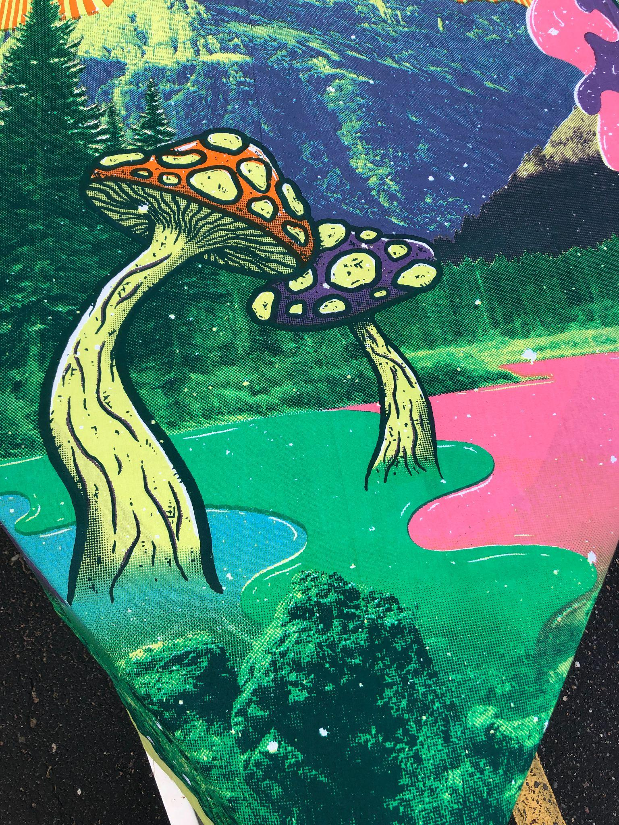
MUSHROOM FORAGE TRIP
SATURDAY, AUGUST 26, 2023

SIGN UP SHEET
$60.00 PER PERSON. UNDER 18 MUST BE ACCOMPANIED BY PARENT OR GUARDIAN WITH TRIP TICKET ALSO.

PRINT OFF FORM AND MAIL TO CFBA, PO 233, CRYSTAL FALLS, MI 49920
ATTN:BARBARA LUCK
CFBA WILL CONTACT YOU ONCE YOUR INFORMATION IS RECEIVED AND CONFIRM TRIP DETAILS.

SATURDAY 9-12 A.M. OR 1-4 P.M. SLOTS ARE AVAILABLE.

SEAN ACKLES FROM GROUSE ACRES WILL BE YOUR “FUN-GI” FOR THE DAY.

OUR LOCAL HOMESTEADER SEAN ACKLES, TAUGHT FOLKS THE JOY OF GROWING MUSHROOMS ON A LOG LAST YEAR AT THE HARBOUR HOUSE. THIS YEAR HE WILL BE TAKING YOU FORAGING FOR KNOWLEDGE OF MUSHROOMS WITH A LOCAL TRIP TO THE WOODS.

AUGUST 26TH CHECK IN- FOREST PARK SCHOOL, PARKING AREA.
PLEASE BE 15 MINS EARLY TO CHECK IN.

WHAT TO BRING?
WATER, BUG SPRAY, CLOTHES FOR WEATHER, CAMERA, NOTEBOOK/PEN, GLOVES, UMBRELLA, SUNSCREEN.

WE DON’T CANCEL BECAUSE OF WEATHER.
LIMITED SPACE NO REFUNDS.
NAME-_______________________________________________________________

ADDRESS____________________________________________________________

PHONE_______________________________________________________________

EMAIL________________________________________________________________

AM TRIP PM TRIP

# PEOPLE- _______________________X $60.00________________Total_________

PLEASE LIST ALL NAMES REQUESTING “TICKETS” FOR FUNGUS TRIP.

______________________________________________________________

______________________________________________________________

______________________________________________________________

______________________________________________________________

______________________________________________________________

NO PICKING OR TOUCHING MUSHROOMS!

LISTEN TO YOUR GUIDE. RESPECT NATURE.

