
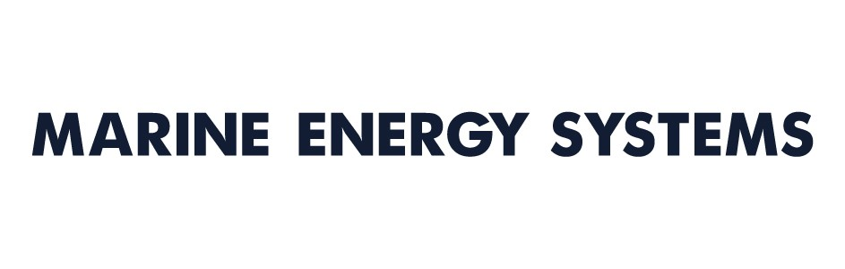

COMPANY STATEMENT

At MES, we have founded our company on the basic principle of engaging with opportunities that we can enjoy being involved with, and doing them in a way that fulfils the best ethical practices.

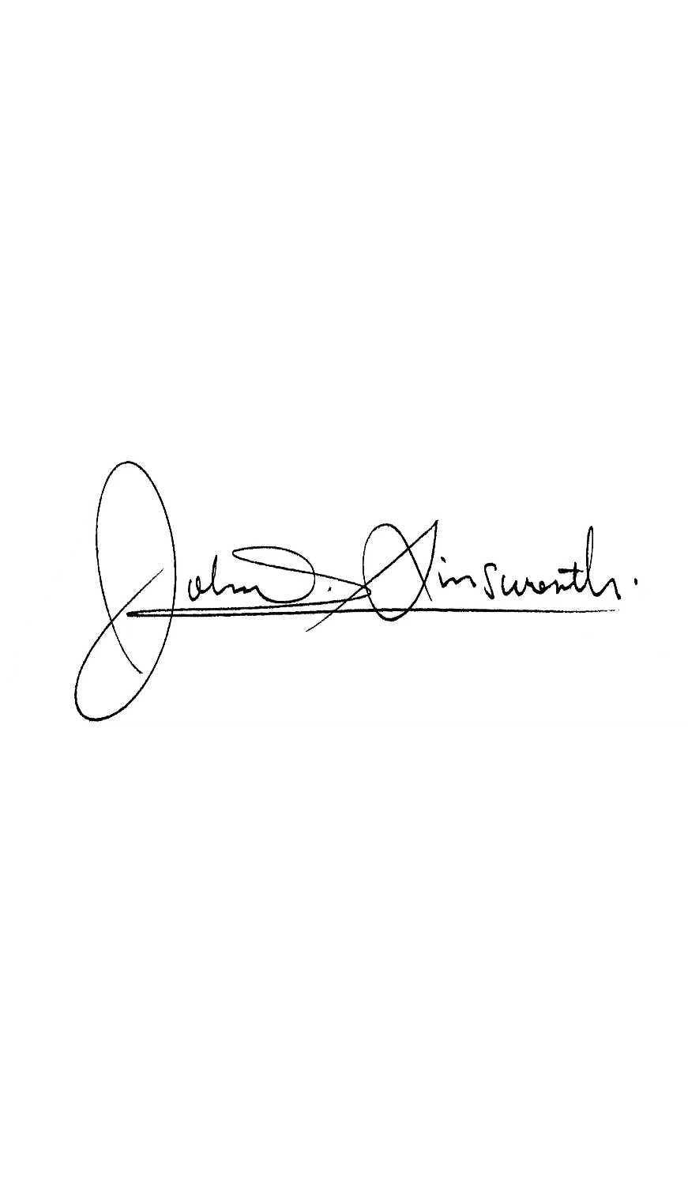
We ensure that we are fully connected with all the people within our business, our supplier and dealer partners and importantly our customers.

We believe that this approach to running our business means that we are always focused on providing the best possible experiences for everyone we encounter.

John Ainsworth
Managing Director

