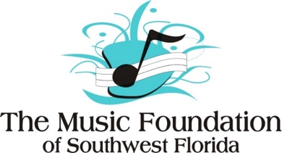

**PRIVATE LESSON APPLICATION**

DATE OF APPLICATION:

STUDENT NAME:

STUDENT SCHOOL AND GRADE:

INSTRUMENT:

YEARS PLAYING THIS INSTRUMENT:

PARENT NAME:

PARENT EMAIL ADDRESS:

PARENT PHONE NUMBER:

HOME ADDRESS AND ZIP CODE:

WOULD YOU LIKE TO BE CONSIDERED FOR A SCHOLARSHIP?

6 Weeks of half hour lessons = $180

A minimum payment/deposit of $25 is requested. Scholarships are available.

After you complete this registration form, please email it to Ruth Christman at

[JCMFA@aol.com](mailto:JCMFA@aol.com). To make a payment, go to The Music Foundation website to make your payment through Paypal.

The Music Foundation is a 501 (c)(3) nonprofit organization,

providing and supporting music education programs since 1991.

13300-56 S. Cleveland Avenue, PMB 214   Fort Myers, FL  33907

239-275-0027 https://music-foundation.org