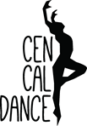
DRESS CODE POLICY
2020-2021
*No jeans will be allowed in any dance class.
*No midriffs showing on any student under 18 years of age.
*Tights to be worn with leotards, trunks/briefs

Combo Classes: Dancers wear a leotard with attached skirt and tights. Long hair should be worn off the neck and away from the face. Both pink ballet shoes and black tap shoes are required for all Combo classes.

Gym Classes: Gymnasts wear a leotard with trunks/shorts or a unitard. Long hair should be worn off the neck and away from the face. No tights or shoes.

Ballet: Solid leotard and pink tights; skirts are optional. Hair must be worn in a bun. Split sole Ballet slippers are required for all ballet classes.

Hip Hop: Leotards, tights, unitards, tight-fitting jazz pants, or trunks (briefs). T-shirts, sweatshirts, and sweatpants may be worn for the first 15–20 minutes of class only (during warm-ups). Athletic or sweatpants with a fitted T-shirt (no oversize baggy T-shirts or sweatshirts). Clean gym shoes (any style) are permitted for Hip Hop. Please provide a pair that are only worn on our dance floors and not out on the street.

Jazz: Dancers may wear leotards, tights, unitards, tight-fitting jazz pants, or trunks (briefs). T-shirts, sweatshirts, and sweatpants may be worn for the first 15–20 minutes of class only (during warm-ups). Long hair should be worn off the neck and away from the face. Black/tan jazz shoes must be worn for all classes. We recommend the leather slip-on jazz shoe with no laces.

Lyrical/Contemporary: Dancers may wear leotards, tights, unitards, tight-fitting jazz pants, or trunks (briefs). T-shirts, sweatshirts, and sweatpants may be worn for the first 15–20 minutes of class only (during warm-ups). Long hair should be worn off the neck and away from the face. Tan jazz shoes & dance paws are permitted for all lyrical/contemporary classes. Dancers may also go barefoot at times during class, but please bring shoes for turning purposes.

Musical Theater: Dancers may wear leotards, tights, unitards, tight-fitting jazz pants, or trunks (briefs). T-shirts, sweatshirts, and sweatpants may be worn for the first 15–20 minutes of class only (during warm-ups). Long hair should be worn off the neck and away from the face. Character shoes/tap shoes must be worn for all classes. Please speak with the teacher regarding his/her preference.

Tap: Dancers may wear leotards, tights, unitards, tight-fitting jazz pants, or trunks (briefs). T-shirts, sweatshirts, and sweatpants may be worn for the first 15–20 minutes of class only (during warm-ups). Long hair should be worn off the neck and away from the face. We recommend Bloch brand, full-sole tap shoes.

Combo | Jazz | Musical Theater
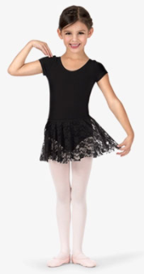 |  | 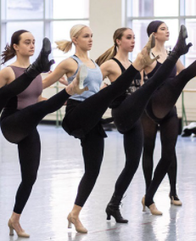
Ballet | Hip Hop | Shoes
 | 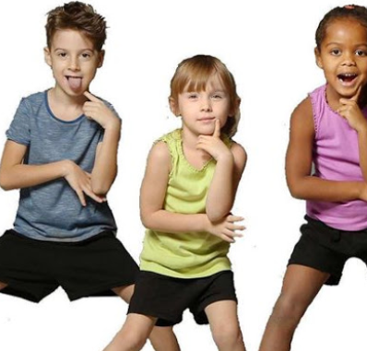 | 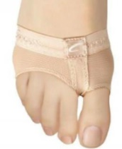  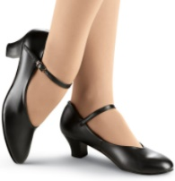  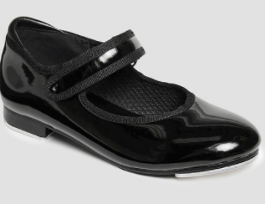  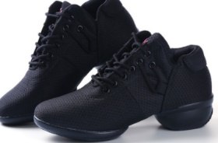
Tap | Lyrical/Contemporary | Gym
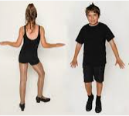 | 