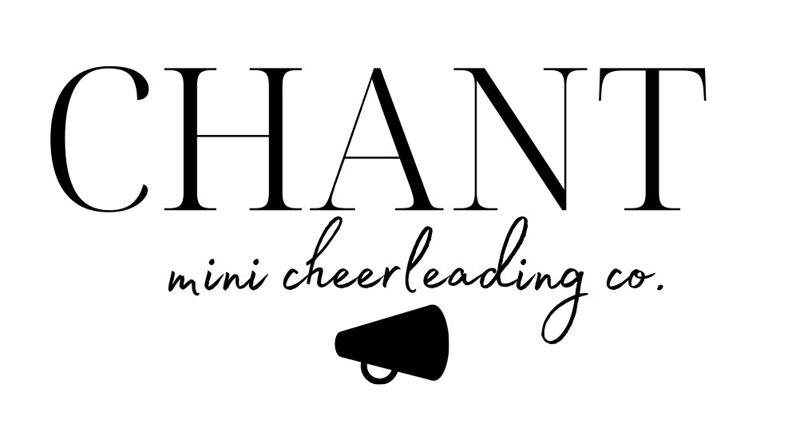

If you are interested in advertising a business or having your family name on the back of the CHANT Cheerleading t-shirts worn by all cheerleaders at the games, please complete the sponsorship information below:
Individual/Business Name:
Contact Person:
Address:
City/State/Zip:
Phone:
Email:

Sponsor: $250
- Business or family name will appear on the back of all cheerleading shirts.
- @CHANTminicheer social media recognition.
Presenting Sponsor: $1000
- Business or family name will appear larger than all other names on the back of all cheerleading shirts.
- @CHANTminiCheer social media recognition.

Please send payment via Venmo to @chantminicheer and email a filed-out sponsorship form to chantcheer@gmail.com. If you have any questions on sponsorship, please email chantcheer@gmail.com.

