**A Few of Our Favorite Things (and Places)**

We were asked to name three or four “must see” places in Aberdeenshire. It’s hard to narrow it to so few and our first two may require an hour’s drive but these are our choices:

*(Photos by Jackie)*

**Dunnottar Castle https://www.dunnottarcastle.co.uk/**

Mike’s #1 Choice (and my second) but be aware, getting up to the castle itself requires a huge amount of stair climbing, (not too steep) but it is so worth it! I have one bionic knee and lots of arthritis in the other and I made it by just taking my time.

They have restored the Great Hall and you can clearly imagine the Lord and Lady plotting to save the crown jewels of Scotland when the castle was under siege. Highly recommend reading more on the castle history before you go. Be sure to take extra batteries for your camera – you will use one up and you don’t want to hike back for another!

**Stonehaven** [**https://www.stunningstonehaven.com**](https://www.stunningstonehaven.com)

Include the town of Stonehaven in your trip. There’s a enjoyable walking path around the harbor with unique sculptures and a peek into beautiful backyard gardens.

If you are there for lunch, the choices are varied from tea rooms to Indian to Chinese cuisine.

We also enjoyed visiting the tiny Tolbooth Museum on the harbor.

**Scottish Museum of Lighthouses in Fraserburgh**

**https://lighthousemuseum.org.uk/**

Jackie’s favorite place to spend lots of time with a camera!!

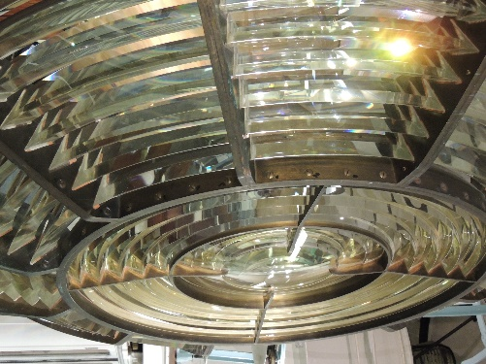The museum is at the base of Kinnard Lighthouse, built in 1824 right through the middle of a castle! A guided tour takes you to the top of the lighthouse with stops along the way to look at the life of the keeper and his family and all the work required to keep the light working.

Back on the ground, put a fresh battery in your camera and photograph the three floors of lighthouse prisms saved from the conversion to more modern lighting. Some sit on table tops others stretch to the ceiling.

A tea room and gift shop on site, of course.

Check out the website for information on other activities in Fraserburgh:

<https://www.visitscotland.com/info/towns-villages/fraserburgh-p238061>

**Spirit of Speyside Whisky Festival** [**https://www.spiritofspeyside.com/**](https://www.spiritofspeyside.com/)

If you are fortunate to be in Scotland Apr 27 to May 2, this festival is a MUST!!!! You can always tour the key distilleries in Dufftown but during the festival they open ones which are normally closed to visitors. No room to list all the other activities here – bottomless brunch at the oldest hotel in the Speyside, the Craigellachie Hotel, unique whisky tasting events, and so much more – take a look at this article for ideas <https://foodanddrink.scotsman.com/in-the-news/spirit-of-speyside-2022-festival-programme-announced-for-this-years-event/?fbclid=IwAR2uPxowav6eKroG-BhY6INLaUMhJYvunp19KAC_DI7dDMDCW5nxYh16G2Y>

**ADVANCE TICKETS ARE A MUST FOR MOST EVENTS! Get them now.**

[**https://tickets.spiritofspeyside.com/**](https://tickets.spiritofspeyside.com/)

**Other Wonderful Places We’ve Visited:**

**Craigievar Castle https://www.nts.org.uk/visit/places/craigievar**

This castle is supposedly an inspiration for Disney’s Cinderella Castle. Neat on this tour – an authentic experience with no artificial lighting beyond the first floor. Use your National Trust for Scotland membership to get in free.

**Crathes Castle https://www.nts.org.uk/visit/places/crathes-castle**

Historic walled garden with plantings dating to 1702. The castle is a maze of turrets, towers, oak panels and painted ceilings.

**City of Aberdeen:** [**https://www.visitabdn.com/**](https://www.visitabdn.com/)

Endless options here – I can spend hours just photographing the St Nicholas Cemetery in the middle of town.

**Places on our list for our May 2022 trip:**

**Pitmedden Garden** [**https://www.nts.org.uk/visit/places/pitmedden-garden**](https://www.nts.org.uk/visit/places/pitmedden-garden)

Recreated Scottish Renaissance walled garden with more than 39,000 annula bedding plants. The original garden was designed in 1675.

**Fraser Castle** [**https://www.nts.org.uk/visit/places/castle-fraser**](https://www.nts.org.uk/visit/places/castle-fraser)

The core of the castle dates to the 1450s but all the additions over the centuries make it one of the largest tower houses in the country. It also has a traditional walled garden.