***Things to see/do If you’re staying near Ballater (Hilton Craigendarroch):***

Ballater is a beautiful Victorian village of moderate size and major interest. Located on the Dee River, the village originally played hosts to visitors coming to the Pannanich Mineral Wells, on the opposite side of the river. Now, much of the focus is on hosting visitors in the area to visit Balmoral Castle. Unique shops, bistros, bakeries and tea rooms stand ready to host everyone.

(The Pannanich Mineral Wells water is now bottled as Deeside Mineral Water.)

If you are staying at the nearby *Hilton Craigendarroch* or another self-catering home and want to stock up on the few groceries, swing by the *Co-Op Food Store* for the basics and then be sure to slide into bakery just a door away for some famous “Ballater bread” or a couple macaroni and cheese pies. (It’s mac and cheese in a pastry shell!) If you still have time to kill before check-In, swing just a little north of town to the Campus O’May Cheese and Melt Hoos for the makings of a charcuteries tray.

**Balmoral Castle:**

This is a must see – if the Queen is not in residence! Her Royal Highness usually visits during the month of September so check the website for open dates. For 2022, the grounds, gardens, exhibitions, gift shop and coffee shop at Balmoral will be open to the Public daily from Friday 1st April until Tuesday 2nd August. Advance tickets must be booked online at <https://www.balmoralcastle.com/index.html>

General admission is £15.00 Admission with afternoon tea is £37.50 (Now, you know you want to post pictures of you having tea at the Queen’s castle on your facebook page!)

You might even catch a glimpse of HRH beloved Highland Ponies during the grounds tour.

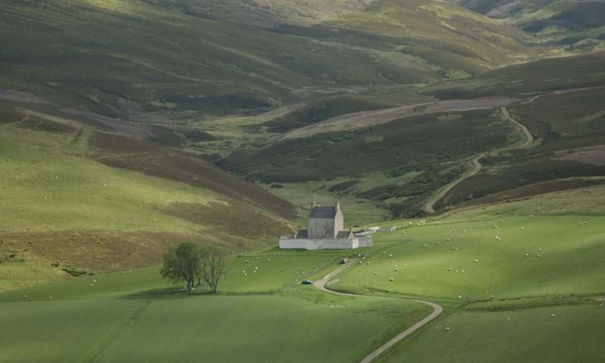 **Corgarff Castle:**

The castle is closed, but visitors are welcome to explore the grounds of this medieval tower house. Originally a noble residence, Corgarff became an army base for hunting down Jacobite sympathizers and, later, whisky smugglers.

**Hiking:**

Choose a direction, fix a picnic and enjoy the Hobbit scenery on walks through places such as Burn O’Vat, Muir of Dinnet and Lock Muick.

**A distillery (of course!)**

If you’re going to visit the vacation home of the Queen, then you should visit the home of a royally sanctioned whisky -Royal Lochnager Distillery, just three minutes from the castle. They offer tours year-round (but check their webpage for exact days and times). They offer a variety of tour specialties ranging from £17.50-30.00. I recommend the chocolate pairing tour!

<https://www.malts.com/en-us/distilleries/royal-lochnagar>

Food & Drink in Ballater

The Balmoral Bar: Great pub food and entertainment for an evening out of the hotel.

Deeside Deli and Garden Shop: Fun combination of great lunch selections, local cheese, fruit and vegetables, flowers and plants to buy.

Brown Sugar Café: A sweet place for breakfast!

**The Village of Braemar**

Braemar is a ten-minute drive from Ballater (past Balmoral Castle) and, again, well worth your time! Unfortunately, one of my favorite stops on the way, Braemar Castle, is closed until 2023 for refurbishment.

Braemar is best known for “The Braemar Gathering”, a weekend of traditional Highland games at the beginning of September.

A favorite place to visit is Braemar Castle – unfortunately for visitors this year, the castle is closed for a £1.5 million renovation. Maybe next trip….

Places to see in town:

Braemar Gallery -- 34 Mar Road: From local craftsmen to well-known Scottish artists, the collection is constantly changing at the Gallery. It’s a great place to pick up a remembrance of Scotland that’s more than just the common souvenir.

The Braemar Highland Games Centre: Opened in 2019, the Centre celebrates the living traditions of the Highland games, focusing on the Braemar Gathering and its long-standing royal connections. In addition to the exhibition, there is a café and gift shop.

**The Horn Shop: You can find everything from cheese knives to drinking horns to chandeliers here – all made from stag antler and cow horn. Definitely a unique gift to take home.**

Food & Drink in Braemer

Invercauld Mews Bar: Recently reopened, this little bar is a great place to catch live music, play darts, shoot pool or catch a game on the telly. They also serve the local Braemar Brewery ale.

The Balmoral Bar: Repeat of the description of Invercauld Mews.

Farquharsons Bar and Kitchen: Just go here because of the name – stay to enjoy great food.

“The Fife Arms Hotel/Flying Stag:

Okay, I’m going to take this straight from their website:

It was said that if you were looking for someone in Braemar, the first place you should look was the public bar at The Fife Arms.  The Flying Stag public bar continues to be the social centre of the village. With regulars rubbing shoulders with visitors, the bar has a vibrant atmosphere with animated conversation and live entertainment. The bar offers local beers, Scottish whiskies and spirits accompanied by a menu of bar snacks and hearty Scottish dishes.

The Flying Stag was created by the renowned artist, James Prosek, who is known for his paintings of unique, hybrid animals. The animal is a union of a ptarmigan’s wings (a bird that lives on the highest peaks of the Cairngorms) and a stag (commonly found in the forested Dee Valley).”

Reservations required!

<https://thefifearms.com/eat-drink/flying-stag/?utm_source=google&utm_medium=local&utm_campaign=restaurant-theflyingstag>