Walrath Tax Service
PO Box 625
Brownville, NY 13615
315-785-9756
Walrathtax@parse.atomanager

Dear Taxpayer(s),
This letter is to confirm our understanding of the terms of our agreement and outline the nature and extent of services we will provide. Based upon the information you furnish to us; we will prepare your Federal and applicable state income tax returns for 2023.

We will not audit or verify the data you submit to us, although we may ask you for clarification when necessary. All the information you submit to us will, to the best of your knowledge, be correct and complete and include all other information necessary for the completion of your tax return.

We will also prepare 2024 estimated tax vouchers if required, based on your income and withholding taxes for 2023. If you anticipate a substantial change in income or withholding taxes for 2024, please advise us as soon as possible. We will then determine whether an adjustment should be made to your tax estimates.

Your returns are subject to review by the taxing authorities. Any items that may be resolved against you by the examining agent are subject to certain rights of appeal. In the event of an examination, we will be available upon request to represent you, or to review the results of any examination. Billing for these additional services will be at our standard rates.

The charges for our services are based on our fee schedule and the complexity of the returns.

You have the final responsibility for your income tax returns. Please review them carefully before you sign them for Efiling.

With my signature I am attesting that all information submitted to Walrath Tax
Service is true, correct, and complete to the best of my knowledge.

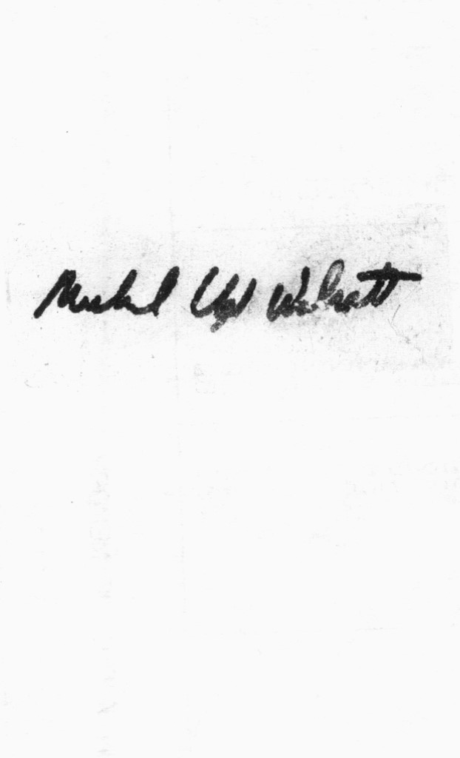
If the above is in accordance with your understanding of the terms and conditions of our agreement, please sign and return a copy of this letter.

__________________________________________
MICHAEL L WALRATH

Accepted by: Date ________________

X______________________________________ X ________________________________
Client signature Spouse signature

______________________________________ ________________________________
Print name Print name

