**Gas Engineering**

Name.................................................

Tutor.................................................

**Core Skills Knowledge**

Explain how pipes should be installed in the following scenarios using drawings.

1. Pipes installed in a concrete floor.
2. Pipes passing through a cavity.
3. Pipe routed in stud partitioning walls.

**Core Skills Knowledge**

1. What is good practice when installing gas pipes in wooden floors?
2. When pipes are installed on walls important facts should be considered?

1. When should pipes be painted?

*A) Before purged and tested*

*B) After purged and tested*

7. What should pipes be protected from?

* .
* .
* .
* .

1. Below are isolation valves what appliances are they used for?

Bayonet (spring valve)

Pedestal valve

Gas cock

Gas spherical valve

ECV

1. Should pipes be installed in voids what must be fitted to meet current regulations?
2. What material for pipe work can only be installed in lift shafts?

Tightness testing

11. Let by test period is min, which confirms the ECV isolates correctly.

12. The stabilisation period is min, which allows air and gas temperatures to mix and stabilise.

13. The final test is tightness which is for min the allowances is;

E6

G4/U6

14. Explain what the following test pressures are for;

Standing pressure

Inlet pressure

Working pressure

Burner pressure

15. What do the following Regulations cover?

3

6

22

26(9)

34

36

16.

**Flues**

17. How should flue liners be installed?

18. Explain what the following tests and how they are performed;

Flue;

Spillage test

19. Flue clearance from combustibles?

20. Open flue appliance must have 600mm clearance before the first

21. Should a fire have excessive flue pull what device can be closed?

22. When installing condensing boilers what must be considered when terminating POC?

23. Should a flue terminate lower than 2m what safety guard must be installed?

24. Where are liners only allowed to be installed?

25. If an external chimney is higher than 11m, what should be installed?

26. When using twin wall, what is the maximum bend degree allowed?

27. List some materials which can be used when installing and sealing flues?

28. Label the drawings below.

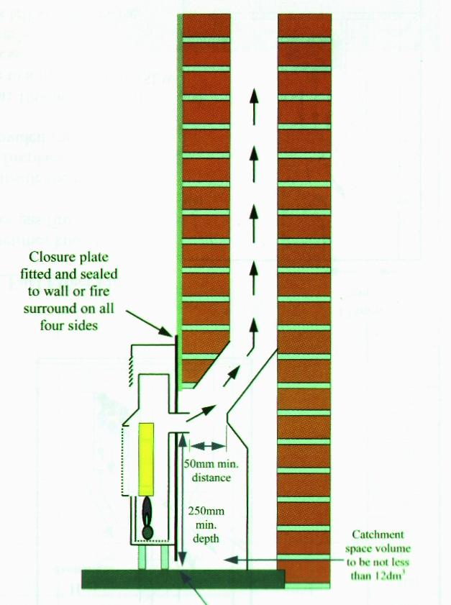

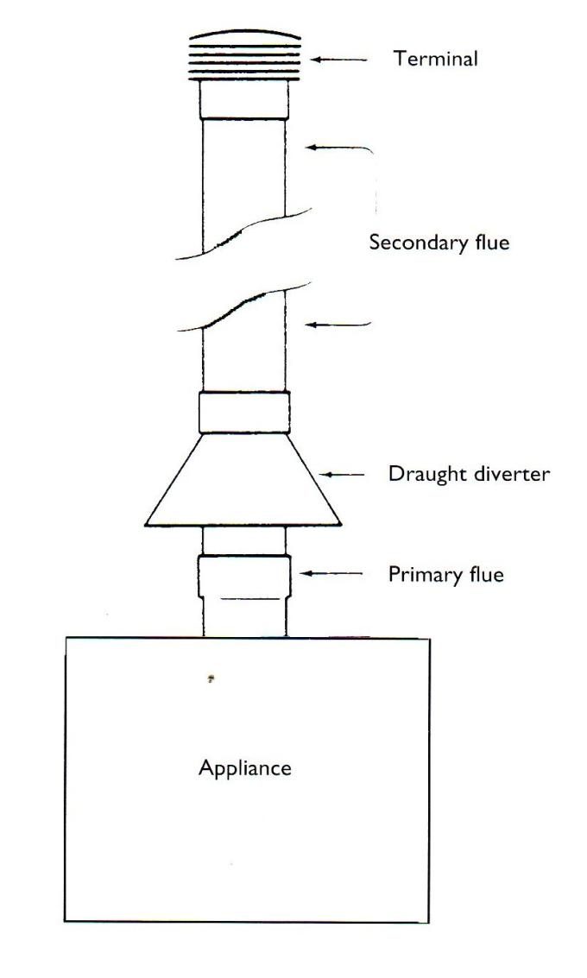

**Metering**

29. Refer to the meter installation in the workshop and write down any faults you discover.

Meter Installation

What type of meter

Earth present

ECV accessible

Correct labels

Pipe work correctly sleeved

Correct materials

Correct valves/installation defects

How would you categorise this installation? (ID-AR-NCS)

Meter Installation *assessment conditions*

What type of meter

Earth present

ECV accessible

Correct labels

Let-by *Pass/Fail* Tightness test *Pass/Fail*

*Overhaul/leakage discovered N/A*

Pipe work correctly sleeved

Correct materials

Correct valves/installation defects

How would you categorise this installation? (ID-AR-NCS)

*Pilots re-lit /purged? LDF test nipple?*

Tutor/ Assessor Signature

Student signature Date

**Cookers**

30. When commissioning an oven what safety checks must be carried out?



31. When inspecting hot plates what must be assessed?



32. What two methods can be used to secure cookers?



33. Spring valves/bayonets are best installed using a

34. Cooker hoses must always hang down to avoid

35. Enter the dimensions.

**Cooker inspection**

Date

Manufacturer

Model

Serial number

Type *built in/free standing/hob/grill*

Any damages

Level/ clearances-dimensions

Acceptable ventilation

Ignition

Flame picture/burner

Operational safety devices *shut down lid/vapour device/thermocouple/thermostat*

Thermostat functioning correctly

By-pass operational (*low flame)*

Gas taps *Stiff/loose/broken/label worn/leaking*

Retaining device present Yes/no

Tutor Signature

**Cookers**

36. Completely remove an oven burner, inform your tutor to discuss component, then write below your order of work and methods used.

Tutor Signature

Learner signature Date

**Cooker inspection** *assessment conditions*

Date

Manufacturer

Model

Serial number

Type *built in/free standing/hob/grill*

Any damages

Level/ clearances-dimensions

Acceptable ventilation

Ignition

Flame picture/burner

Operational safety devices *shut down lid/vapour device/thermocouple/thermostat*

Thermostat functioning correctly

By-pass operational (*low flame)*

Gas taps *Stiff/loose/broken/label worn/leaking*

Retaining device present Yes/no

Tutor Signature

Any cause for concern? ID/AR/NCS

**Heating appliances**

36. Discuss with your tutor and answer the table below referring to the display of heating components.

|  |  |  |  |  |
| --- | --- | --- | --- | --- |
| Item number | Component name | Job description | Service procedure | Symptoms when faulty |
| 1 |  |  |  |  |
| 2 |  |  |  |  |
| 3 |  |  |  |  |
| 4 |  |  |  |  |
| 5 |  |  |  |  |
| 6 |  |  |  |  |
| Item number | **Component name** | **Job description** | **Service procedure** | **Symptoms when faulty** |
| 7 |  |  |  |  |
| 8 |  |  |  |  |
| 9 |  |  |  |  |
| 10 |  |  |  |  |
| 11 |  |  |  |  |
| 12 |  |  |  |  |
| Item number | **Component name** | **Job description** | **Service procedure** | **Symptoms when faulty** |
| 13 |  |  |  |  |
| 14 |  |  |  |  |
| 15 |  |  |  |  |
| 16 |  |  |  |  |
| 17 |  |  |  |  |
| 18 |  |  |  |  |
| Item number | **Component name** | **Job description** | **Service procedure** | **Symptoms when faulty** |
| 19 |  |  |  |  |
| 20 |  |  |  |  |
| 21 |  |  |  |  |
| 22 |  |  |  |  |
|  |  |  |  |  |
|  |  |  |  |  |

**Boiler service**

Site location.....................................................

Model..............................................................

Make...............................................................

Engineer..........................................................

Date.................................................................

GC number......................................................

Serial number..................................................

Is the electrical connection to the manufacturers guidelines? (accessible/fuse/ducting)...................................................................................................................................................................................................................................................

Clearances correct?....................................................................................................................

Tightness test correct?...............................................................................................................

Meter installation acceptable?...................................................................................................

Pipe work to current standards?.......................................................................................................................................................................................................................................................................................

Standing pressure......................................

Working pressure.......................................

Smooth ignition?........................................

Burner pressure.........................................

Gas rate......................................................calculations.............................................................

FSD(response secs)....................................

Exchanger condition?.................................

Burner condition........................................

Insulation pads...........................................

AAV.............................................................

Flow flue test..............................................

Spillage test/casing................................................

Pump speed, cold feed, filling loop, expansion pipe and by-pass installed to standard?

................................................................................................................................................................................................................................................................................................................................................................................................................................................................................................................................................................................................................

Tutor............................................................

Signature......................................................

Date.............................................................

*Feedback.........................................................................................................................................................................................................................................................................................*

**Boiler service** assessment conditions

Site location.....................................................

Model..............................................................

Make...............................................................

Engineer..........................................................

Date.................................................................

GC number......................................................

Serial number..................................................

Is the electrical connection to the manufacturers guidelines? (accessible/fuse/ducting)...................................................................................................................................................................................................................................................

Clearances correct?....................................................................................................................

Tightness test correct?...............................................................................................................

Meter installation acceptable?...................................................................................................

Pipe work to current standards?.......................................................................................................................................................................................................................................................................................

Insulation pads...........................................

Working pressure.......................................

Smooth ignition?........................................

Burner pressure.........................................

Gas rate......................................................calculations.............................................................

FSD(response secs)....................................

Exchanger condition?.................................

Burner condition........................................

Standing pressure......................................

AAV.............................................................

Flow flue test..............................................

Spillage test................................................

Pump speed, cold feed, filling loop, expansion pipe and by-pass installed to standard?

................................................................................................................................................................................................................................................................................................................................................................................................................................................................................................................................................................................................................

Tutor..........................................................

Signature....................................................

Date............................................................

*Feedback.........................................................................................................................................................................................................................................................................................*

Decommissioning Boiler

Date:..........................................................

Appliance/Location:..................................

First task:

...........................................................................................................................................................................................................................................................................................................................................................................................................................................................................................................................................................................

Decommissioning Boiler:

...............................................................................................................

..............................................................................................................

..............................................................................................................

..............................................................................................................

..............................................................................................................................................................................................................................

Completion procedure/other trades:

............................................................................................................................................................................................................................................................................................................................................................................................................................................................*Feedback*.............................................................................................................................................................................................................................................................................................................................................................................................................................................

37. Refer to the Anton website and answer the following questions on power flushing.

**Power flush Criteria**

1 What is the preparation checks prior to flushing?

1…………………………………….........................…………….

2…………………………………………………..........................

3…………………………………………………..........................

4…………………………………………………..........................

5…………………………………………………..........................

6…………………………………………………..........................

7…………………………………………………..........................

2 Where must the dump hose exit?

…………………………………………………………

………………………………………………………….

3 Why must the cap be left off the flushing equipment?

……………………………………………………………………………………………………………...........………………………

4 If pump access is difficult where can the flusher be connected?

………………………………………………………………………………………………………………………………….............

5 How must chemicals be added in the feed and expansion cistern?

……………………………………………………………………………………………………………………………………………………………………………………………………...................................................................................

6 When heat flushing the system what must you remember?

………………………………………………………………………………………………………………………………………………..............................................................................................................………………………..

7 How can you flush the system more efficiently?

………………………………………………………………………………

………………………………………………………………………………

**Glow Worm Hide Away**

38. Refer to the manufacturer’s instructions to answer the following.

1 What type of flue is this appliance?

2 Where would you test for flue pull on this appliance?

3 Should the rope seal on the combustion chamber become damaged why this is dangerous?

4 What fuse should this appliance have?

5 What is the lighting procedure for this appliance?

6 What is the minimum working pressure allowed at the appliance?

7 What is the clearance for the appliance inside the dwelling?

8 What is the recommended temperature difference between the flow and return?

9 What is the minimum gravity pipe work size?

10 When installing the pump within the boiler casing what consideration must be allowed?

11 What is a Piezo?

12 What should the distance be from the pilot tip to the thermocouple?

13 Should the pilot not light what may be the fault?

14 What is the Lint Arrester?

15 Why should the insulation panels be in good solid condition?

16What is the fault should power supply be proven both sides at the thermostat but no ignition?

17 Should gas not flow from pilot assembly what might be the fault?

18 What is the GC and serial number for this appliance?

19 What is the GC part number for the Gas valve?

20 What is the part number for the thermostat?

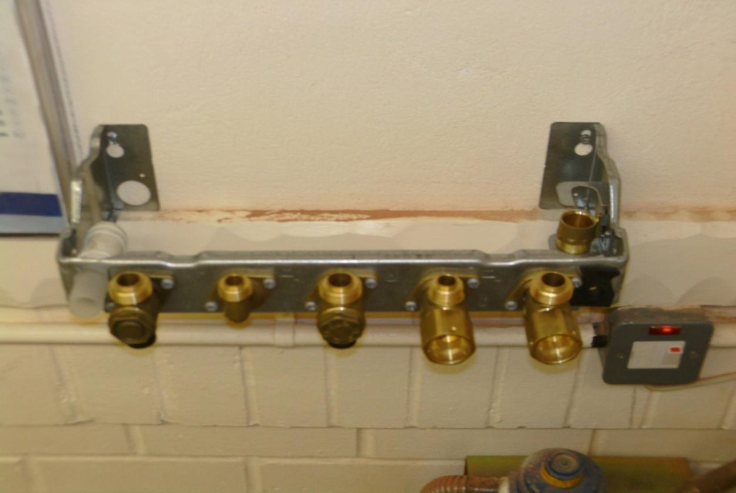

……………………………………………………………………………………………………………………………………………………………………………………………………………………………………………………………………………………………………………………………………………………………………………………………………………………………………………………………………………………………………………………………………………………………………………………………………………

**Combination jig**

………………………………………………………………………………………………………………………………………………………………………………………………………………………………………………………………………………………………………………………………………..…

…………………………………………………………………………………………………………………………………………………………………………………………………………………………………………………………………………………………………………………………………………

……………………………………………………………………………………………………………………………………………………………………………………………………………………………………..

……………………………………………………………………………………………………………………………………………………………………………………………………………………………………………………………………………………………………………………………………………………………………………………………………………………………………………………………………………………………………………………………………………………………………………………………………………

………………………………………………………………………………………………………………………………………………………………………………………………………………………………………………………………………………………………………………………………………………………………………...

...............................................

..............................................

……………………………………………………………………………………………………………………………………………………………………………………………………………………………………………………………………………………………………………………………………………………………………………………………………………………………………………………………………………………………………………………………………………………………………………………………………………

**Cold**

**Gas**

**Hot**

**How to use a Flue Analyser**

39. Refer to the Anton Sprint V2 manual answer the following question.

What tasks can a flue analyser do?

1………………………………………………………………………………

2………………………………………………………………………………

3……………………………………………………………………………..

4………………………………………………………………………………

5………………………………………………………………………………

2 Should the analyser be serviced?

………………………………………………………………………………………………………………………………………………………………………………………………………………………………………………………………………………………………………………………………………………………………………………………………………………………………………………………………………………………………………………………………………………………………………………………………………………………………..

3 Prior to using the analyser what should be checked?

……………………………………………………………………………………………………………………………………………………………………………………………………………………………………………………………………………………………………………………………………………………………………………………………………………………………………………………………………………………………………………

4 after confirming the various checks what and where should the analyser probe be put inserting into the appliance?

……………………………………………………………………………………………………………………………………………………………………………………………………………………………………………………………………………………………………………………………………………………………………………………………………………………………………………………………………………………………………………………

**Vaillant Eco Tec**

40. Refer to the Vaillant Eco Tec manual to answer the following questions.

1 What size fuse is needed to supply the appliance?

2 Why is hard water a concern for this appliance?

3 Should an additional expansion vessel be installed, which pipe should it be connected to?

4 Is a by-pass required on this boiler?

5 What size fuse is installed on the PCB?

6 What task should be performed to existing heating systems prior to connecting the new condensing boiler?

7 On servicing condensing boilers always clean the trap then refill with water prior to re-installing this is to prevent?

8 On commissioning new heating systems what should be performed to the pipe work and boiler?

9 What is the minimum working pressure allowed for the following?

Eco TEC plus 637/837 ......................................................

10 Should the working pressure result in below manufacturer’s guidelines what is this situation?

AR ID NCS

11 How often should the appliance be dismantled on a service?

12 When is it necessary to perform CO2 tests?



13 When servicing heating appliances always commission in two burner’s stages called?

14 How is the co2 ratio adjusted?

15 What is needed on commissioning the burners and re installing?

16 On 5 year servicing what should be performed on the expansion vessel?

17 What might be the fault should the appliance fail to re ignite?

18 locate the following parts and describe their role and appliance sequence operation;

**Vokera Unica HE**

**Components and fault finding**

41. Answer the following questions using the manufacturer’s manual.

1 After the flow sensor what component is next to begin the sequence for hot water?

2 What is fan speed measured in?

3 What is the pressure charge inside the expansion vessel?

4 When applying more charge using a pump, what must be done to the system?

5 How do you carry out an earth continuity test?

6 What is a polarity check?

7 Should the burner only ignite on low flame, what might be the possible fault?

8 When the boiler is not operating what two functions are active?

Fires

42. To help answer the following questions use the Valor manual.

1 What does ASD stand for?

2 Can this appliance be installed in a bedroom?

3 What room cannot contain this appliance?

4 Prior to installing fire to brick chimneys what must be considered?

5 What are dampers, what precautions must be taken when found in chimneys?

6 Enter the dimensions in the boxes below?

7 Should the fire not be installed on a hearth what is the minimum distance the burner should be from the floor?

8 Should the flue be of pre cast design, what is the minimum distance the flue can be from spigot to terminal?

9 What is the minimum size flue liner allowed to operate with this appliance?

10 When assessing chimney using smoke pellets what rooms must you assess?

11 Why do closure plates have large holes in?

12 What can be done to prevent excessive flue pull? Can this method be used on pre cast flues?

13 Where should the spillage match be installed?

14 Should the appliance fail the spillage test what is next process to achieve a pull?

15 List reasons why pilot may not light?



16 What might cause the flame to be yellow?

17 Prior to beginning service what must be carried out?

18 What details should be noted when servicing or ordering parts?

19 Should the gas control be hard to turn how can this be overhauled?

20 Prior to carrying out a spillage test what should be checked?

21 What additional safety device can be advised to the client when working with gas fires?

22 Are combustible objects allowed in the builders opening?

23 What is recommended when servicing gas appliances, to prove work has been carried out?

24 Why must operatives check behind the radiant’s?

25 if the chimney is less then 170mm what is needed on the terminal?

26. Assess the three flue installations in the workshop and discuss the faults with your lecturer then write your results.



27. View the pictures in the workshop of flues and terminals and write down if the scenario is to current regulations.












**Gas Fire Service**

Make....................................................... Date...........................................

Model..................................................... Tutor..........................................

GC number............................................. Tutor signature..........................

Sr Number..............................................

Visual condition Pass/fail

........................................................................................................................................

Brief operational check *(flame/ignition/burner)*  Pass/fail

........................................................................................................................................

Surrounding clearances/materials Pass/fail

........................................................................................................................................

Catchment area/ Pass/fail

........................................................................................................................................

Chimney route/terminal Pass/fail

........................................................................................................................................

Flue flow test Pass/fail

........................................................................................................................................

Closure plate Pass/fail

Radiants Pass/fail

Canopy/heat exchanger *(cracked/warped)* Pass/fail

Burner *(cracked/warped)* Pass/fail

Thermocouple/pilot/electrode/HT Pass/fail

........................................................................................................................................

Safety devices Pass/fail

Type of devices...................................................................................................

Shut off time.................................................................................................secs

Burner pressure ........mb

Working pressure ........mb

Tightness test Pass/fail

Pipe work concerns.............................................................................................

Spillage test Pass/fail

........................................................................................................................................

Feedback

........................................................................................................................................

........................................................................................................................................

........................................................................................................................................

........................................................................................................................................

**Gas Fire Service** *assessment conditions*

Make....................................................... Date...........................................

Model..................................................... Tutor..........................................

GC number............................................. Tutor signature..........................

Sr Number..............................................

Visual condition Pass/fail

........................................................................................................................................

Brief operational check *(flame/ignition/burner)*  Pass/fail

........................................................................................................................................

Surrounding clearances/materials Pass/fail

........................................................................................................................................

Catchment area/ Pass/fail

........................................................................................................................................

Chimney route/terminal Pass/fail

........................................................................................................................................

Flue flow test Pass/fail

........................................................................................................................................

Closure plate Pass/fail

Radiants Pass/fail

Canopy/heat exchanger *(cracked/warped)* Pass/fail

Burner *(cracked/warped)* Pass/fail

Thermocouple/pilot/electrode/HT Pass/fail

........................................................................................................................................

Safety devices Pass/fail

Type of devices...................................................................................................

Shut off time.................................................................................................secs

Burner pressure ........mb

Working pressure ........mb

Tightness test Pass/fail

Pipe work concerns.............................................................................................

Spillage test Pass/fail

........................................................................................................................................

Feedback

........................................................................................................................................

........................................................................................................................................

........................................................................................................................................

........................................................................................................................................

**Tumble dryers**

43. What size fuse is required for tumble dryers?

44. Where is the air inlet located on most tumble dryers?

45. What are the ventilation requirements?

46. Where are tumble dryers prohibited?



47. What are the guided locations for installing the wall plate spring valve?



48. What are the possible causes for tumble dryers to overheat?



49. What is the sequence of operation for most tumble dryers?



**Tumble dryer service**

Make....................................................... Date...........................................

Model..................................................... Tutor..........................................

GC number............................................. Tutor signature..........................

Sr Number..............................................

Visual condition Pass/fail

........................................................................................................................................

Electrical supply to specifications Pass/fail

........................................................................................................................................

Brief operational check *(flame/ignition/burner)*  Pass/fail

........................................................................................................................................

Surrounding clearances/materials Pass/fail

........................................................................................................................................

Hose connect/stability bracket Pass/fail

........................................................................................................................................

Terminal Pass/fail

........................................................................................................................................

Ventilation acceptable Pass/fail

........................................................................................................................................

Door seals Pass/fail

........................................................................................................................................

Fan filter Pass/fail

........................................................................................................................................

Vent hose Pass/fail

........................................................................................................................................

Drum belt Pass/fail

........................................................................................................................................

Burner *(cracked/warped)* Pass/fail

........................................................................................................................................

Thermocouple/pilot/electrode/HT Pass/fail

........................................................................................................................................

Safety devices Pass/fail

Type of devices...................................................................................................

Shut off time.................................................................................................secs

Burner pressure ........mb

Working pressure ........mb

Tightness test Pass/fail

Pipe work concerns.............................................................................................

Feedback

........................................................................................................................................

........................................................................................................................................

**Tumble dryer service** *assessment conditions*

Make....................................................... Date...........................................

Model..................................................... Tutor..........................................

GC number............................................. Tutor signature..........................

Sr Number..............................................

Visual condition Pass/fail

........................................................................................................................................

Electrical supply to specifications Pass/fail

........................................................................................................................................

Brief operational check *(flame/ignition/burner)*  Pass/fail

........................................................................................................................................

Surrounding clearances/materials Pass/fail

........................................................................................................................................

Hose connect/stability bracket Pass/fail

........................................................................................................................................

Terminal Pass/fail

........................................................................................................................................

Ventilation acceptable Pass/fail

........................................................................................................................................

Door seals Pass/fail

........................................................................................................................................

Fan filter Pass/fail

........................................................................................................................................

Vent hose Pass/fail

........................................................................................................................................

Drum belt Pass/fail

........................................................................................................................................

Burner *(cracked/warped)* Pass/fail

........................................................................................................................................

Thermocouple/pilot/electrode/HT Pass/fail

........................................................................................................................................

Safety devices Pass/fail

Type of devices...................................................................................................

Shut off time.................................................................................................secs

Burner pressure ........mb

Working pressure ........mb

Tightness test Pass/fail

Pipe work concerns.............................................................................................

Feedback

........................................................................................................................................

........................................................................................................................................

**Leisure**

It might be use full to refer to Onward manual to answer the following questions.

50. What are the clearances when using a natural gas barbeque?



51. Where are barbeques prohibited?



52. What materials and components should be used to connect the barbeque?

.............................................

.............................................

.............................................

53. Each occasion the hose is connected or disconnected what should you spray on the component coupling?

54. Should the barbeque not light what might be the fault?



**Warm Air heating**

55. Should a warm air unit be installed within 75mm of combustible material what should be installed?

56. What criteria must be met when installing ducts in stairways?



56**.** What should be periodically cleaned by service engineers and clients?

57. Ducting should be insulated within m of the warm air unit.

58. Why is it vital return grille positions are correctly installed?

59. What is a Plenum box?

60. List three items which must be installed on duct pipe work;



61. List possible causes which may activate the limit switch (trip the safety thermostat, blow cold air).



62. What might cause flame disturbance, pilot failure and possible ID situation?











63. What is the sequence of operation for warm air heater?



64. What is a Dwyer meter?

65. What are diffusers?

66. What are Modairflow heaters?

**Warm Air unit service**

Make....................................................... Date...........................................

Model..................................................... Tutor..........................................

GC number............................................. Tutor signature..........................

Sr Number..............................................

Defects to current regulations *(ventilation/pipe work)* Pass/fail

........................................................................................................................................

Visual condition Pass/fail

........................................................................................................................................

Electrical supply to specifications Pass/fail

........................................................................................................................................

Brief operational check *(flame/ignition/burner)* Pass/fail

........................................................................................................................................

Operate all controls and functions Pass/fail

........................................................................................................................................

Surrounding clearances/materials Pass/fail

........................................................................................................................................

Clean return air filter Pass/fail

........................................................................................................................................

Pipe work concerns........................................................................................... Remove Fan assembly clean motor and propeller Pass/fail

........................................................................................................................................

Burner *(cracked/warped)* Pass/fail

........................................................................................................................................

Flue flow test Pass/fail

Assess for signs of soot/deposits Pass/fail

Thermocouple/pilot/electrode/HT Pass/fail

........................................................................................................................................

Safety devices Pass/fail

Limit stat.............................................................................................................

Type of devices...................................................................................................

Shut off time.................................................................................................secs

Burner pressure ........mb

Working pressure ........mb

Gas rate.............................................................Calculations..........................................

Tightness test Pass/fail

Spillage test Pass/fail

........................................................................................................................................

Ductwork/Plenum/Grills/heat test Pass/fail

Feedback

........................................................................................................................................

**Water Heaters**

67. Should burners not light when taps are calling what component may be faulty?

68. Where should isolation valves be installed for water heaters?

69. What is the venture and its purpose?

70. What is the throttle screw?

71. Should the burners ignite too quickly or sensitive what is the adjustment device called?

72. What should be installed to prolong the heat exchanger life?

73. To meet regulations what should be placed on flue less heaters? Advise clients?

**Water Heater**

Make....................................................... Date...........................................

Model..................................................... Tutor..........................................

GC number............................................. Tutor signature..........................

Sr Number..............................................

Defects to current regulations *(ventilation/pipe work)* Pass/fail

........................................................................................................................................

Visual condition Pass/fail

........................................................................................................................................

Electrical supply to specifications Pass/fail

........................................................................................................................................

Brief operational check *(flame/ignition/burner)* Pass/fail

........................................................................................................................................

Operate all controls and functions Pass/fail

........................................................................................................................................

Surrounding clearances/materials Pass/fail

........................................................................................................................................

Fan assembly clean motor and propeller Pass/fail

........................................................................................................................................

Burner *(cracked/warped)* Pass/fail

........................................................................................................................................

Boiler casing seal Pass/fail

Assess for signs of soot/deposits Pass/fail

Thermocouple/pilot/electrode/HT Pass/fail

........................................................................................................................................

Safety devices Pass/fail

Limit stat.............................................................................................................

Type of devices...................................................................................................

Shut off time.................................................................................................secs

Burner pressure ........mb

Working pressure ........mb

Gas rate....................................................Calculations...................................................

Tightness test Pass/fail

Pipe work concerns Pass/fail

........................................................................................................................................

Water temperature.........................................................................................................

Flow rate.........................................................................................................................

Advisory..........................................................................................................................

Feedback.........................................................................................................................

**Water Heater assessment condition**

Make....................................................... Date...........................................

Model..................................................... Tutor..........................................

GC number............................................. Tutor signature..........................

Sr Number..............................................

Defects to current regulations *(ventilation/pipe work)* Pass/fail

........................................................................................................................................

Visual condition Pass/fail

........................................................................................................................................

Electrical supply to specifications Pass/fail

........................................................................................................................................

Brief operational check *(flame/ignition/burner)* Pass/fail

........................................................................................................................................

Operate all controls and functions Pass/fail

........................................................................................................................................

Surrounding clearances/materials Pass/fail

........................................................................................................................................

Fan assembly clean motor and propeller Pass/fail

........................................................................................................................................

Burner *(cracked/warped)* Pass/fail

........................................................................................................................................

Boiler casing seal Pass/fail

Assess for signs of soot/deposits Pass/fail

Thermocouple/pilot/electrode/HT Pass/fail

........................................................................................................................................

Safety devices Pass/fail

Limit stat.............................................................................................................

Type of devices...................................................................................................

Shut off time.................................................................................................secs

Burner pressure ........mb

Working pressure ........mb

Gas rate....................................................Calculations...................................................

Tightness test Pass/fail

Pipe work concerns Pass/fail

........................................................................................................................................

Water temperature.........................................................................................................

Flow rate.........................................................................................................................

Advisory..........................................................................................................................

Feedback.........................................................................................................................

**Under floor heating**

74. What pressure should the system and manifold be pressurised and tested to?

........................................................................................................................................

........................................................................................................................................

75. What should be stuck to each manifold exit?

........................................................................................................................................

76. Prior to connecting the manifold to the existing system what should be done?

........................................................................................................................................

........................................................................................................................................

……………..........................................................................................................................

........................................................................................................................................

77. What caution must be considered when turning the adjustment spindle?

........................................................................................................................................ ........................................................................................................................................

........................................................................................................................................

........................................................................................................................................

78. What component one the manifold closes the supply when temperature reached?

........................................................................................................................................

........................................................................................................................................

........................................................................................................................................

79. When installing under floor heating to suspended flooring what must the pipes be

Laid on?

........................................................................................................................................

........................................................................................................................................

........................................................................................................................................

80. When installing pipes under screed flooring what must be installed around the

base of the room?

........................................................................................................................................

81. for long lengths of under floor heating what should installed?

........................................................................................................................................

........................................................................................................................................

82. What should you treat the water with on completion of installion?

........................................................................................................................................

........................................................................................................................................

Cold water fault finding assessment

|  |  |  |  |  |  |
| --- | --- | --- | --- | --- | --- |
| Item number | Scenario of situation | Fault of situation | Remedial action | Fluid category | Back flow prevention installed |
| 1 |  |  |  |  |  |
| 2 |  |  |  |  |  |
| 3 |  |  |  |  |  |
| 4 |  |  |  |  |  |
| 5 |  |  |  |  |  |
| 6 |  |  |  |  |  |
| 7 |  |  |  |  |  |
| 8 |  |  |  |  |  |
| 9 |  |  |  |  |  |
| 10 |  |  |  |  |  |
| 11 |  |  |  |  |  |
| 12 |  |  |  |  |  |

Sanitation bay

|  |  |
| --- | --- |
| Faults on installation  (incorrect pipe work, blockages and leaks) | Remedial work required |
|  |  |