# Island View Beach Association Treasurer’s Report for June 2020

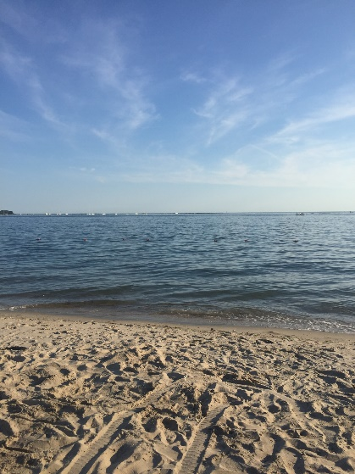

Island View Beach

# Assets:

**As of 6/10/20**

**Key Bank:** $12,958

**TD Ameritrade:** $76,142

Cash: $17,949

Securities: $58,192

**Total: $89,100**

**_________________________________________________________**

**As of 6/19**

**Key Bank**: $14,254

**TD Ameritrade**: $71891

Cash: $ 17,945

Securities: $ 53,946

**Total: $86,145**

**As of 5/18**

**Key Bank**: $12,297

**TD Ameritrade:** $70,645

Cash: $15,834

Securities: $54,811

**Total $82,942**

## Tracking Budget:

## Total expenditures 7/1/19 - 6/7/20 $21,733

2019-2020 Budget: $22,660

## Expenses Pending until 6/30/20:

## Beach Supplies

## Triangle Maintenance

* Beach Planting
* Beach lighting
* Printing & Reproduction

## Total Proposed 2020-2021 Budget: $24,107

## Tax Collections and carting due 8/1/2020

# Web Site: [www.islandviewbeach.org](http://www.islandviewbeach.org)

Submitted: June 10, 2020

James Delldonna: Treasurer