# Island View Beach Association Treasurer’s Report for June 2021

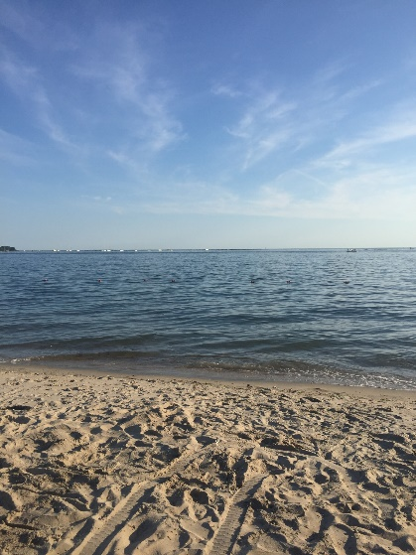

Island View Beach

# Assets:

**As of 6/11/21**

**Key Bank Checking:** $12,070

**Key Bank Savings:** $80,048

**Total** $92,118

**As of 6/10/20**

**Key Bank:** $12,958

**TD Ameritrade:** $76,142

Cash: $17,949

Securities: $58,192

**Total:** $89,100

**As of 6/19**

**Key Bank**: $14,254

**TD Ameritrade**: $71891

Cash: $ 17,945

Securities: $ 53,946

**Total: $86,145**

## Tracking Budget:

## Total expenditures 7/1/20 - 6/11/21 $18,415

2020-2021 Budget: $24,107

## Expenses Pending until 6/30/21:

## Beach Supplies

## Triangle Maintenance

* Beach Planting
* Beach lighting
* Printing & Reproduction

## Total Proposed 2021-2022 Budget: $26,902

## Tax Collections and carting due 8/1/2021

# Web Site: [www.islandviewbeach.org](http://www.islandviewbeach.org)

Submitted: June 13, 2021

James Delldonna: Treasurer