# Island View Beach Association Treasurer’s Report for June 2019

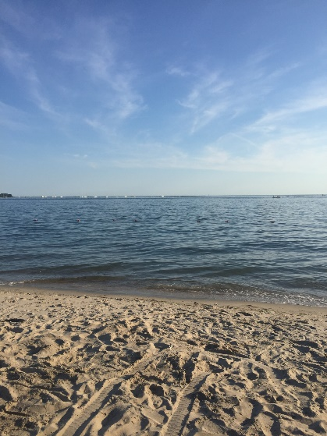

Island View Beach

# Assets:

**As of 6/04/19**

**Key Bank:** $14,254

**TD Ameritrade:** $71,891

Cash: $17,945

Securities: $53,946

**Total: $86,145**

**_________________________________________________________**

**As of 5/18**

**Key Bank**: $12,297

**TD Ameritrade**: $70,645

Cash: $ 15,834

Securities: $ 54,811

**Total: $82,942**

**As of 4/17**

**Key Bank**: $13,209

**TD Ameritrade:** $67,878

Cash: $21,144

Securities: $46,734

**Total $81,087**

## Tracking Budget 2019 - 2020

## Tax Collections and carting due 8/1/2019

## Expenses Pending:

## Beach Supplies

## Triangle Maintenance

* Beach Planting
* Postage, Stamps, Mailings

## Total Budget: $22,660

2018-2019 Budget: $22,725

# Web Site: [www.islandviewbeach.org](http://www.islandviewbeach.org)

Submitted: June 9, 2019

James Delldonna: Treasurer