

**Annual Meeting and Banquet**

January 11th, 2025 at Rivers Bend Resort

Social Hour at 5:00 pm

Dinner at 6:00 pm Meeting to follow

ONLY 85 Tickets Available

Rivers Bend will again host the event. We are hoping for a wonderful turnout this year. The cost is only $25.00. Cash Bar is available. Get your tickets early as only 85 tickets will be available and they are on a first come basis. **Tickets may not be available at the door.**

There will be raffle tickets available for purchase. All profits will be given away as cash prizes at the end of the night. RSVP by **January** **1st 2025.**

The meeting is open to any members that want to attend, no dinner required. Raffles will be only for dinner attendees.

Also a friendly reminder to renew your annual membership. Form is also available on the website under the “Membership” tab.

**Membership needs to Paid current before Jan 1st to Vote at Annual Meeting**.

This is a great event to attend. Great people, great conversation, and great raffles. This is an event you do not want to miss. We hope to see you all there!

Dinner Attendees

Name: __________________________________________________

Attending: ________xS25.00=

Please make checks payable to: **Montello** **Rod** **and Gun Club**

**Mail to:** **Tony Alexander**

**MRGC Secretary**

**N5421 State Rd 22**

**Montello WI, 53949**

**RSVP BY JANUARY 1, 2025**

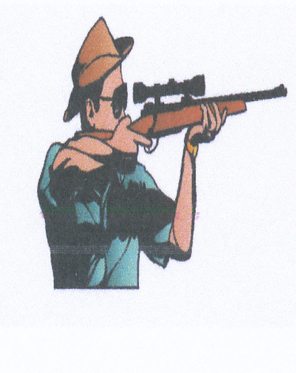 Montello Rod & Gun Club

N3740 State Rd 22

P.O. Box 365

Montello, WI 53949

www. montellorodandgunclub.com

montellorodandgunclub@gmail.com

Membership Renewal Form

Payable to “Montello Rod & Gun Club”

Mail renewal to;

Tony Alexander

MRGC Secretary

N5421 State Rd 22

Montello, WI 53949

Member Name _____________________________________

Street _____________________________________

City, State, Zip _____________________________________

Phone Number _____________________________________

Email _____________________________________

Dues, $60 or $20 with 10 hours worked _______________

Dues are $60.00, however members can receive up to $40.00 credit (10 x $4.00) for hours they work at the club, also ½ hour credit is given for each meeting attended. Remember we are on the honor system so calculate your own hours.