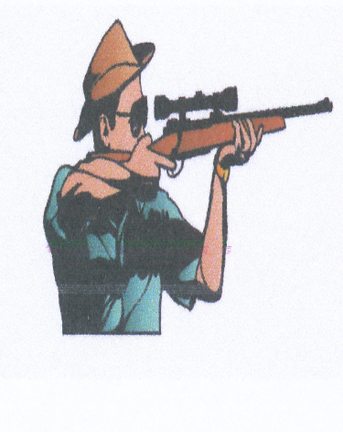
Montello Rod & Gun Club
N3740 State Rd 22
P.O. Box 365
Montello, WI 53949
www. montellorodandgunclub.com
montellorodandgunclub@gmail.com

Membership Renewal Form

Payable to “Montello Rod & Gun Club”

Mail renewal to;

Tony Alexander

MRGC Secretary

N5421 State Rd 22

Montello, WI 53949

Member Name _____________________________________

Street _____________________________________

City, State, Zip _____________________________________

Phone Number _____________________________________

Email _____________________________________

Dues, $60 or $20 with 10 hours worked _______________
Dues are $60.00, however members can receive up to $40.00 credit (10 x $4.00) for hours they work at the club, also ½ hour credit is given for each meeting attended. Remember we are on the honor system so calculate your own hours.

