**1/4 Squats**

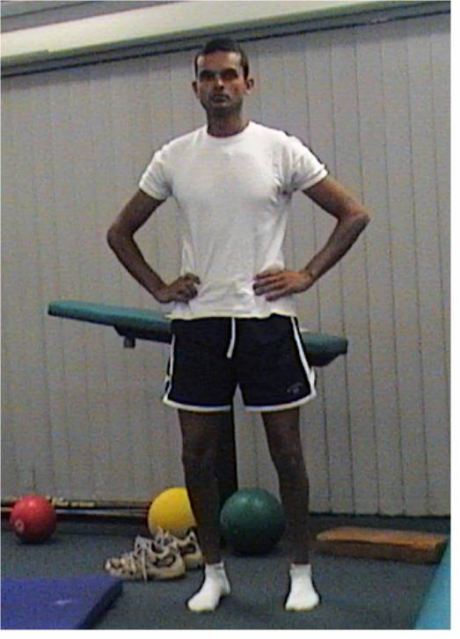

The exercise which ties all the other exercises together is the one you should start with. It’s the quarter squat – so named because it is only a ¼ of a squat. Place your feet perfectly straight, hip joint width apart. Your limbs will then be vertical from hip to foot with toes pointing straight. If you over-pronate, your knees will fall in when you bend them & your arches will also collapse. Rotate your knees out so your knees are over the line of your feet therefore straightening your limbs. Tilt your pelvis posteriorly in the same manner as a subtle pelvic thrust. Tuck your belly and bottom in, lift your chest, rotate your shoulders back and down, look straight ahead(not up), and relax your toes. Perform the ¼ squat just like a gym squat in smooth movements as you would in a gym with slow, smooth movements. These should be performed every morning and evening, varying the number of repetitions according to the nature of the problem. It can also be extrapolated into specific hydrotherapy.

**Calf Stretch**

|  |  |  |
| --- | --- | --- |
| **Basics**   * Straight posture * Feet next to each other * Tuck bottom in * Stand tall * Point toe straight or slightly inward   PURPOSE - stretch calf for full ankle range |  | **Calf** |

Place a phone book on the floor. Stand over the book with your feet astride the book. Stand straight with correct posture. Place one foot on the book. Position the foot so only your toes are on the book and your heel is on the ground. Point your foot inward slightly to avoid any toe-out angle. This will ensure that you isolate the calf muscles from other muscle groups. When you do this, it is most likely your bottom will fall back to compensate for tight calf muscles. If this happens, tuck your bottom in and correct your posture.

**Hamstring Stretch**

|  |
| --- |
| **Basics**   * Stand closer than you need * Point grounded foot at raised foot * Point toes vertically * Back straight * Hips square to leg   PURPOSE - stretch lateral hamstring, allow uncompensated stride |

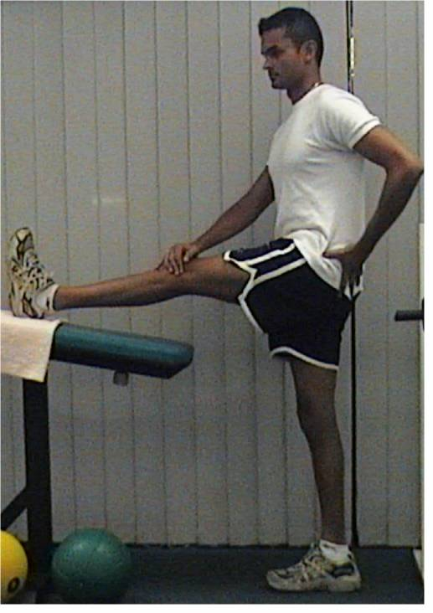

Place one foot on a piece of furniture which has a height comfortable to reach. Keep your back straight & your weight-bearing foot pointed to the foot of the leg you are stretching. Feel across your buttocks to ensure your hips are square on to your stretched leg. When this position is maintained at a suitable height you will feel a significant strain in your lateral hamstring. This (biceps femoris) muscle is the most likely to be injured of the hamstring muscles & the most responsible of this group for contributing to pelvic instability during locomotion. It also is a significant contributor to back pain in many weight-bearing & non weight-bearing situations. The intensity of this stretch can be increased by rotating your torso to the side of the stretching limb. If you can achieve a torso-to-limb angle of 90 degrees it is highly likely you are cheating. Most untrained people will struggle to achieve a hamstring extension angle of 50-70degrees using this technique.

**Quadriceps Stretch**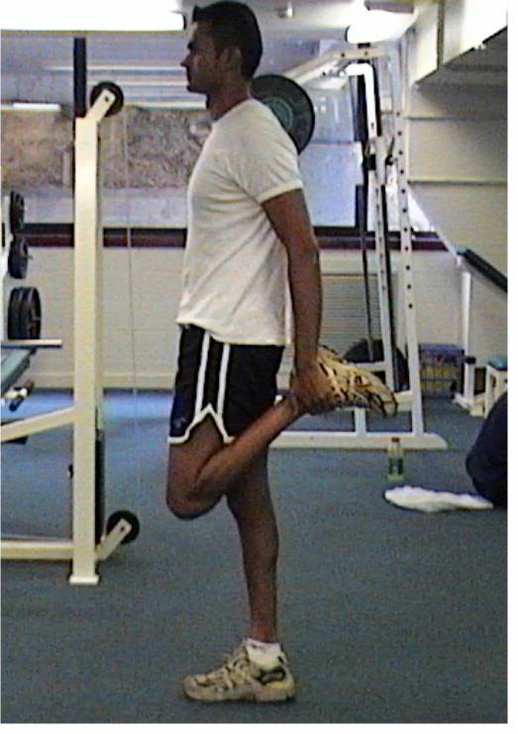

Most people are familiar with this stretch. Pull your foot up to your bottom while standing, maintaining a posterior pelvic tilt & perfectly straight torso. The thigh should be in perfect alignment with the torso when viewed from the front and side.

If it is not possible for you to perform this standing up, you may use a towel to loop around your ankle while lying on your side. The relative alignment goals are still the same.

**Trapezius stretch**

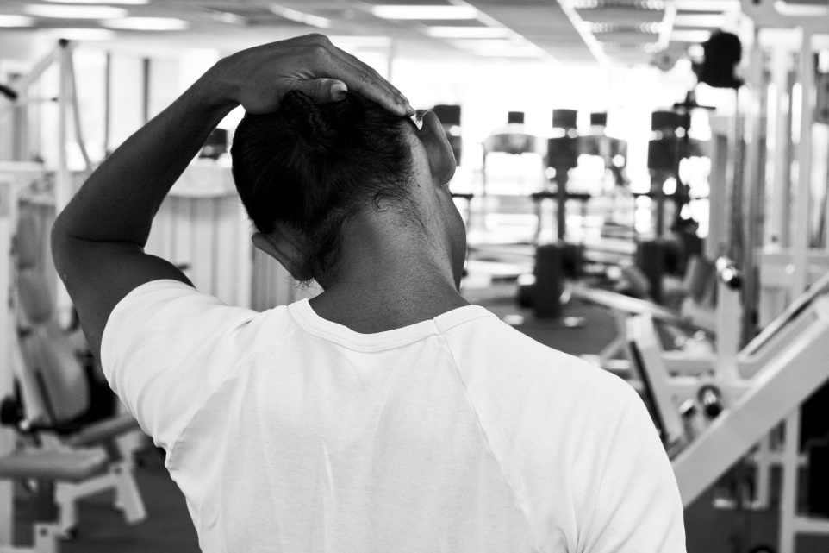

|  |
| --- |
| **Basics**   * Stand/sit straight * Chest out * Shoulders back * Chin stays over breast bone * Crown of head toward opposite shoulder * Chin down first THEN crown across   PURPOSE – maintain shoulder girdle & upper spinal/neck/head position |

Stand or sit with your spine straight & tall. Place your chin on your breastbone (sternum). If your chin doesn’t reach your sternum, keep it in line with it throughout the stretch. Puff your chest out to keep the rest of your spine straight. Place your right hand on the left side of the crown of your head. Gently pull the crown of your head to the right keeping both your chin on your sternum & and your left shoulder back & down. End the stretch by allowing the crown back to centre & then raising the chin from the sternum. The chin NEVER leaves the alignment of the sternum. Repeat for the opposite side.

**Crucifix Stretch**

**This was a variant of what I showed you at the park bench to open the chest.**

|  |
| --- |
| **Basics**   * Diaphragm breathing * Heat pack solar plexus & intercostals   PURPOSE – relax intercostals, fascia, decrease autonomic nerve activity |

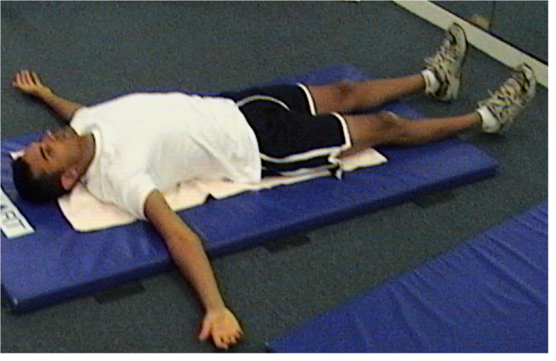

This stretch is intended to release the anterior (front) fascia. It is beneficial to both posture & breathing. Place a medium sized pillow on the floor & lie on the pillow length-wise i.e. the pillow should run along the line of the spine from behind the head toward the small of your back. Place your hands out to the side in crucifix form, breathing with your diaphragm. This exercise lasts for 2-4 minutes.

|  |
| --- |
| **Hip Flexor Stretch**  **HIp Flexor**  **Basics**   * Torso strict posture * Sideways first, then tilt * Keep chest up & square * Stretch sensation deep groin   PURPOSE – stretch true hip flexors & allow true stride |

The true hip flexor is actually a muscle group of two large internal muscles. The other more superficial muscles will readily compensate for these hidden muscles and isolating them in a stretch is difficult.

Get down on one knee, placing your lead (other) foot further to the side than you would if you were simply holding position. Performing this stretch in front of a mirror will help. Keep your torso straight while moving it toward the side of the lead leg. This will produce a slight groin stretch sensation. Perform a posterior pelvic tilt (tummy & bottom tuck in while raising belly button). Maintain a straight torso. Do not allow your chest to rotate or drop. If the stretch is performed properly, you will feel notable discomfort at one point in the deep upper groin. Any stretch sensation on the front or side of the thigh indicates a failure to maintain neutral position of the torso.