Superior Tree Farm
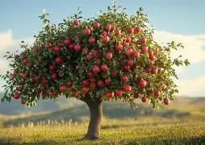

Chassell
906-523-6200

906trees.com

Spring 2026 Price List

Apple: $50.00 ea Plum: $50.00 ea
Honeycrisp Mount Royal
McIntosh
Honeygold
Wolfriver Pear: $50.00 ea
Summercrisp
Parker
Peach: $50.00 ea
Reliance Cherry: $50.00 ea
Lapin (Sweet)
Montmorency (sour)
Small Fruits:
Blueberries: Patriot $10.00 ea Raspberries: Heritage $5.00 ea
Rhubarb: Canada Red $15.00 ea
Blackberries: thorneless Chester $5.00 ea
Hascap: Indigo Gem and Aurora $10.00 ea (need both kinds to produce fruit)

Give us a call
We do require a 50% down Deposit.
Apple Trees and Pear trees need Pollinator
Cherry, Peach and Plum Trees are self-fertile but will produce more fruit with another tree

