ACH Fee payments to Harbour from clients

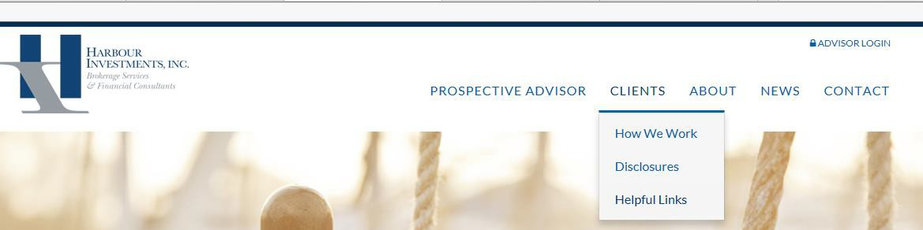
- Go to Harbour website (www.harbourinv.com) → under CLIENTS click Helpful Links
(https://harbourinv.com/clients/helpful-links/ - link directly to webpage)
- Scroll down to bottom of page and click on Smart Pay Express for ACH Payments
  - For a One-Time payment → click Pay Now
    - Pay To → Client Advisory Fees
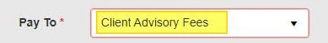

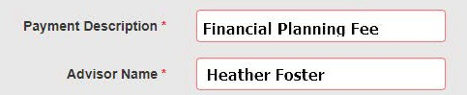
    - Payment description → Financial Planning Fee
    - Address → Client Address
  - To set up recurring payments → click Create Account
    - Complete information and you will be sent an e-mail from Madisonclientservices@firstbusiness.com with a temporary password. Go back to the log in screen and use your e-mail address and the temporary password to log in.
    - Once you log back in, follow the prompts to Make a payment.
      - Pay to → Client Advisory Fees
      - Payment Description → Advisory Fee, Financial Planning Fee……

      - After you have entered the payment information click continue to review the information and ACH authorization Agreement.

      - Click Agree & Submit and the next screen will be a transaction receipt. The client will have the
option to “save receipt” or “print receipt” for their records.

The client will receive an e-mail from donotreply@harbourinv.com confirming the payment that was processed.

The transaction will show up in the client bank account as: “Harbour Investments WEB PMTS VVW Client Name”.

