Credit Card Payments to Harbour from Clients


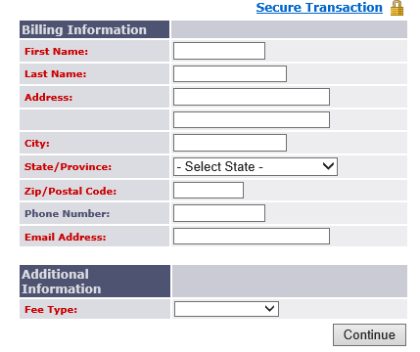
(https://harbourinv.com/clients/helpful-links. – link directly to webpage)
2. Scroll down to bottom of page and click on Pay by Credit Card
3. Enter your information in all fields in the box
4. In Fee Type dropdown, select financial planning click Continue
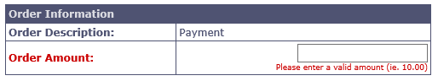
5. Enter the dollar amount you are paying to Harbour click Continue
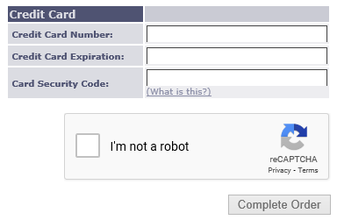
6. Enter your credit card information
check the I’m not a robot box click Complete Order

