Christmas Buffet Menu
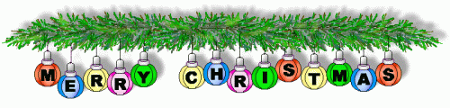
Sandwiches:
Brie & Cranberry
Turkey & Stuffing
Beef & Horseradish

Sage & Onion Stuffing Balls

Battered King Prawn

Pigs In Blankets

Smoked Salmon and Cream Cheese Bites

Pate with Bruschetta

Cheese & Bacon Potato Skins

Selection of Cheeses with Crackers

Mince Pies

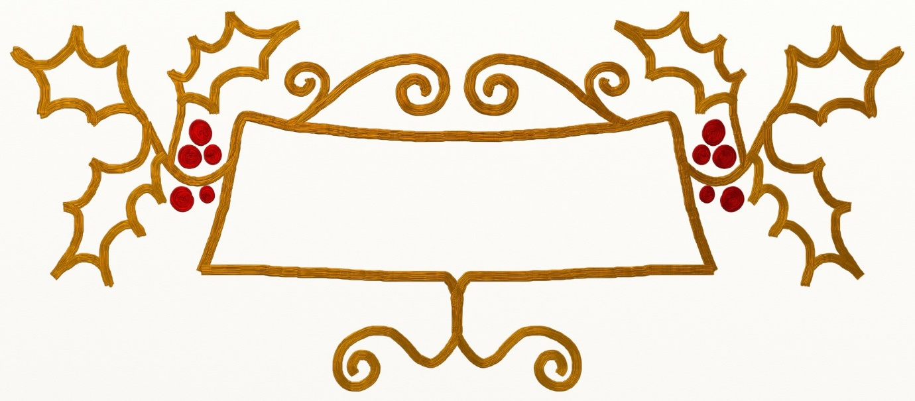
Pre booking required with a 50% deposit. Please ask at the Bar for more information!

