Christmas Buffet Menu
Available from 1st November
£17.50 Per Head

Sandwiches:
Brie & Cranberry
Turkey & Stuffing
Beef & Horseradish
--------------
Sage & Onion Stuffing Balls
-------------
Battered King Prawn
----------
Pigs In Blankets
-----------
Smoked Salmon and Cream Cheese Bites
----------
Pate with Bruschetta
----------
Cheese & Bacon Potato Skins
----------
Selection of Cheeses with Crackers
----------
Mince Pies
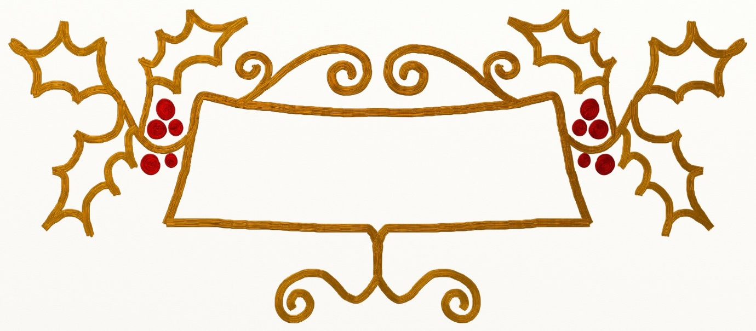
Pre booking required with a 50% deposit. Please ask at the Bar for more information!

