Having a Christmas Party?
One Course for £16.95, Two Courses for £19.95 or Three Course for £25.95.
Serving from Nov 24th ‘til Dec 23rd
(With exception of 30th November due to the Comedy Club)
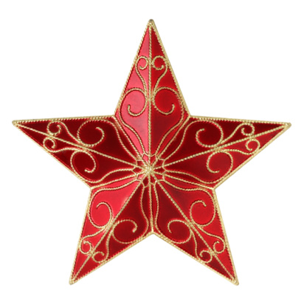
MENU
This Photo by Unknown Author is licensed under CC BY-NC-ND

Starters
Roasted Winter Vegetable Soup (VE)
Smoked Salmon & Prosecco Centre Parfait
Hog Roast Pork, Sage & Onion Rillette

Mains
Turkey Paupiette Served with Pigs in Blankets & all the Trimmings
Mushroom, Brie, Hazelnut & Cranberry Wellington Served with all the Trimmings
Plum, Honey & Star Anise glazed Salmon Served with Roast Carrots, Parsnips & Roast Potatoes
Dessert
Christmas Pudding & Brandy Butter
Mince Pies & Cream
Black Forest Gateau
Selection of Cheese & Biscuits
Please call or Email to Book and Place your Pre-order
forestersarmsbagshot@gmail.com
01276472038
Kids Half Price!

