CSQG Block of the Quarter
Feb-April 2020
Square Knot Block
This is a block from Missouri Star Quilt. The video link is https://www.youtube.com/watch?v=27HyfgoNLWw
You will need for each block:
- One 2 ½ inch brightly colored strip
- One 2 ½ inch white or white on white strip
- One 2 ½ inch contrasting colored strip.
Cut four 2 ½” squares of both A and B. Cut four 4 ½ “ rectangles of both A and B. Separate them into piles by color. Cut four 2 ½” squares from C. Draw a diagonal line on the back side of each 2 ½ “ square.
Sew 2 ½” square of B onto 4 ½” rectangle of A. Make 4. Sew from corner to corner from the top left to the bottom right on the 2 ½” square ensuring that all seams are going the same direction.
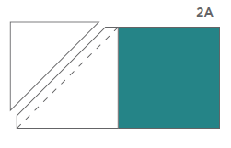
Sew 2 ½” square of C onto 4 ½” rectangle of B. Make 4. Using the same technique as above.
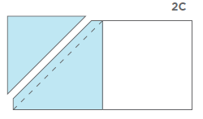

Trim off excess, leaving ¼” seam allowance. Press open to the 2 ½” squares. You will have eight rectangles. Separate them into pairs, one A and one C. Sew together with the triangle on the top left. Press towards the darker piece.
The four blocks will go together just like a four patch. Arrange units as shown below. 2 ½ inch triangles will go towards the middle. Sew the top two pairs together and press seam to the right. Sew the bottom two pairs together and press seam to the left. Nest the seams and sew units together to complete the block.

