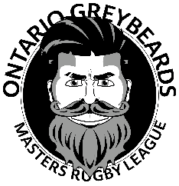
ONTARIO GREYBEARDS MASTERS RUGBY LEAGUE
MEMBER REGISTRATION FORM
ALL FIELDS REQUIRED
Forename: |  | Surname: | Date Of Birth:
Address:

Phone: |  | Email:  c)
Renewal  ☐ | New Member ☐ | Emergency Contact Name: | Emergency Contact Phone:

Fees can be paid by e-transfer to ontariogreybeards@gmail.com

Membership and/or Participation Agreement for Ontario Greybeards Masters Rugby League (“OGMRL”)
1. CONDUCT: I agree to abide by and support the current OGMRL codes of conduct as defined in the bylaws and constitution. All policies can be found at: www.ontariogreybeards.com
2. USE OF IMAGE: I hereby grant OGMRL the irrevocable right to use at their sole discretion any information and/or photographs of or about myself for publicity, advertising, or other promotion of OGMRL. I understand that this may include, written, pictorial, digital or video materials.
3. PERSONAL INFORMATION: I consent to the collection, use and distribution of my personal information for the purposes of OGMRL. The personal information will be used for the purposes reasonably associated with my registration as a OGMRL Participant. The personal information will not be disclosed to third parties other than as stipulated unless required by law
4. FEES: I agree to pay the OGMRL fees as communicated in line with the OGMRL bylaws and constitution which can be found at: www.ontariogreybeards.com

I acknowledge that I am 35 years of age or older and have provided proof of age at the time of registration.

REGISTRATION ACKNOWLEDGEMENT
Member Signature: | Date:

