Definitions of Floral Accessories

Traditional Formal Buttonhole
A single flower, most commonly a rose backed with foliage usually asparagus fern or ivy leaves. More modern choices for a traditional buttonhole may include a calla lily or mini gerbera.
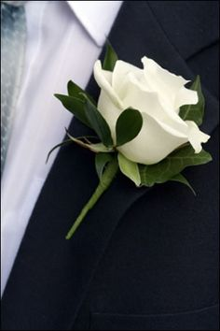
Designer Buttonhole
A dominant flower with the addition of complementary materials used for effect and distinction such as wire work, beads, feathers and dried materials
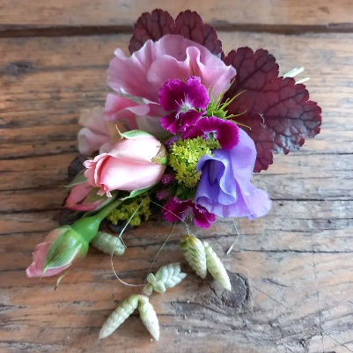
Boutonniere
Constructed from several small flowers, very often of the same variety. The groom can sometimes wear a selection of foliage from the bridal bouquet.
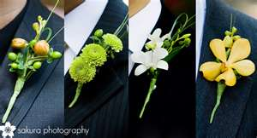
Traditional Corsage
A design created for formal occasions. Flower material is either natural, feathered, and pipped with or without foliage, wired on natural and false stems with the wires concealed and protected. A selection of prepared materials assembled into a design such as a triangle, crescent, hogarth etc suitable for personal wear and adornment. A corsage may also be worn on the body, shoulder, wrist neckline, etc as a body adornment. A corsage-like design can also be attached to an accessory such as a bag
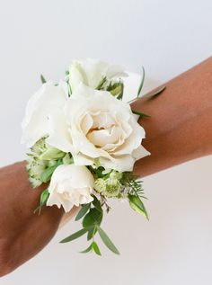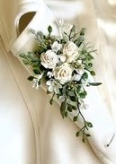

Artisan Boutonnieres

Current trends of more artisan floristry styles have seen a simpler approach to construction and styles. Often couples will choose to have the same design for all guests opting for boutonniere styles. These more artisan styles eliminate the individually wired elements seen in more traditional designs, instead embracing the natural stems and movement of the materials. If delicate varieties of flowers are used support wiring methods will be required.

