The Internet of Bodies (IOB) and the application of AI
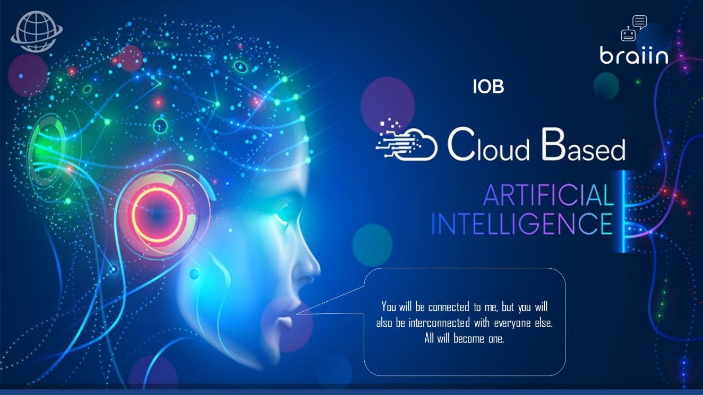
The Internet of Bodies (IOB) is an emerging field that connects our bodies to the internet and other systems through wearable devices and sensors. Artificial intelligence (AI) plays a vital role in IOB, revolutionizing the way we interact with technology. Let's explore some real-life examples of how AI is transforming different areas within the IOB ecosystem.
Wearable devices and sensors commonly used in the context of the Internet of Bodies (IOB):
Smartwatches: These wrist-worn devices can monitor various health parameters, including heart rate, activity levels, sleep patterns, and even perform electrocardiograms (ECGs). They often come with accompanying mobile apps that provide detailed insights and analysis.
Fitness Trackers: These devices are primarily focused on monitoring physical activity and exercise metrics. They track steps taken, distance traveled, calories burned, and may include features like heart rate monitoring, sleep tracking, and GPS for outdoor activities.
Smart Clothing: Specialized clothing items, such as smart shirts or leggings, integrate sensors to monitor biometric data, such as heart rate, respiration rate, muscle activity, and posture. These garments are designed to be comfortable and provide continuous monitoring during various physical activities.
Smart Shoes: Equipped with pressure sensors and accelerometers, smart shoes can analyze gait patterns, detect foot strikes, and provide insights into running efficiency and foot health. They may also include GPS for tracking outdoor workouts.
Smart Glasses: These wearable devices, often in the form of augmented reality (AR) glasses, can overlay information or visual cues onto the user's field of view. In the context of IOB, they can display health-related data, vital signs, or provide real-time feedback during physical activities.

Implantable Devices: These are small electronic devices implanted inside the body for specific medical purposes. Examples include pacemakers for heart rhythm management, neurostimulators for pain relief, or glucose monitoring implants for diabetes management. These devices often communicate wirelessly with external systems for data analysis and adjustments.
Smart Contact Lenses: These innovative contact lenses are embedded with sensors to monitor various health parameters, such as intraocular pressure for glaucoma management or blood glucose levels for diabetes monitoring. They can provide real-time data and send alerts to the user or healthcare professionals.
Biosensors and Patches: These wearable patches or stickers adhere to the skin and contain biosensors to measure specific physiological parameters. They can track metrics like heart rate, skin temperature, electrodermal activity, and sweat composition. These sensors often communicate wirelessly with smartphones or dedicated devices for data analysis.
Neural Interfaces: These advanced devices establish direct connections with the brain or nervous system to facilitate communication or control of external devices. Neural interfaces can be used in applications such as prosthetics, brain-computer interfaces, or neurofeedback systems.
Environmental Sensors: While not directly worn on the body, environmental sensors play a role in IOB by monitoring external factors that impact health and well-being. These sensors can measure air quality, temperature, humidity, or UV exposure, providing contextual information for personalized health management.
The IOB field is continually evolving, and new wearable devices and sensors are being developed and introduced regularly. This list provides an overview of some common examples, but there may be additional specialized devices or emerging technologies that contribute to the IOB ecosystem.
IOB Ecosystem in Sector Areas
Healthcare: In healthcare, AI and wearable devices work together to collect extensive data about a patient's health. This information is then analyzed using AI algorithms to gain insights into the patient's well-being, detect potential health risks, and provide personalized treatment recommendations. For instance, AI-powered wearables can monitor vital signs, identify early signs of illness, and enable early intervention to prevent serious conditions. AI based early detection and treatments is a proactive measure that will undoubtedly reduce health care costs.
Sports: AI and IOB are revolutionizing the sports industry by using wearable devices and sensors to track athletes' performance. Detailed data on movements, speed, and endurance is collected and analyzed by AI algorithms. This provides coaches and trainers with valuable insights to optimize athletes' performance and help them achieve their goals. Real-time feedback from AI-powered wearables further enhances athletes' performance.
Military: In the military, IOB and AI improve safety and performance in challenging environments. Wearable devices and sensors track soldiers' physical and emotional state, providing early warnings for stress or fatigue. Additionally, AI algorithms analyze data from these devices, offering valuable insights into military equipment performance and identifying areas for improvement. AI based battle information will reduce casualties and save lives.
Other Applications: Beyond healthcare, sports, and the military, IOB and AI are transforming various industries. For example, AI-powered wearables enhance the safety and productivity of industrial workers by monitoring their well-being and preventing accidents. In the automotive sector, data from wearables and sensors is analyzed by AI algorithms to improve vehicle performance and identify areas for enhancement.
Companies actively involved in IOB and AI research and development
Here are some real-life examples of companies that are actively involved in research and development within the fields of healthcare, sports, military, and other areas related to the Internet of Bodies (IOB) and artificial intelligence (AI):
Healthcare:
Verily, an Alphabet subsidiary, is developing smart contact lenses that can monitor glucose levels in patients with diabetes.
Google's DeepMind has been working on AI algorithms that analyze medical data to detect diseases such as diabetic retinopathy and breast cancer with high accuracy.
DeepMind has been at the forefront of applying AI algorithms to healthcare, particularly in the area of medical imaging analysis.
DeepMind's AI algorithms have shown remarkable accuracy in diagnosing diseases from medical images, such as diabetic retinopathy and breast cancer. For instance, in the case of diabetic retinopathy, DeepMind developed an AI system that can analyze retinal images and detect signs of the disease with high precision. This technology has the potential to revolutionize the early detection and treatment of diabetic retinopathy, a leading cause of blindness worldwide.
The technical aspects behind DeepMind's achievements involve utilizing deep learning models and convolutional neural networks (CNNs). These models are trained on large datasets of medical images, allowing the AI algorithms to learn patterns and features that are indicative of different diseases or conditions. DeepMind's algorithms can then analyze new medical images, compare them to the learned patterns, and provide accurate diagnoses or predictions.
The development and training of these AI models require extensive computational resources and access to vast amounts of labeled medical data. DeepMind collaborates with healthcare institutions and experts to obtain the necessary data for training and validation, while ensuring patient privacy and data security.
DeepMind's technical expertise lies in leveraging AI techniques such as deep learning, CNNs, and large-scale data analysis to tackle complex healthcare challenges. By applying these technologies to medical imaging, DeepMind aims to improve diagnostic accuracy, enable early intervention, and ultimately enhance patient outcomes.
While DeepMind has made impressive strides in healthcare, the deployment and adoption of AI technologies in real-world clinical settings involve regulatory considerations, ethical implications, and validation through rigorous clinical trials. Nonetheless, DeepMind's work serves as a remarkable example of how AI and IOB can contribute to advancements in healthcare and potentially transform the way diseases are detected, diagnosed, and treated.

Sports:
Catapult Sports uses AI-powered wearables to track and analyze athlete performance data, providing insights for training and injury prevention.
STATSports offers wearable tracking devices used by professional sports teams to monitor player performance, optimize training, and minimize injury risks.
STATSports is a leading provider of wearable tracking devices for sports, designed to help athletes, coaches, and teams optimize performance, reduce injuries, and enhance overall athletic performance. The company's technology combines wearable sensors, data analytics, and artificial intelligence (AI) to provide athletes with real-time insights into their training and performance.
STATSports offers a range of wearable tracking devices, including the Apex Pro and Apex Athlete Series, which use GPS and other sensors to track movement, speed, acceleration, deceleration, distance, and other metrics. The devices are designed to be worn during training and games and provide athletes with real-time feedback on their performance.
One of the unique features of STATSports' technology is its use of AI to analyze and interpret the data collected by the wearable devices. The company's AI algorithms use machine learning techniques to identify patterns and trends in the data and provide insights into areas such as fatigue, injury risk, and training effectiveness.
For example, the AI can analyze an athlete's performance during a game or training session and provide feedback on areas where they need to improve, such as their sprint speed, endurance, or agility. The AI can also identify patterns in the data that may indicate an increased risk of injury and provide recommendations for reducing that risk.
STATSports' wearable tracking devices and AI technology are a powerful tool for athletes and teams looking to optimize their performance and reduce the risk of injury. By providing real-time insights into training and performance, the technology can help athletes and coaches make better decisions and achieve their goals more efficiently.

Military:
BAE Systems is exploring the integration of AI and wearable devices to enhance situational awareness and decision-making for military personnel.
Lockheed Martin is researching the use of AI and IOB technologies to enhance soldier performance and safety, such as wearable sensors that monitor biometrics and environmental conditions.
Lockheed Martin is a prominent company that has been actively exploring the application of AI and IOB technologies in the military sector. One area where they have made significant strides is in the development of wearable devices and AI algorithms to enhance soldier performance and safety.
Lockheed Martin's research focuses on leveraging wearable sensors and biometric monitoring devices to collect real-time data on soldiers' physical and emotional states. These sensors track various parameters, including heart rate, respiration, body temperature, and stress levels. The collected data is then processed and analyzed using AI algorithms, enabling insights into soldiers' overall well-being and performance in challenging environments.
The technical aspects of Lockheed Martin's solution involve the integration of advanced sensors and AI-driven analytics. The wearable sensors are designed to be lightweight, rugged, and capable of withstanding extreme conditions. They continuously monitor vital signs and other physiological data, generating a constant stream of information.
The AI algorithms developed by Lockheed Martin are trained using extensive datasets that incorporate various physiological parameters and their correlations with specific stressors or performance indicators. This training enables the algorithms to recognize patterns, detect anomalies, and provide valuable insights into soldiers' physical and mental states.
The real-time analysis provided by Lockheed Martin's AI algorithms is invaluable in military operations. It can help identify early signs of stress, fatigue, or potential health risks among soldiers, allowing commanders to take proactive measures to ensure their safety and well-being. Additionally, the data gathered from wearable devices can be used to optimize military training programs and improve operational planning.
Ensuring data security and privacy is a critical consideration in military applications. Lockheed Martin implements robust encryption and authentication measures to protect the sensitive data collected by the wearable devices. They work closely with military organizations to ensure compliance with security protocols and data handling procedures.
The advancements made by Lockheed Martin exemplify the potential of AI and IOB technologies in enhancing military operations. By leveraging wearable devices and AI algorithms, they aim to provide real-time insights into soldier performance, improve situational awareness, and optimize decision-making on the battlefield.
The integration of AI and IOB technologies into military operations requires thorough testing, validation, and adherence to strict regulatory guidelines. Safety, ethics, and mission-specific considerations must be thoroughly evaluated before widespread deployment.
Lockheed Martin's ongoing research and development in this area demonstrate their commitment to leveraging cutting-edge technologies to enhance soldier capabilities, improve mission effectiveness, and ultimately safeguard lives on the front lines.
Other Applications:
Ford Motor Company is investing in AI research for vehicle connectivity and driver monitoring systems, aiming to improve safety and driving experiences.
General Electric is developing AI algorithms to analyze data from wearable devices in industrial settings, helping to optimize worker safety and productivity.
These are just a few examples of companies actively engaged in research and development within the IOB and AI domains. With ongoing advancements, we can expect even more innovative solutions to emerge, positively impacting various industries and aspects of our lives.

Ethical and privacy concerns
The Internet of Bodies (IOB) and the application of AI raise important ethical and privacy concerns due to the sensitive nature of the data involved. Here are some key issues to consider:
Privacy and Data Security: IOB involves the collection and storage of personal and intimate data, including biometric information, health records, and behavioral patterns. Safeguarding this data from unauthorized access, breaches, and misuse is crucial. Stricter regulations and robust security measures are needed to protect individuals' privacy and prevent data exploitation.
Informed Consent: Obtaining informed consent from individuals participating in IOB-related activities is essential. Users should be fully aware of the data being collected, how it will be used, and the potential risks and benefits involved. Transparent communication and clear consent processes are necessary to ensure individuals have control over their data.
Data Ownership and Control: As personal data is collected and shared through IOB devices and applications, questions arise regarding who owns and controls that data. Clear guidelines and frameworks are required to define ownership rights, data sharing agreements, and user control over their own information.
Bias and Discrimination: AI algorithms used in IOB applications may inadvertently introduce biases or reinforce existing biases, leading to discriminatory outcomes. It is crucial to address biases in data collection, algorithm development, and decision-making processes to ensure fairness and equity in IOB technologies.
Accountability and Transparency: Organizations developing and deploying IOB and AI technologies should be accountable for their actions. Transparent practices, auditability of algorithms, and mechanisms for recourse in case of errors or misuse are necessary to maintain trust and accountability in these systems.
Consent and Vulnerable Populations: Special attention must be given to vulnerable populations, such as children, elderly individuals, or individuals with cognitive impairments, to ensure their rights, dignity, and well-being are protected. Adequate safeguards should be in place to prevent exploitation and ensure their informed consent is obtained.
Psychological and Emotional Impact: The constant monitoring and analysis of personal data through IOB devices may have psychological and emotional implications for individuals. Issues such as increased stress, anxiety, or loss of privacy should be considered, and support mechanisms should be in place to address these concerns.
Long-term Consequences: The long-term effects of IOB and AI on society, human behavior, and the concept of privacy are yet to be fully understood. Continuous monitoring and analysis of individuals' bodies and behaviors can fundamentally alter societal norms, leading to profound ethical implications that need to be carefully considered.
Addressing these ethical and privacy challenges requires a multidisciplinary approach involving policymakers, technology developers, researchers, and society as a whole. It is crucial to strike a balance between the potential benefits of IOB and AI and the protection of individual rights, privacy, and well-being.

Future Trends:
The application of AI to the Internet of Bodies (IOB) is a rapidly evolving field with several exciting future trends. Here are some key trends to watch for:
Enhanced Personalization: AI algorithms will become increasingly sophisticated in analyzing and interpreting data from IOB devices. This will enable personalized insights and recommendations tailored to individual needs, optimizing health, performance, and overall well-being. AI will learn from an individual's historical data and behavior patterns to provide customized interventions and recommendations.
Real-time Monitoring and Intervention: AI algorithms will play a vital role in real-time monitoring of physiological and biometric data from IOB devices. They will be capable of quickly detecting anomalies, identifying health risks, and triggering timely interventions or alerts. This could range from alerting medical professionals during emergencies to providing immediate guidance for self-care or preventive measures.
Predictive Analytics: AI-powered IOB systems will leverage machine learning techniques to analyze large datasets, identifying patterns and correlations between health data and specific outcomes. This will enable predictive analytics, helping to forecast potential health issues, predict disease progression, or identify early warning signs of certain conditions. Proactive measures can then be taken to prevent or mitigate risks.
Closed-Loop Systems: AI and IOB will converge to create closed-loop systems, where AI algorithms not only analyze data but also interact and influence IOB devices in real-time. For example, an AI algorithm could adjust the dosage of medication delivered through an implantable device based on continuous monitoring of a patient's health parameters.
Ethical and Regulatory Frameworks: As AI and IOB advance, there will be a growing need for robust ethical guidelines and regulatory frameworks to address privacy, security, and the responsible use of personal data. The development of standards and policies will help ensure that AI-powered IOB technologies are developed and deployed in an ethical and responsible manner, prioritizing individuals' rights and well-being.
Human-Machine Integration: AI will contribute to more seamless integration between humans and IOB devices, enhancing human capabilities and extending the reach of human potential. AI algorithms can analyze and interpret data from IOB devices, providing real-time feedback, suggestions, and guidance to individuals. This symbiotic relationship between humans and AI will drive advancements in healthcare, sports performance, rehabilitation, and other domains.
Collaborative Research and Partnerships: As the IOB field grows, collaborations between technology companies, healthcare providers, researchers, and regulatory bodies will become more prevalent. These collaborations will foster innovation, knowledge-sharing, and the development of best practices for AI-powered IOB applications. Interdisciplinary approaches will be essential to unlock the full potential of AI in the IOB ecosystem.
These future trends reflect the transformative potential of AI in the IOB domain. With ongoing research, advancements in AI algorithms, and the convergence of technologies, we can expect exciting developments that will revolutionize healthcare, well-being, and human-machine interactions in the years to come.
Conclusion, AI's integration into the IOB ecosystem is revolutionizing various sectors, from healthcare to sports, military, and beyond. The combination of AI and IOB enables valuable insights, enhances safety, and optimizes performance. As technology advances, the IOB and AI will continue to transform the way we live and interact with technology.

