Big Dog Endowment Financial Standards
September 2022
Financial Health
- Program Expense Ratio
Average Program Expense Percentage* =
Average Program Expenses* ÷ Average Total Expenses*
(When Calculating Using Form 990) = Average of Part IX line 25B* ÷ Average of Part IX line 25A*
*Explanation of 3-year averaging.
This metric evaluates what percentage of a nonprofits total expenses are going to the programs and services that it exists to deliver.
The “program service expense” ratio is the proportion of expenses incurred for purposes of the organization’s mission. It does not measure program effectiveness, only the extent to which available resources are directed toward the organization’s mission. The Better Business Bureau’s Wise Giving Alliance recommends a minimum threshold of 65% for this measure. Charity Watch uses a grading system ranging from A+ (> 90%) to F (<35%), with 60% or greater required for a satisfactory rating.
Charity Navigator generally gives the highest rankings to those organizations whose ratio of program expenses is 85% or higher of their total expenses. Other agencies, such as the Better Business Bureau's Wise Giving Alliance, recommend a ratio of 65% or higher.
- Current Ratio
The current ratio is used to measure the overall liquidity of a nonprofit organization.
In its simplest form, it shows how many dollars of current assets an organization has to cover its current obligations. The higher the ratio, the more liquid the organization.

As a rule of thumb, organizations should strive for a current ratio of 1.0 or higher. An organization with a ratio of 1.0 would have one dollar of assets to pay for every dollar of current liabilities.

The current ratio for nonprofits is calculated as follows: Current Assets/Current Liabilities = Current Ratio

- Accounts Receivable Turnover Ratio
The accounts receivable turnover ratio is used to show aging trends in the organization’s accounts receivable.

The benchmark depends on an organization’s typical payment terms. For example, if an organization’s typical payment terms are net 30 days, then you would expect the accounts receivable turnover to be around 12 times per year (every 30 days).

If the accounts receivable turnover for the same organization was nine times a year (every 40 days), it would be an indicator that the organization was having difficulty collecting its receivables on a timely basis.

The accounts receivable turnover ratio is calculated as follows:
Net Sales/Average Accounts Receivable = Accounts Receivable Turnover

- Admin Expense Ratio
Average Administrative Expense Percentage* = Average Administrative Expenses* ÷ Average Total Expenses*
(When Calculating Using Form 990) = Average of Part IX line 25C* ÷ Average of Part IX line 25A*
*Explanation of 3-year averaging.
This measure reflects what percent of a nonprofits total budget is spent on overhead, administrative staff and associated costs, and organizational meetings. Dividing a charity's average administrative expenses by its average total functional expenses yields this percentage.

Charity Navigator generally gives its highest rankings to organizations that spend less than 15% of expenses on overhead. The Better Business Bureau’s Wise Giving Alliance recommends a ratio of less than 35%.

- Personnel Expense Ratio
The personnel expense ratio simply measures the personnel costs of producing revenue.

The benchmark for this nonprofit ratio may look different for each organization, depending on how service-based the organization is.

For example, an organization that provides counseling services may have a higher ratio than an organization that provides information and advocacy. Organizations should look for trends in this ratio. If it’s costing more to generate the same level of revenue, it could be a sign that there are inefficiencies in operations.

The personnel expense ratio is calculated as follows:
Total Salaries, Wages and Benefits/Total Revenues = Personnel Expense Ratio

- Fundraising Expense Ratio
Average Fundraising Expense Percentage* = Average Fundraising Expenses* ÷ Average Total Expenses*
(When Calculating Using Form 990) = Average of Part IX line 25D* ÷ Average of Part IX line 25A*
This measure reflects what a charity spends to raise money. Fundraising expenses can include campaign printing, publicity, mailing, and staffing and costs incurred in soliciting donations, memberships, and grants. Dividing a charity's average fundraising expenses by its average total functional expenses yields this percentage.
- Fundraising Efficiency
Average Fundraising Efficiency* = Average Fundraising Expenses* ÷ Average Total Contributions*
(When Calculating Using Form 990) = Average of Part IX line 25D* ÷ Average of Part VIII line 1h*
*Explanation of 3-year averaging.
The amount spent to raise $1 in charitable contributions. To calculate a charity's fundraising efficiency, we divide its average fundraising expenses by the average total contributions it receives.
A lower ratio is considered better, and Charity Navigator gives its highest ratings to those organizations that spend less than $.10 for every dollar raised. This equates to a ratio of 10.0 to 1.0, and can be calculated as follows: Total Contributions/Fundraising Expenses = Fundraising Efficiency Ratio

Fundraising efficiency is the average dollar amount of contributions raised for each dollar expended on fundraising. Values less than $1.00 indicate the cost of fundraising exceeds its benefits. Charity Watch advises a minimum level of $2.85 for most charities

- Cash Reserves Ratio
The cash reserves ratio, sometimes referred to as the defensive interval ratio, measures the adequacy of an organization’s resources that are available to support its mission.

This nonprofit ratio looks at how many months of cash are on hand to cover expenses. The recommended range for cash reserves is three to six months.

The cash reserves ratio is calculated as follows:
Unrestricted Cash + Liquid Investments/Average Monthly Expenses (less Depreciation and Other Noncash Expenses) = Cash Reserves

- Working Capital Ratio
Working Capital Ratio = Working Capital ÷ Average Total Expenses*
(When Calculating Using Form 990) = (Part X line 27 + Part X line 28) ÷ Average of Part IX line 25A*
Determines how long a charity could sustain its level of spending using its net available assets, or working capital, as reported on its most recently filed Form 990. We include in a charity's working capital unrestricted and temporarily restricted net assets and exclude permanently restricted net assets. Dividing these net available assets in the most recent year by a charity's average total expenses, yields the working capital ratio.
Charities depend upon their reserves of liquid assets to survive downward economic trends and sustain their existing programs and services. If a charity has insufficient working capital, then it faces the difficult choice of eliminating programs or staff, amassing debts and liabilities, or dissolving. On the other hand, when giving flows, those charities that build working capital develop a greater capability for expanding and improving their programs. We analyze a charity's working capital ratio by determining how long it could sustain its current programs without generating new revenue.
We calculate the charity's working capital for the rated year and its average total expenses over its three most recent fiscal years*. Working capital includes unrestricted and temporarily restricted net assets, and excludes permanently restricted net assets. We then calculate the ratio between working capital and average total expenses and assign a score using the corresponding conversion scales listed in our Financial Score Conversions and Tables.
As of 12/1/2020, charities that filed the Form 990 using new FASB standard ASU 2016-14 had their working capital figure calculated by subtracting the amount of permanent restricted endowment funds listed on Schedule D from total net assets. The rest of the working capital equation and the rating tables remain the same as described above.
*Explanation of 3-year averaging.
- Program Expense Growth
Program Expense Growth = [ ( Yn / Y0 ) ^ ( 1 / n ) ] - 1
Yn is the value (Part IX line 25B) in the most recent year of the interval.
Yo is the value (Part IX line 25B) in the oldest year of the interval.
n is the length of the interval in years.
Charities that spend more year over year on their programs and services continue to have a greater impact on their charitable missions. Organizations that demonstrate consistent annual growth in program expenses are able to outpace inflation and thus sustain their programs year to year.
These organizations also supply givers with greater confidence by maintaining broad public support for their programs.
Charity Navigator analyzes a charity's annual program expenses growth rate over its 4 most recent fiscal years, using the standard formula for computing annualized growth. If we determine an organization has engaged in non-recurring, atypical activities in the 1st of 4 years over which we evaluate the organization, we will expand the data evaluated to 5 years. If a 5th year is unavailable, we instead reduce the data we evaluate to 3 years.
We compute the average annual growth of program expenses using the following formula: [(Yn/Y0)(1/n)]-1, where Y0 is a charity's program expenses in the first year of the interval analyzed, Yn is the charity's program expenses in the most recent year, and n is the interval of years passed between Y0 and Yn.
- Liabilities to Assets
Liabilities to Assets Ratio = Total Liabilities ÷ Total Assets
(When Calculating Using Form 990) = Part X line 26 ÷ Part X line 16
Part of our goal in rating the financial performance of charities is to help donors assess the financial capacity and sustainability of a charity. As do organizations in other sectors, charities must be mindful of their management of their total liabilities in relation to their total assets.
This ratio is an indicator of an organization’s solvency and or long-term sustainability. It can signal potential issues within an organization, and additionally, it displays how well the charity is managing this balance in comparison to organizations in the same cause area. This metric helps donors understand if their donations are being used to service debt and/or other obligations rather than servicing the charitable mission. Charities will, of course, have liabilities on their balance sheet, but certain liabilities require a long-term commitment of resources and this can impact long term sustainability.
We calculate a charity's ratio of liabilities to assets by comparing the organization’s total liabilities to total assets in the most recent tax year, and then we assign a score using the conversion scale listed in our Financial Score Conversions and Tables.
As of 12/1/2020, charities that filed the Form 990 using new FASB standard ASU 2016-14 had their liabilities to assets ratio calculated after subtracting the newly required reported amounts for operating leases listed on Schedule D from total assets and total liabilities. The rest of the equation and the rating tables remain the same as described above.
- Leverage Ratio
The leverage ratio measures how heavily leveraged an organization is. In other words, how reliant is an organization on debt?

A lower score is better here, with the top-rated charities generally having ratios of less than 5% to 10%. Nonprofits should also pay attention to increasing trends with this ratio. An increasing leverage ratio could be a sign of financial trouble for an organization.

The leverage ratio is calculated as follows: Total Liabilities/Total Assets = Leverage Ratio

- Government Reliance Ratio
The government reliance ratio measures a nonprofit organization’s reliance on governmental funding.
This nonprofit ratio is important, particularly when overall levels of government funding are declining.

The higher this ratio is, the less likely a nonprofit organization will be able to continue to support its programs in the event that funding goes away. Organizations with high ratios in this category should consider how they can diversify their revenue sources.

The government reliance ratio is calculated as follows: Government Grants and Contributions/Total Revenue = Government Reliance Ratio

- Net Margin Ratio
The net margin ratio measures an organization’s ability to operate at a surplus. In simple terms, it’s what is left at the end of the day to reinvest into an organization’s mission.

Nonprofits should not be expected to not make a profit. They should, however, be expected to be good stewards of the profit that is generated. In addition, continued negative trends in the net margin ratio can be an indicator of poor financial management.

The net margin ratio is calculated as follows:
Total Revenues less Total Expenses/Total Revenues = Net Margin Ratio
There is no single formula or ratio all nonprofits use to determine how much of their total budget should go to operating expenses and, as a result, you’ll hear all kinds of advice. The commonly accepted rule of thumb is that a nonprofit is doing well if overhead, or the combination of administrative and fundraising expenses, remains at 25% or less.
In fact, charity rating organizations grade nonprofits partly on how much they spend on overhead. For example, CharityWatch.com reports that it’s reasonable for most charities to spend up to 40% of their budget on operating expenses—in other words, at least 60% should go to programs, and 40% should go to everything else. However, charities that spend less than 40% get higher grades from CharityWatch, with those spending 25% or less on operating expenses receiving the highest “A” grades. Charity Navigator, which employs a sophisticated rating system, gives bonus points to nonprofits with lower operating expenses. The Better Business Bureau says that no more than 35% of a nonprofit’s budget should be spent on operating expenses.
Regardless of the specific ratios selected, two characteristics make ratio analysis more useful:
- Trend analysis. Within an organization, the value of ratio analysis lies in directing management’s attention to areas of changing conditions. Therefore, it is important to measure and report financial ratios across time. Once agreed upon, the selected ratios should be consistently measured and presented to the governing board within each financial report so that trends can be identified. The authors’ recommendation is that financial reports provided to the governing board contain five years of ratios.
- Benchmarking. No generally accepted ideal or target levels exist for ratios. The desirable level for a given ratio is a matter of judgment and will vary according to the circumstances facing each organization. Ratios are generally evaluated against a benchmark rather than a theoretically optimal value; these benchmarks are typically calculated as an average value from a comparison group. Therefore, in addition to agreeing upon a set of ratios to measure and monitor, each not-for-profit should also agree on a comparison group of five to ten peer organizations. Ideally, this group would consist of well-managed not-for-profits of similar size and mission.

Allocation Adjustments
Joint Cost Allocation Adjustment:
Consistent with Generally Accepted Accounting Principles (GAAP), some organizations report a portion of their specific joint costs from combined educational campaigns and fundraising solicitations as program costs (those that follow SOP 98-2 or ASC 958-720-45). The IRS requires that these organizations disclose the allocation on the Form 990. In most cases, but not all, charities utilizing this technique allocate a small percentage of their solicitation costs to program expenses from fundraising expenses.
Donors should have the information they need to make informed giving decisions. Observations demonstrate that in many cases it is simply not clear to donors that their donation may be used for educational/awareness campaigns, as opposed to providing direct services. Our main concern is not that organizations are misreporting joint costs (in fact, they are required to identify some of these costs in their joint costs), rather, that the information is not clearly indicated to the donor.
Therefore, in the analysis of an organization that reports Joint Cost Allocations on their tax return, the process includes reviewing the main programs of the organization (as reported in the return), as well as a review of the organization’s website. In those situations where it is clear to potential donors how their money will be used and that joint cost activities have a role in the charity’s mission, we use the joint cost numbers as they are reported on the tax return (specifically, on page 10, Line 26) in our analysis of that charity’s financial performance. In those where it is not clear, we reallocate the portion of joint costs reported as program expenses into the fundraising expenses.
If one of the rated charities on our website reports Joint Cost Allocations, here is what they would need to do in order to receive an exception to our JCA adjustment policy:
- Clearly describe the programs that include the Joint Cost Allocations on the tax return (page 2 of the Core Form)
- On the organization’s website:
  - Describe the activities that include Joint Costs and be very clear about how a donor can typically expect their donation to be spent.
  - Explain the programs and services the charity offers, whether direct services, educational mailings, awareness campaigns etc.
Here are examples of how charities disclose the information on their website:
- For nearly 50 years, *redacted* has relied on direct mail to recruit and maintain the large Membership we have. . . Additionally, direct mail is used to maintain our subscriber base in our award winning publications. This is one of our primary mission statements. We communicate by postal mail -- and other channels -- not only to generate income and maintain our membership base, but to educate the public thereby advancing our mission. As a result, in accordance with the Financial Accounting Standards Board (FASB) guidelines, we allocate a portion of our direct mail costs to program services and to fundraising.
- *redacted* is committed to efficiency and transparency. We communicate with our supporters, donors, and prospective donors by email, postal mail, phone, and other means, both to request contributions to our cause and to educate the public about *redacted* year round programs, volunteer opportunities, and ? events in local communities and around the world. These efforts help advance our mission to .... As a result, in accordance with the Financial Accounting Standards Board (FASB) guidelines and Internal Revenue Service (IRS) guidance, *redacted* allocates a portion of our fundraising costs to program services. As a nonprofit organization that is exempt from federal taxation, we ensure our donors’ money is spent as efficiently and effectively as possible.
Indirect Cost Allocation Adjustment:
The IRS requires charities to allocate their expenses into three categories: Program, Management/General, and Fundraising. Most organizations we evaluate allocate costs directly, the simplest and most transparent technique for fulfilling this requirement. A few use indirect cost allocation for some or all of their accounts, entering all their expenses for those accounts into one category, and then reversing out the expenses that belong to other categories in a single line item. In an effort to treat all evaluated organizations consistently and fairly, we factor out indirect cost allocations where sufficient financial documentation and a reasonable description for the basis used to determine such allocated costs have not been provided to us.
Some nonprofits engage in accounting tricks to keep their reported overhead costs as low as possible—sometimes ridiculously low. A study of over 220,000 nonprofits found that more than a third reported no fundraising costs at all, while one in eight reported no management or general expenses. The researchers concluded that 75% to 85% of these nonprofits were improperly allocating their expenses.
The issue of nonprofits and overhead costs became heated several years ago; the heads of the three leading nonprofit rating organizations--GuideStar, Charity Navigator, and BBB Wise Giving Alliance—created a website called The Overhead Myth. The website includes an open letter from the heads of these organizations denouncing the “overhead ratio” as a valid indicator of nonprofit performance.
- Transparency & Accountability (Checklist)
  - Governance
    - Independent Voting Board Members (At least 5)
    - No Material Diversion of Assets
    - Audited Financials Prepared by Independent Accountants
    - Does not provide loans or receive loans from related parties
    - Documents Board meetings minutes
    - Distributes 990 to board before filing
    - All Compensation disclosed on 990
  - Policies
    - Conflict of Interest
    - Whistleblowers
    - Records Retention and Destruction
    - CEO Compensation Process Documentation
  - Transparency
    - CEO salary listed on 990
    - Board of Directors listed on website
    - Key staff listed on website
    - Audited Financial Statements on website
    - 990 available on website
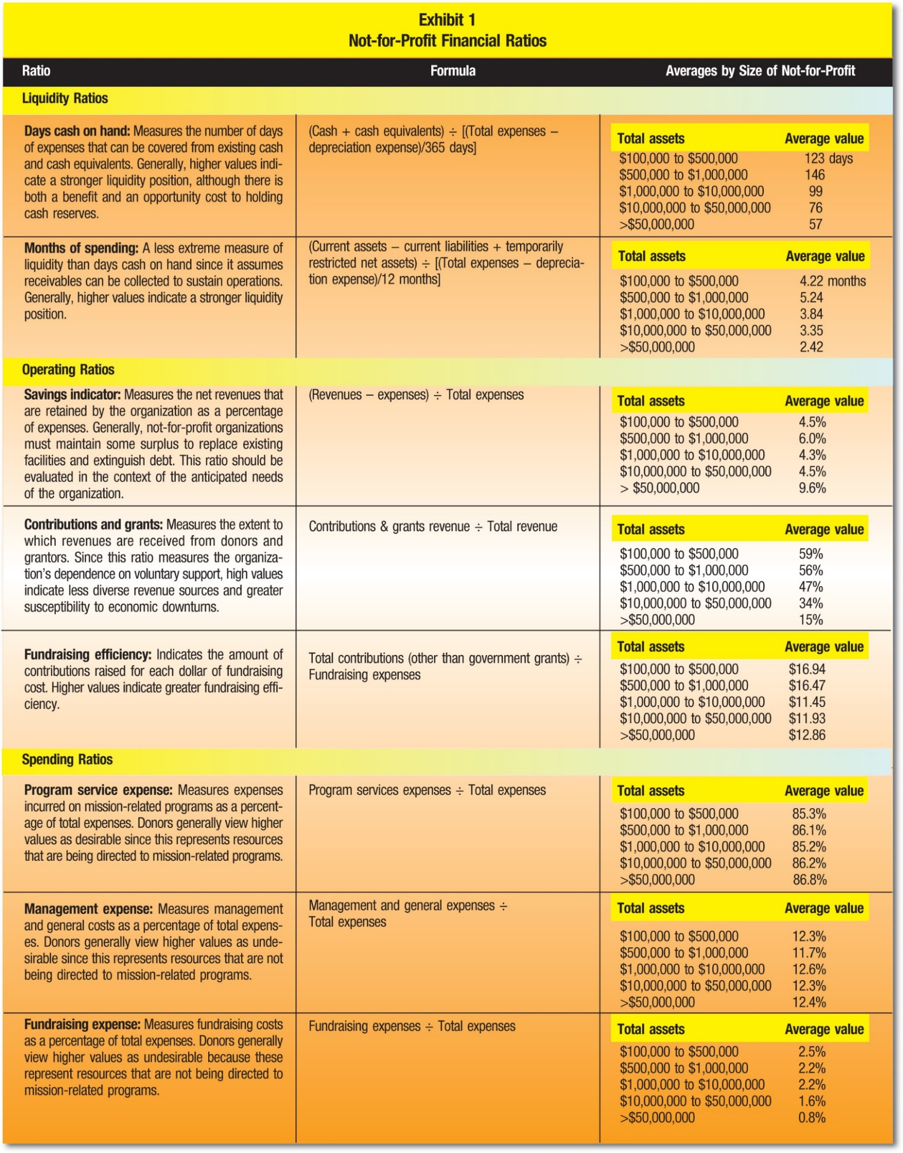
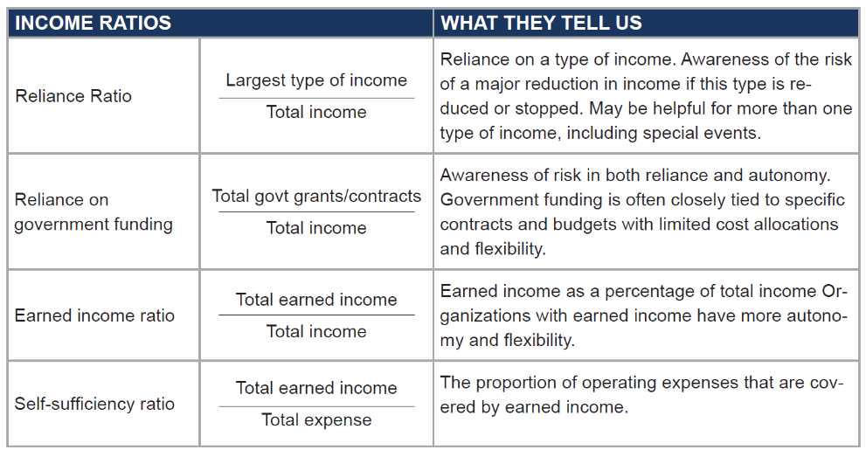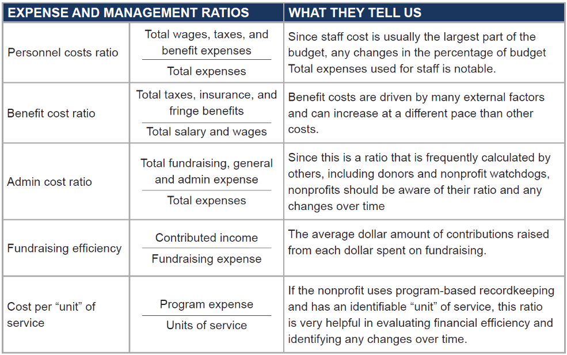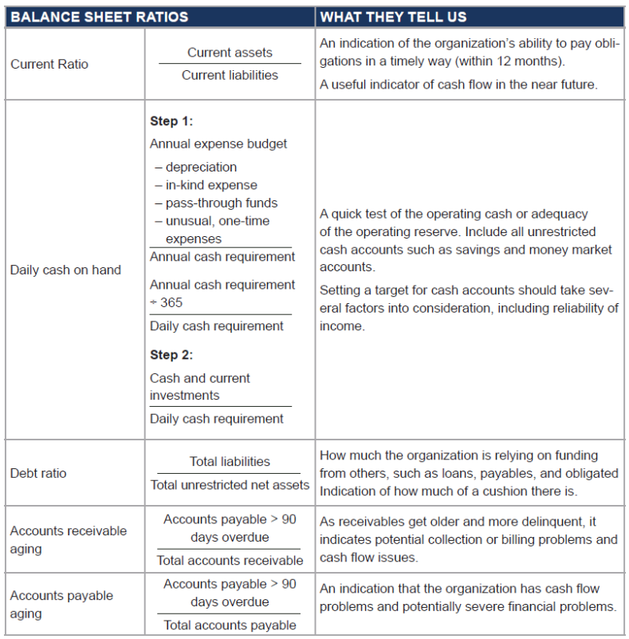

CHARITY WATCH
- Financial Health
  - Efficiency Ratio (greater than 75%)
  - Cost to Raise $100 (less than $25)
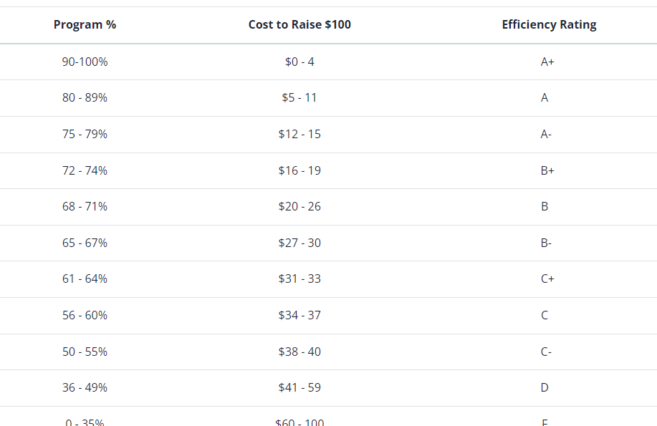
https://www.charitywatch.org/our-charity-rating-process
Top Rated
https://www.charitywatch.org/top-rated-charities
- Governance & Transparency

Some Overhead Costs in Nonprofits Can be a Good Thing

One question I am often asked is “ how much should we be spending on operating expenses?” The truth is, there really isn’t an absolute answer. Many nonprofits choose to minimize or even eliminate to the degree possible any expenses other than direct program expenses or “support to the cause.” Sometimes this can be achieved without a negative impact on the organization. More often these nonprofits experience slow growth or an inability to become sustainable due to a lack of investment in infrastructure and management. In many cases, the nonprofit is left with a few volunteers who shoulder much of the work. But what happens when these volunteers move on? The organization is left at risk.
There is a growing realization that not only are reasonable overhead expenses acceptable, they can also be critical to a nonprofit’s ability to function effectively and ultimately meet its mission. But how do we calculate overhead expenses?

Categorizing nonprofit expenses
Nonprofit expenses can be divided into three distinct categories: Program, administrative, and fundraising expenses. Program expenses are directly related to carrying out your nonprofit’s mission and result in goods or services being provided. For example, expenses to run a camp, deliver a class, put on a performance, allocate a scholarship, provide health care, or deliver food or clothing to the underserved are all considered program expenses.
Administrative expenses apply to the nonprofit’s overall operations and management. For example, the costs of board of directors’ meetings, committee meetings, general legal services, accounting, insurance, and bookkeeping. Fundraising expenses, on the other hand, include costs for promoting and conducting fundraising campaigns, maintaining donor lists, preparing acknowledgment letters, conducting special events, and any other activities that involve soliciting contributions.
So how do you break down your operating budget by category?
When categorizing expenses, the first thing you need to do is break out any expense lines that encumber all three categories, like staff expenses for example. If you have staff support for your organization, you need to break out the actual tasks by category.
Many nonprofits make the mistake of applying all admin costs to “administrative.” That would be incorrect. For instance, if the main purpose of your organization is to award scholarships and you have an administrative assistant who is managing your scholarship program, i.e., receiving applications, responding to applicants, securing missing materials, typing award letters, then these tasks would be categorized under “program.” If that same assistant is accepting and posting entries for your golf tournament, that would be categorized under fundraising.

There are no hard and fast rules
The IRS does not require that nonprofits spend any specific portion of their income on each category. It just wants nonprofits to report how they spend their money.
There is no single formula or ratio all nonprofits use to determine how much of their total budget should go to operating expenses and, as a result, you’ll hear all kinds of advice. The commonly accepted rule of thumb is that a nonprofit is doing well if overhead, or the combination of administrative and fundraising expenses, remains at 25% or less.
In fact, charity rating organizations grade nonprofits partly on how much they spend on overhead. For example, CharityWatch.com reports that it’s reasonable for most charities to spend up to 40% of their budget on operating expenses—in other words, at least 60% should go to programs, and 40% should go to everything else. However, charities that spend less than 40% get higher grades from CharityWatch, with those spending 25% or less on operating expenses receiving the highest “A” grades. Charity Navigator, which employs a sophisticated rating system, gives bonus points to nonprofits with lower operating expenses. The Better Business Bureau says that no more than 35% of a nonprofit’s budget should be spent on operating expenses.
Unfortunately, the desire to keep overhead costs as low as possible has had negative effects on many nonprofits. One study found that the lack of overhead investment has left many with insufficient administrative support, a lack of technology, inadequate office space, insufficient supplies, and staff members who lack the training they need to do their jobs properly. This “starvation” often leads to poor performance and an inability to meet the goals and objectives of the organization.
In addition, some nonprofits engage in accounting tricks to keep their reported overhead costs as low as possible—sometimes ridiculously low. A study of over 220,000 nonprofits found that more than a third reported no fundraising costs at all, while one in eight reported no management or general expenses. The researchers concluded that 75% to 85% of these nonprofits were improperly allocating their expenses.
The issue of nonprofits and overhead costs became so heated that several years ago the heads of the three leading nonprofit rating organizations--GuideStar, Charity Navigator, and BBB Wise Giving Alliance—created a website called The Overhead Myth. The website includes an open letter from the heads of these organizations denouncing the “overhead ratio” as a valid indicator of nonprofit performance.
In other words, the charity rating organizations recognize that nonprofits need to invest in the organization to produce successful results.

Using Ratio Analysis to Manage Not-for-Profit Organizations
By Kaitlin Cashwell, Paul Copley, PhD, CPA and Michael Dugan, DBA
Featured, Analysis, May 2019 Issue |
June 2019
Thousands of CPAs work in the not-for-profit sector, and thousands more volunteer as members of the governing boards of not-for-profit organizations. There is little in the academic background or experience of many accountants, however, to prepare them to analyze and evaluate not-for-profits. University courses in not-for-profit accounting emphasize the recording of transactions and the preparation of financial statements, rather than the evaluation of financial and operational effectiveness. Board members without substantial accounting expertise are even less equipped to interpret not-for-profit financial reports.
Because not-for-profit organizations exist for purposes other than earning a return for equity investors, measures commonly used to evaluate commercial enterprises are not well suited for evaluating them. Furthermore, although they are commonly represented as a single class of organization, great variety exists in the mission and finances of not-for-profit organizations. While many not-for-profits rely heavily on contributions, others derive most of their revenues from the sale of services or membership dues. Because of varying missions and funding sources, there are no sector-wide norms to guide managers and board members.
It is often difficult for not-for-profit managers and governing boards to plan for the organization’s financial future because of a reliance on contributions and the lack of predictability of demand for their services. The future can be daunting if a not-for-profit does not have a strong grasp on its financial position. A not-for-profit can, however, help maintain its financial sustainability by following prudent financial management standards and monitoring financial ratios. Financial management standards help a not-for-profit monitor its budget, cash flow, resource utilization, and revenue sources. This article’s focus is on the use of financial ratios in trend analysis and benchmarking to improve the effectiveness of management and boards charged with monitoring not-for-profit organizations, specifically those not-for-profits that file Form 990. Financial ratios can help determine if a not-for-profit has sufficient resources and determine if it is using those resources efficiently to support its mission. Ratios are useful because they express underlying financial relationships as a single value, allowing comparisons across time and among entities of varying size.

Not-for-Profit Ratios: Investors, creditors, and analysts routinely use ratios to evaluate commercial enterprises. Because many of these ratios focus on profitability measures, their usefulness in guiding not-for-profit managers is limited. Historically, discussion of financial ratios among not-for-profits has focused on spending ratios: program, fundraising, and management expenses as percentages of total expenses. Donors in particular employ these measures to evaluate the extent to which their contributions support mission-related activities. There is ongoing discussion in the not-for-profit literature suggesting that being overly focused on spending measures can have unintended consequences. Sector leaders have called for greater attention to measuring operational effectiveness; others contend that measures of financial position are necessary to assess liquidity and sustainability. Responding to this demand, FASB standards now require greater disclosure related to liquidity.
The authors contend that not-for-profit managers and boards should actively measure and evaluate not just spending ratios, but also measures of liquidity and operational effectiveness. The selection of a set of ratios to monitor is challenging because not-for-profit missions vary extensively, as do their sizes and the industries in which they operate. The most accurate statement that may be made about the choice of ratios to monitor is that no single set of ratios is suitable for all not-for-profits. The management team of each not-for-profit should consider its needs and select a set of ratios to measure that address its particular concerns. Regardless of the specific ratios selected, two characteristics make ratio analysis more useful:
- Trend analysis. Within an organization, the value of ratio analysis lies in directing management’s attention to areas of changing conditions. Therefore, it is important to measure and report financial ratios across time. Once agreed upon, the selected ratios should be consistently measured and presented to the governing board within each financial report so that trends can be identified. The authors’ recommendation is that financial reports provided to the governing board contain five years of ratios.
- Benchmarking. No generally accepted ideal or target levels exist for ratios. The desirable level for a given ratio is a matter of judgment and will vary according to the circumstances facing each organization. Ratios are generally evaluated against a benchmark rather than a theoretically optimal value; these benchmarks are typically calculated as an average value from a comparison group. Therefore, in addition to agreeing upon a set of ratios to measure and monitor, each not-for-profit should also agree on a comparison group of five to ten peer organizations. Ideally, this group would consist of well-managed not-for-profits of similar size and mission.
Because many ratios focus on profitability measures, their usefulness in guiding not-for-profit managers is limited.
For purposes of illustration, the authors present a set of eight ratios that are likely to be useful to a variety of not-for-profit organizations. The ratios represent the three broad areas of liquidity, operations, and spending. Exhibit 1 describes the ratios, what they measure, and how they are calculated. It also computes average values for these ratios for over 200,000 not-for-profits, divided into five categories by entity size, using information available from the IRS website.

Exhibit 1: Not-for-Profit Financial Ratios
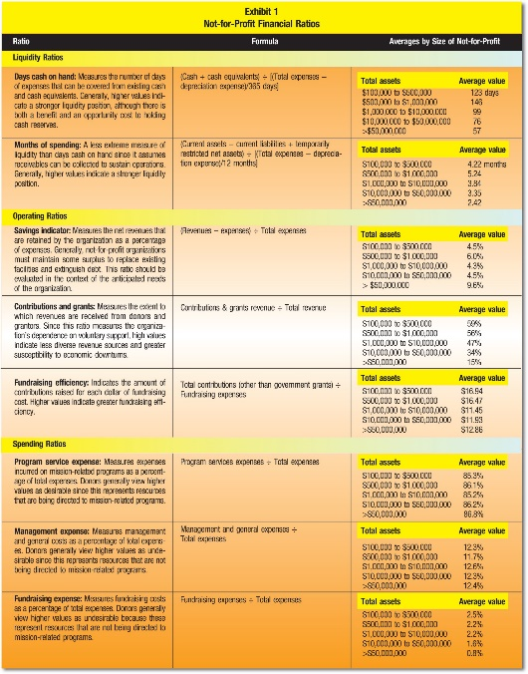
Because commercial businesses are reluctant to share detailed financial information with competitors, developing suitable benchmarks can be very challenging. In contrast, not-for-profits are aided in this process by the IRS’s requirement that tax-exempt organizations file a Form 990 and it be made publicly available. Many notfor-profits post their Form 990s to their websites or make them available through organizations such as Guidestar. In addition, the IRS website provides annual extracts of Form 990 data; users may download financial information for all tax-exempt organization filings in a given year. Form 990 contains much more detailed financial information than is typically available in corporate financial statements and includes a wealth of nonfinancial information, including information about organizational governance and employee compensation. A list of potential ratios and the lines on the Form 990 where the information can be found appears in the article, “Why So Many Measures of Nonprofit Financial Performance? Analyzing and Improving the Use of Financial Measures in Nonprofit Research” (Christopher Prentice, Nonprofit and Voluntary Sector Quarterly, August 2016, http://bit.ly/2GlwUHX).

Liquidity ratios. The “days cash on hand” ratio measures the number of days of expenses that could be paid from existing cash and cash equivalents. Depreciation is removed from total expenses (denominator) since it does not require a cash outlay. Higher values indicate a stronger liquidity position. The “months of spending” ratio represents a longer planning horizon since it assumes receivables can be collected to sustain operations. Because the ratio removes current liabilities and donor-restricted resources from the numerator, it closely parallels the liquidity management disclosures that are now required of notfor-profit organizations.
Both ratios indicate whether the not-for-profit has a sufficient “cushion” of cash and near-cash resources (often described as liquid resources—assets that can be quickly converted into cash) to meet organizational expenses as they come due. Many organizations have a policy of maintaining cash reserves equal to two or three months of expenses; higher values indicate a stronger liquidity position, suggesting that the notfor-profit is better prepared to address periodic declines in revenues or unexpected expenses. Several factors influence the desired level of financial liquidity. Larger organizations and those with more predictable expenses and more diverse revenue sources may maintain lower levels. In addition, organizations relying on donated goods, such as food banks, can operate with lower levels of liquidity since those goods (rather than cash) are the source of the bulk of their average monthly expenses. As is the case with many financial ratios, maximizing either of these ratios comes at a cost. While reserves in the form or cash or short-term investments may make the organization financially secure, these resources could also be used in programs that further the organization’s mission.

Operating ratios. The “savings indicator” ratio expresses the annual surplus (or deficit) of revenues over expenses and should be evaluated in combination with the liquid funds indicators. Improving liquidity ratios requires an organization to increase its annual savings; similarly, a governing board that is comfortable with its liquidity may spend a greater proportion of its resources, driving the savings rate to zero, or even a negative value, for a short period. A common misunderstanding about not-for-profits is that operating surpluses (i.e., savings) are undesirable. In most not-for-profits, accounting surpluses are necessary if equipment and facilities are to be enhanced, debt retired, or liquidity maintained.
The “contributions & grants” ratio indicates the organization’s reliance on external support. Very high values indicate the absence of a diverse revenue stream and a funding model that depends upon donations and grants. This ratio is particularly tied to the not-for-profit’s industry; religious and public broadcasting charities rely heavily on donations, while many larger organizations have multiple sources of revenue, including program revenues, charges for services, and member dues. For example, hospitals receive most of their revenue from patient services, and professional associations rely on membership dues. These not-for-profits typically report low values for this ratio.
Many organizations have a policy of maintaining cash reserves equal to two or three months of expenses; higher values indicate a stronger liquidity position.
“Fundraising efficiency” is the average dollar amount of contributions raised for each dollar expended on fundraising. Values less than $1.00 indicate the cost of fundraising exceeds its benefits. Charity Watch advises a minimum level of $2.85 for most charities. As with most ratios, care must be exercised in its interpretation. Fundraising capacity may take several years to develop, with the result that fundraising appears more expensive as an organization is building capacity. For this reason, studies find that smaller organizations dedicate higher proportions of their budget to fundraising than larger entities (e.g., Patrick Rooney, Mark Hager, and Thomas Pollak, “Research about Fundraising and Administrative Costs,” Giving USA Update,2003, http://bit.ly/2G2qQCw). It is also important to recognize that the ratio is an average and not a marginal return. This distinction becomes important if development activities are evaluated on the basis of this ratio. In such a situation, notfor-profits may forego productive fundraising efforts for the purpose of keeping the ratio artificially high, thereby leaving money on the table that could have been used to further the organization’s mission. Fundraising opportunities should not be rejected merely because the expected pay-back is less than the current average.

Spending ratios.
The next three ratios all measure a given category of expense as a percentage of total expenses. Conventional wisdom is that expenses incurred for program services are good, while expenses incurred for management and fundraising are undesirable. Because accounting standards require expenses to be classified with the categories of program, fundraising, and management and general, the three ratios must sum to 100% for any given organization.
Because these ratios are relatively easy for non-experts to interpret (e.g., how much of each dollar is spent on programs), they are widely reported by the media, not-for-profit watchdog organizations, and not-for-profits themselves. Ample evidence exists that these ratios are widely used by governing boards, granting agencies, and donors. While these ratios are industry standards, they are also often misused. Because of the prevailing perceptions, incentives exist to shift costs to the program category and thereby improve the desirable ratio while decreasing the other two. To address abuse, accounting rulemaking bodies provide standards for the allocation of joint costs.
The “program service expense” ratio is the proportion of expenses incurred for purposes of the organization’s mission. It does not measure program effectiveness, only the extent to which available resources are directed toward the organization’s mission. The Better Business Bureau’s Wise Giving Alliance recommends a minimum threshold of 65% for this measure. Charity Watch uses a grading system ranging from A+ (> 90%) to F (<35%), with 60% or greater required for a satisfactory rating.
“Management expense” may be the most commonly misinterpreted ratio. Sometimes called “administrative expense,” it includes expenditures for training, planning, internal controls, and organizational governance. Training employees and volunteers, safeguarding assets, and assuring responsible governance are all desirable things, but the conventional view of this ratio is that higher values are undesirable. In addition, the costs associated with securing government grants and complying with grant requirements are classified as management and general expenses and can significantly affect this ratio, particularly among smaller not-for-profits. As organizations grow in size, they require more layers of management for institutional control. Yet while the amount spent on administration increases with notfor-profit size, management expense as a percentage of total expenses may remain constant or even decline, depending upon economies of scale.
“Fundraising expense” is the proportion of total expenses devoted to development activities, and together with management and general expense is commonly described as “overhead costs.” Substantial empirical evidence exists that investments in overhead vary with the size and nature of organizations (Rooney et al 2003), but that increased overhead spending contributes to organizational performance. For example, a study by the Urban Institute’s Center on Nonprofits and Philanthropy (Getting What We Pay For: Low Overhead Limits Nonprofit Effectiveness, 2004, https://urbn.is/2X8svNX) found charities that spend too little on overhead are less effective. In response to these and similar findings, the chief executives of the Wise Giving Alliance, Guidestar, and Charity Navigator jointly authored a letter to donors alerting them to the “overhead myth” and encouraging greater attention to not-for-profit performance, transparency, and governance. Curtis Klotz proposed adoption of a new reporting model for not-for-profit expenses to overcome the inherent limitations of current reporting (“A Graphic Re-visioning of Nonprofit Overhead,” Nonprofit Quarterly, Aug. 16, 2016, http://bit.ly/2FeaZ3x). Until accounting standards or the format of Form 990 are changed, however, the existing expense categories and reporting will persist. Because of the visibility of these spending ratios and their importance to donors, management and governing boards should continue to monitor them. But it is important to recognize their inherent shortcomings and not base strategic decisions exclusively on the ratios.

Use of Ratios to Evaluate a Not-for-Profit: In this section, the authors calculate the eight ratios for an example not-for-profit organization for purposes of illustrating how ratios may be used in both trend and benchmarking analyses. The organization chosen was a Young Men’s Christian Association (YMCA) from a moderatesized U.S. city. YMCAs are easily comparable because each community’s YMCA is separately incorporated—and thus prepares its own Form 990—and they have relatively uniform missions, organization, and activities. The information necessary to calculate the ratios presented here took less than two hours to collect using the free section of Guidestar’s website; this suggests that once a not-for-profit selects a set of peer organizations, the annual investment necessary to obtain relevant benchmarking data is not significant.
Exhibit 2 presents ratios for the selected YMCA over a five-year period. Longitudinal analysis permits the identification of trends and highlights aberrations. During the past four years, the selected YMCA has consistently maintained a cash balance of approximately 2½ months of spending and an overall liquid net asset balance of approximately 3½ months.

Exhibit 2: Use of Ratios in Trend Analysis
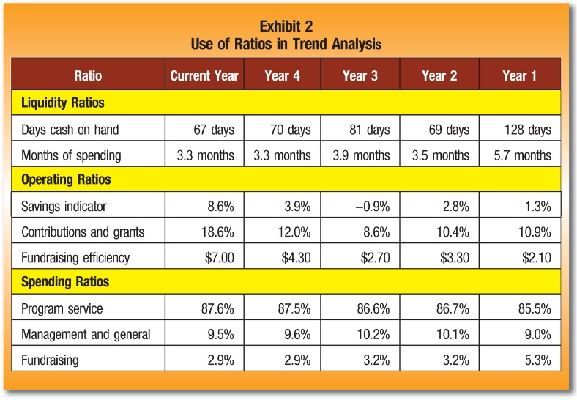
One benefit of trend analysis is that it identifies deviations in the ratios, such as the unusually high liquidity values in Year 1. A 46% decline in cash from Year 1 to Year 2 would almost certainly merit investigation. In this case, the organization had undertaken a capital campaign in Year 1, resulting in high cash balances, which were expended for long-term assets in Year 2. The presentation of five years of ratios provides a context for unusual amounts; presentation of only two years of ratios (Years 1 and 2) would likely leave the governing board uncertain about which year was abnormal.
Among the operating ratios, the savings indicator exhibits the greatest year-to-year fluctuation. Although negative savings (deficits) are not sustainable in the long run, not-for-profits may experience occasional deficits. In this case, the YMCA held expenses constant over a three-year period (Year 2 to Year 4), and the deficit reported in Year 3 was attributable to a 20% decline in contributions that year. Because the savings indicator returned to positive in the subsequent year, the one-year deficit should not be of particular concern to the governing board.
Exhibit 2 also highlights the interrelationships among financial ratios. The decline in contribution revenue in Year 3 caused the deficit reported for the savings indicator as well as a decline in the contributions and grants and fundraising efficiency ratios. Conversely, contribution revenue increased nearly 70% in the current year, causing all three operating ratios to increase.
The purpose of a benchmarking analysis is to evaluate the current position of a notfor-profit with respect to similar organizations and to identify areas for improvement. The value of benchmarks as an evaluation tool is dependent upon the selection of an appropriate peer group. Not-for-profits vary widely in mission, activities, and funding sources, and benchmarks developed from disparate organizations are likely to be of marginal value. In many instances, not-for-profit managers will be able to identify organizations with similar missions. Trade associations and networking opportunities provided by industry conferences and meetings may also be useful in identifying peers.
Exhibit 3 presents the current year financial ratios of the selected YMCA and average values for a sample of 10 peer YMCAs. To ensure comparability, the peer YMCAs are from similarly sized cities within the same geographic region; geographic proximity contributes to comparability since real estate, utilities, and other costs vary across regions. Ratios were calculated for the peer institutions using information from their Form 990s. Exhibit 3 presents both average values and ranges of values for the peer group.

Exhibit 3: Use of Ratios in Benchmarking Analysis
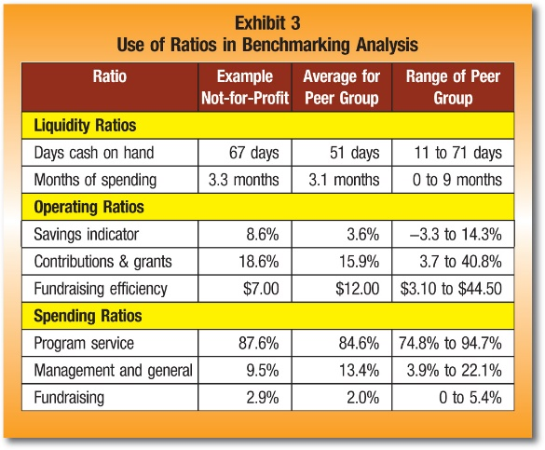
With regard to liquidity, the selected YMCA is very close to the peer group average for the months of spending ratio and has a cash position near the top of the peer group distribution. The operating ratios are also close to the peer averages. Although the selected YMCA has a higher-than-average contributions and grants ratio, it is not high in an absolute sense, with most revenues continuing to come from program fees and membership dues. The fundraising efficiency ratio is less than the peer group average, but well above the minimum recommended by charity watchdog groups. Finally, the spending ratios are close to peer averages. Overall, both the trend and benchmarking analyses suggest nothing is out of the ordinary in this year’s liquidity, operating, or spending ratios. Accordingly, the governing board could better use its members’ time discussing strategic matters affecting the future of the organization rather than past financial results.

Using Benchmarks and Ratios to Their Fullest
The requirement that all tax-exempt organizations complete and make available their Form 990s provides access to a wealth of financial information about peer organizations at minimal cost. In some cases, it may be desirable to develop multiple benchmarks. For example, colleges and universities commonly develop benchmarks for both peer and aspirant institutions. Doing so enables organizations to evaluate how well they are doing and what is required to move up to the next level.
Financial ratios can be useful tools for those in charge of monitoring a not-for-profit’s financial position and operations. Ratios are not a goal in themselves, however, and care should be taken in their interpretation. Conventional wisdom regarding desirable levels for some ratios may be unsupported by empirical data. For example, not-for-profits often feel pressured to lower overhead ratios, even though research shows that investment in overhead is often critical to overall not-for-profit mission success.
Each not-for-profit faces unique circumstances, and pursuit of a given strategy may improve one ratio while worsening another. It is also important for boards to understand that resource providers monitor the organization’s ratios. Management should anticipate and be prepared to address the concerns of donors and grantor agencies regarding the organization’s financial position.

