Baptism of the Lord
January 16, 2022
All BOLD type to be read by congregation

PRELUDE

*OPENING HYMN Spirit Song UMH 347

* CALL TO WORHIP
Our God is a God of power and strength!
God has created each of us with tender care.
Our God is a God of majesty and awe!
God walks with each of us every step of the way.
Our God is a God of glory and wonder!
God loves each of us with tenderness and passion.
Our God calls us each by name.
God calls each of us to unite in worship together!

WELCOME

*OPENING PRAYER
Holy God of glory and majesty, you have called us by name. We pray in this moment for the courage and the strength to answer your call. As we open our ears to hear the story of your Son’s baptism, open our hearts also, that we may experience again the renewing power of rebirth in the Holy Spirit. Inspire us in this time of worship, that we may claim our own identity as your beloved children. We pray in the name of Jesus Christ. Amen

SCRIPTURE: Psalm 29

*HYMN Spirit of the Living God UMH 393

OFFERTORY
As forgiven and reconciled people,
let us offer ourselves and our gifts to God.

*Doxology #95
“Praise God, from whom all blessings flow;
praise him, all creatures here below;
praise him above, ye heavenly host;
praise Father, Son, and Holy Ghost. Amen.”

*OFFERTORY PRAYER

CHOIR

SCRIPTURE: Luke 3:15-17; 21-22

MESSAGE

PRAYER

THE LORD’S PRAYER #895
Our Father, who art in heaven, hallowed be thy name.
Thy kingdom come, thy will be done
on earth as it is in heaven.
Give us this day our daily bread.
And forgive us our trespasses, as we forgive those
who trespass against us.
And lead us not into temptation, but deliver us from evil.
For thine is the kingdom, and the power,
and the glory, forever. Amen.

* PRAISE SONG: Breathe on Me, Breath of God UMH 420

*BENEDICTION
Go and do no harm, do good and stay in love with God.
Amen.

*POSTLUDE

Grace St. Paul’s
United Methodist Church
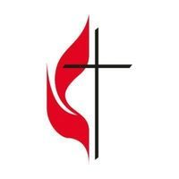
Leadership Meeting January 13 at 7 p.m.
Bible Studies to be announced

January 9
Greeters: Linda Hydro
Lay Leader: Rich Leeman
Counters: Rich Leeman, Jim Cottrell and Connie Jacobs

January 16
Greeters: Linda Hydro
Lay Leader: Rick Tweed
Counters: Sue Whiteley and Eva Beckman

Need more volunteers for technology for church service.
Will train.

Worship 9:00AM
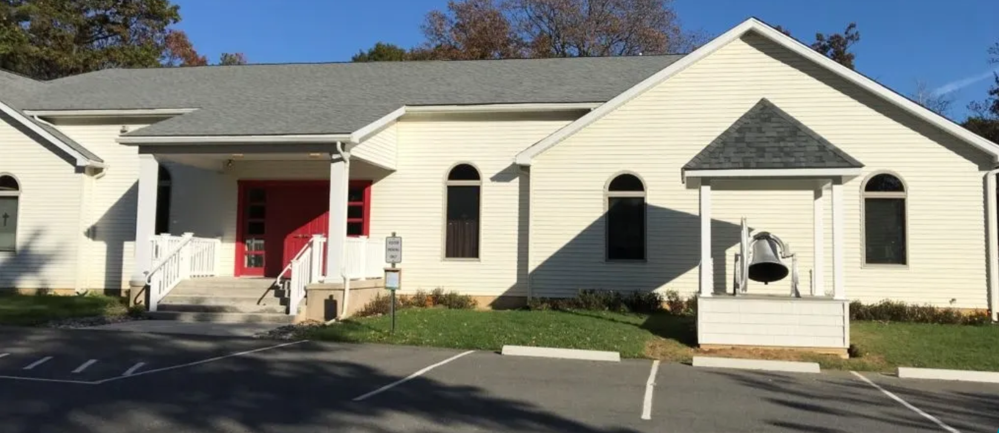

40 Church Road
Jim Thorpe, PA 18229
www.gracestpauls.church
570-325-9151

Email: gspumcoffice@gmail.com
Pastor Email: alltogethergsp@gmail.com

Rev. Kimberly Leskowich
Pastor cell 610-533-1269
Office Hours Tuesdays 8 – 11 AM
Other hours by appointment

CCLI Copyright License #A11250967
CCLI Streaming License #A20197444

A sanctuary of hope & Jesus’ love for everyone

