3rd Sunday After the Epiphany
January 23, 2022
All BOLD type to be read by congregation

PRELUDE

*OPENING HYMN Joyful, Joyful We Adore Thee UMH 89

* CALL TO WORHIP
Come to the celebration!
We rejoice in the God of love!
God rejoices in your presence this day.
Our delight is in our God.
God’s delight is in you, my friends!
Let us celebrate this joyous news!

WELCOME

*OPENING PRAYER
Fountain of life, we praise you for your steadfast love and abiding faithfulness. Dance with us, as we come into your presence with joy. Celebrate with us, as we recognize and remember your many gifts. Call to us, as we listen for your voice and learn to develop and share these gifts. River of love, wash over us with your wisdom this day. Amen

SCRIPTURE: Psalm 36:5-10

*HYMN Great Is Thy Faithfulness UMH 140

OFFERTORY
As forgiven and reconciled people,
let us offer ourselves and our gifts to God.

*Doxology #95
“Praise God, from whom all blessings flow;
praise him, all creatures here below;
praise him above, ye heavenly host;
praise Father, Son, and Holy Ghost. Amen.”

*OFFERTORY PRAYER

CHOIR

SCRIPTURE: 1 Corinthians 12:1-11

MESSAGE

PRAYER

THE LORD’S PRAYER #895
Our Father, who art in heaven, hallowed be thy name.
Thy kingdom come, thy will be done
on earth as it is in heaven.
Give us this day our daily bread.
And forgive us our trespasses, as we forgive those
who trespass against us.
And lead us not into temptation, but deliver us from evil.
For thine is the kingdom, and the power,
and the glory, forever. Amen.

* PRAISE SONG: On Eagle’s Wings UMH 143

*BENEDICTION
Go and do no harm, do good and stay in love with God.
Amen.

*POSTLUDE

Grace St. Paul’s
United Methodist Church

Worship 9:00AM

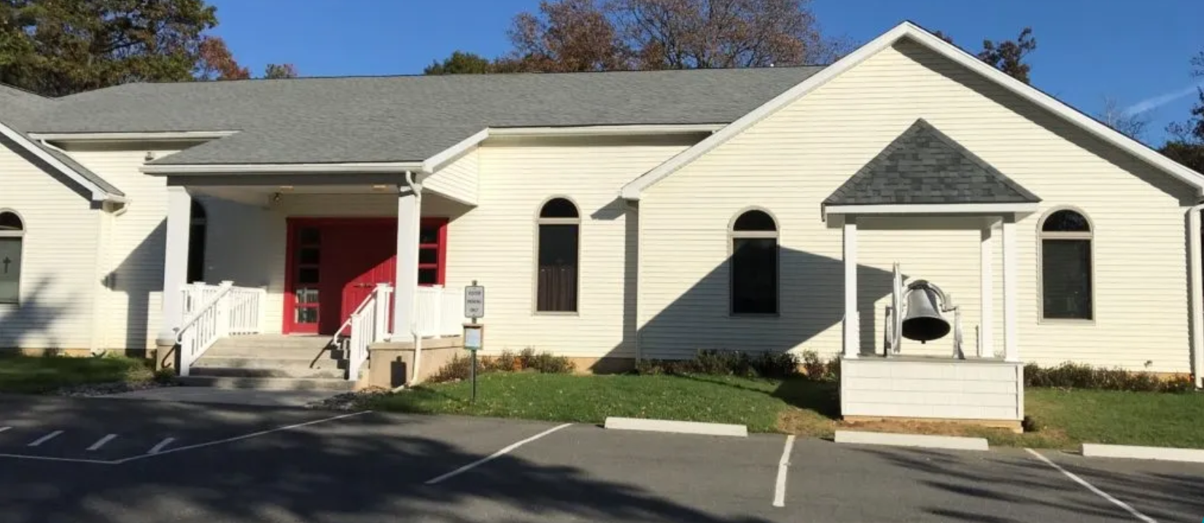

40 Church Road
Jim Thorpe, PA 18229
www.gracestpauls.church
570-325-9151

Email: gspumcoffice@gmail.com
Pastor Email: alltogethergsp@gmail.com

Rev. Kimberly Leskowich
Pastor cell 610-533-1269
Office Hours Tuesdays 8 – 11 AM
Other hours by appointment

CCLI Copyright License #A11250967
CCLI Streaming License #A20197444

A sanctuary of hope & Jesus’ love for everyone

