4th Sunday After the Epiphany
January 30, 2022
All BOLD type to be read by congregation

PRELUDE

*OPENING HYMN How Great Thou Art UMH 77

* CALL TO WORHIP
Come! Hear the word of the Lord.
We hear but do not understand. Who will teach us, that our hearts may rejoice?
Listen to the heavens, for they are telling the glory of God. Day pours forth speech and night declares knowledge.
Who can hear these voices— voices that speak without words or speech?
Listen with your heart and you will hear. Pray in the Spirit and you will perceive. Amen,
Amen

WELCOME

*OPENING PRAYER
God of wisdom, we have come to sit at Jesus’ feet— to hear as he brings good news to the poor; to rejoice as he proclaims release to the captives, recovery of sight to the blind, and freedom for the oppressed; to marvel as he declares the year of your favor. Help us to hear, teach us the music of the heavens that we may truly understand the fullness of life you have in store for us. Amen

SCRIPTURE:1 Corinthians 12:12-31

*HYMN To God Be the Glory UMH 98

OFFERTORY
As forgiven and reconciled people,
let us offer ourselves and our gifts to God.

*Doxology #95
“Praise God, from whom all blessings flow;
praise him, all creatures here below;
praise him above, ye heavenly host;
praise Father, Son, and Holy Ghost. Amen.”

*OFFERTORY PRAYER

CHOIR

SCRIPTURE: Luke 4:14-21

MESSAGE

PRAYER

THE LORD’S PRAYER #895
Our Father, who art in heaven, hallowed be thy name.
Thy kingdom come, thy will be done
on earth as it is in heaven.
Give us this day our daily bread.
And forgive us our trespasses, as we forgive those
who trespass against us.
And lead us not into temptation, but deliver us from evil.
For thine is the kingdom, and the power,
and the glory, forever. Amen.

* PRAISE SONG: Blest Be the Tie that Binds UMH 557

*BENEDICTION
Go and do no harm, do good and stay in love with God.
Amen.

*POSTLUDE

January 30

Grace St. Paul’s
United Methodist Church
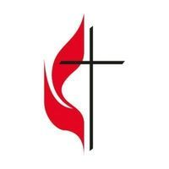
Greeter: Linda Hydro
Lay Leader: Connie Jacobs
Counters: Mike Bacsick, Carol Cottrell, Christine DiRobbio
Technology:

February 6
Greeters: Kathy Westrip and Jim Hunt
Lay Leader: Judy Sibbach
Counters: Pete Morey and Bob Walker
Technology:

Calendar
January 30: Church Service 9 a.m.

February 6: Bible Study at 9 a.m. Bible Study will be every
Week at the church or on Zoom. Please let the Pastor know if
you want to be on Zoom.

February 13: Leadership Board meeting 7 p.m.

We need HELP IN TECHNOLOGY. No experience needed.
Will train you. We only have two technology people and
need more. We all used the Live Stream at one time.
All you need is a servant’s heart. This is an important mission.

Worship 9:00 A.M.

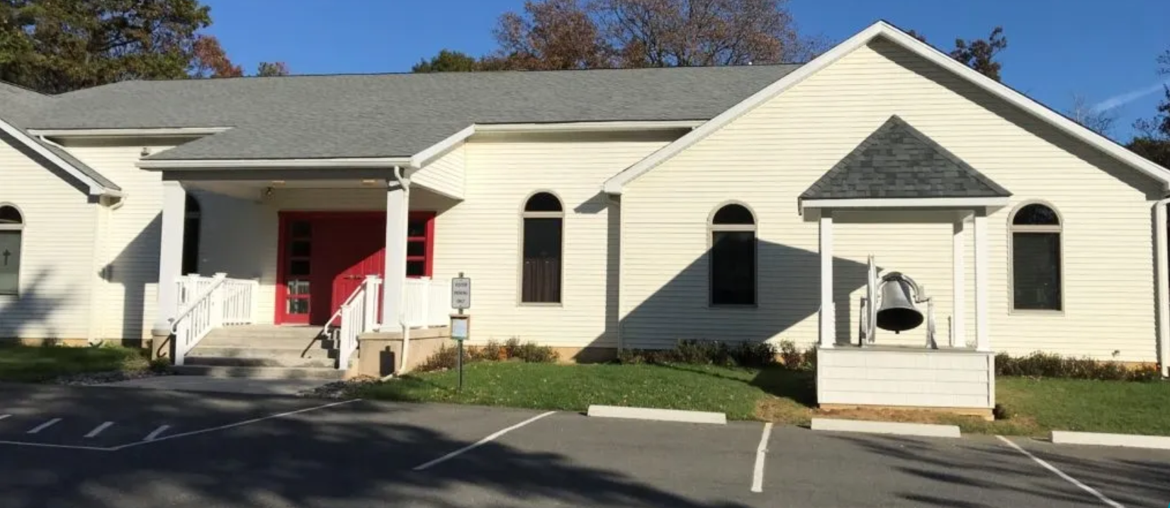

40 Church Road
Jim Thorpe, PA 18229
www.gracestpauls.church
570-325-9151

Email: gspumcoffice@gmail.com
Pastor Email: alltogethergsp@gmail.com

Rev. Kimberly Leskowich
Pastor cell 610-533-1269
Office Hours Tuesdays 8 – 11 AM
Other hours by appointment
CCLI Copyright License#A11250967
CCLI Copyright License#A20197444 Sanctuary of hope & Jesus love for everyone

