**Pastor Kim’s Last Sunday**

**June 26, 2022**

L=Leader; C=Congregation; P=Pastor \*Please stand

PRELUDE

WELCOME

\*OPENING HYMN “Be Thou My Vision” #451

\* CALL TO WORHIP

L. God’s people have gathered to worship the Father, Son and Holy Spirit.

**C. Let us remember that all things are possible with God!**

\*OPENING PRAYER (John Wesley’s Covenant Prayer)

**C. I am no longer my own, but thine. Put me to what thou wilt. Put me to doing, put me to suffering. Let me be employed by thee or laid aside for thee, exalted for thee or brought low for thee. Let me full, let me be empty. Let me have all things, let me have nothing. I freely and heartily yield all things to thy pleasure and disposal. And now, O glorious and blessed God, Father, Son and Holy Spirit, thou are mine and I am thine. So be it. And the covenant which I have made on earth, let it be ratified in heaven. Amen.**

SCRIPTURE:

Jeremiah 29:11 *“For I know the plans I have for you,” declares the Lord, “plans to prosper you and not to harm you, plans to give you hope and a future.”*

Philippians 1:3-11 *“I thank my God every time I remember you,**constantly praying with joy in every one of my prayers for all of you,**because of your sharing in the gospel from the first day until now.**I am confident of this, that the one who began a good work among you will bring it to completion by the day of Jesus Christ.**It is right for me to think this way about all of you, because you hold me in your heart, for all of you share in God’s grace with me, both in my imprisonment and in the defense and confirmation of the gospel.**For God is my witness, how I long for all of you with the compassion of Christ Jesus.**And this is my prayer, that your love may overflow more and more with knowledge and full insight**to help you to determine what is best, so that on the day of Christ you may be pure and blameless, having produced the harvest of righteousness that comes through Jesus Christ for the glory and praise of God.*

Philippians 4:13 *“I can do all this through Christ who gives me strength.”*

Mark 10:27 *“All things are possible with God.”*

\*HYMN “There’s Something About That Name” #171

OFFERTORY

P. As forgiven and reconciled people,

let us offer ourselves and our gifts to God.

\*Doxology #95

**C. “Praise God, from whom all blessings flow;**

**praise him, all creatures here below;**

**praise him above, ye heavenly host;**

**praise Father, Son, and Holy Ghost. Amen.”**

\*OFFERTORY PRAYER

P. Glorious God, please accept our offerings of song, worship, dance, and money. You have given us all things; we offer to You all that we have and all the we are. Look upon us with grace and peace, as we look forward to what the future holds for this congregation and for me as retired pastor. We give You thanks and honor. AMEN.

CHOIR

MESSAGE “I Thank God for You”

PRAYER

THE LORD’S PRAYER as sung by Donna Tweed

\* CONTEMPORARY SONG: “Friends” Michael W. Smith

\*BENEDICTION

P. Go and do no harm, do good and stay in love with God.

**C.** **Amen.**

\*POSTLUDE

Today

Greeter: Noellie Laube

Lay Leader: Jim Hunt

Counters: Mike Bacsick

Technology:

Next Week

Greeter: Judy Sibbach

Lay Leader: Rich Leeman

Counters: Pete Morey and Bob Walker

Technology:

Calendar

Thursday at 9:00 AM at the church or on Zoom Bible Study.

Leadership Board Meeting July 14, 2022 at 7:00 PM

July 1, 2022 The Reverend Daniel Meader will be appointed as pastor at Grace St. Paul’s UMC July 3, will be his first Sunday.

Come welcome him and his family!

July 10 Church Picnic after Worship!

**Today’s Worship included elements that are dear to Pastor Kim. Such as the John Wesley’s Covenant Prayer, the Scripture that was read, the songs and even the prayers. She would like to say that Grace St. Paul’s UMC has been a pleasure to serve. She wishes and prays the best for the congregation. Thank you for a wonderful 6 months. It went by so very fast. She hopes that you will remember even just one little thing from our time together. Above all; do no harm, do good and stay in love with God!**

Grace St. Paul’s

United Methodist Church

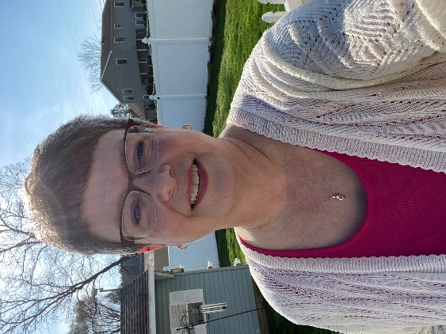

40 Church Road

Jim Thorpe, PA 18229

[www.gracestpauls.church](http://www.gracestpauls.church)

570-325-9151

Email: [gspumcoffice@gmail.com](mailto:gspumcoffice@gmail.com)

Pastor Email: [alltogethergsp@gmail.com](mailto:alltogethergsp@gmail.com)

Rev. Kimberly Leskowich

CCLI Copyright License #A11250967

CCLI Streaming License #A20197444

A sanctuary of hope & Jesus’ love for everyone

“Friends” by Michael W. Smith

Packing up the dreams God planted  
In the fertile soil of you  
I can't believe the hopes He's granted  
Means a chapter of your life is through

But we'll keep you close as always  
It won't even seem you've gone  
'Cause our hearts in big and small ways  
Will keep the love that keeps us strong

And friends are friends forever  
If the Lord's the Lord of them  
And a friend will not say never  
'Cause the welcome will not end

Though it's hard to let you go  
In the Father's hands we know  
That a lifetime's not too long  
To live as friends

And with the faith and love God's given  
Springing from the hope we know  
We will pray the joy you live in  
Is the strength that now you show

But we'll keep you close as always  
It won't even seem you've gone (it won't seem you're gone)  
'Cause our hearts in big and small ways  
Will keep the love that keeps us strong  
Yeah, yeah

And friends are friends forever  
If the Lord's the Lord of them  
And a friend will not say never  
'Cause the welcome will not end

Though it's hard to let you go  
In the Father's hands we know  
That a lifetime's not too long  
To live as friends

And friends are friends forever (friends are friends forever)  
If the Lord's the Lord of them (for all of them)  
And a friend will not say never (a friend will not say never)  
'Cause the welcome will not end (ooh, ooh)

Though it's hard to let you go  
In the Father's hands we know  
That a lifetime's not too long  
To live as friends  
To live as friends

Though it's hard to let you go  
In the Father's hands we know  
That a lifetime's not too long  
To live as friends

No, a lifetime's not too long  
To live as friends

Songwriters: Michael W. Smith (1436), Deborah D. Smith (1843)  
For non-commercial use only.  
Data From: [Musixmatch](https://www.bing.com/ck/a?!&&p=598d043c9e11701cea835db1ca274aace9fb1de3979e40fe19a61983f106eff3JmltdHM9MTY1NDA0NDMzMCZpZ3VpZD1lMjQ3ODc2NS1jM2UyLTRjODctYTVlZC0yOGQ3OTE0MTVlYzcmaW5zaWQ9NTQ2NA&ptn=3&fclid=22ba364b-e144-11ec-b156-6647bbe8a0c4&u=a1aHR0cHM6Ly93d3cubXVzaXhtYXRjaC5jb20v&ntb=1" \t "_blank)