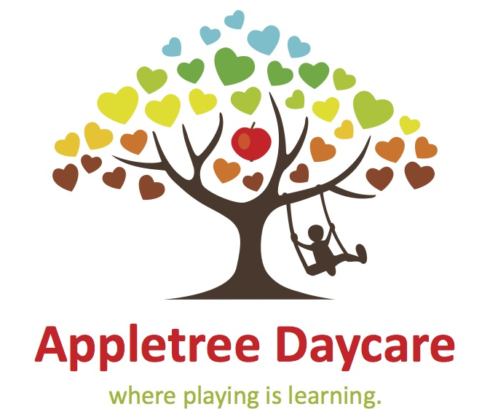

APPLE TREE BREAKFAST INFORMATION FORM

CHILD’S NAME :_________________ DOB : _______________

PRIMARY CLASS (e.g P2) _________ TEACHERS NAME : ___________________________

CONTACT NUMBER : ________________________

DAYS REQUIRED ________________________________

Does your child suffer from any allergies, or require special dietary measures to be taken into account during preparation of food and activities carried out at Appletree Breakfast Club If **Yes** please provide further details below.

 Dairy produce YES / NO  Nuts or Seeds YES / NO

 Eggs YES / NO Gluten YES / NO  Other foods (lactose) YES / NO  Vegetarian YES / NO

Details of Allergies suffered or Dietary requirements ____________________________________________________________________________________________________________________________

Disclaimer : It is the Parents / Guardians sole responsibility to inform Appletree Daycare of **ALL** allergies and medical conditions that your child suffers from, including the symptoms and the appropriate medical care responses and procedures to administer.

Appletree Daycare and its employees and directors assume **NO** liability in any event where a substance that your child may come into contact with results in an allergic reaction. The parent / guardian also accepts that all necessary and appropriate procedures will be taken, however no guarantees are offered.

Appletree Breakfast club will endeavour to keep our area free from nuts

However as this area is not solely used by us, nut products may have been consumed or prepared in this area.

Parental Signature :

Date :