**Emotional Freedom Technique (EFT) – Tapping (abbreviated version)**

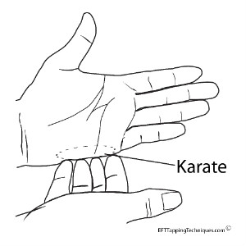 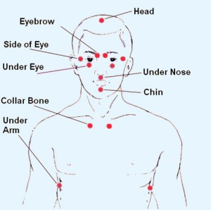

Setup Point Tapping Sequence Points

1. **Identify the problem:** Focus on the feeling/anxiety/distress. This can be general anxiety or something more specific.

Rate the intensity of these feelings from 0-10.

1. **Create a Setup Phrase**: The Setup Phrase should acknowledge the issue and focus on accepting yourself, despite the problem.

**TAP: Say the Setup Phrase 3 times while tapping on the Setup Point/Karate Chop.**

“Even though I feel this (anxiety) _______, I deeply and completely accept myself”

“Even though this (anxiety) ________, is really uncomfortable, I love and accept myself”

1. **Tapping Sequence:** The Reminder Phrase will be a few short words that describe your issue.

You will speak this phrase out loud at each of the additional eight points in the tapping sequence.

Tap through the eight Sequence Points while repeating the Reminder Phrase. Tap 4-7 times at each point. There is no exact number, if 20 or 50 times feels better to you, then do that!

* Beginning of Eyebrow **TAP: Say the Reminder Phrase on the Tapping Points.**

* Side of Eye “All this anxiety”

* Under Eye “All this anxiety about my work deadline”

* Under Nose “All this anxiety keeps me awake at night”

* Under Lip

* Beginning of Collar Bone

* Under Arm

* Top of Head

1. **Focus on distress and rate it**:
2. If 0 or 1, stop.
3. If 2 or more, repeatwith a **modified Setup Phrase**. “Even though I still have some _____, I love and accept myself”
4. Repeat with a **modified Reminder Phrase** “This remaining ________”
5. Focus again and continue until rating is 0-1.

Once you have completed your round of tapping, take a DEEP BREATH. Feel your body and notice what’s happening. Do you feel a shift of any kind in your emotions? How intense does your pressing issue feel on a scale of 0-10 now? If your intensity went from a 9 to an 8, that means tapping is beginning to relieve your stress! It is common for people to need more than one round of tapping to feel relief. When you tap, make a point of noticing how your body responds. (yawning, sighing, etc.)