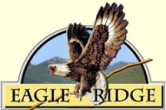

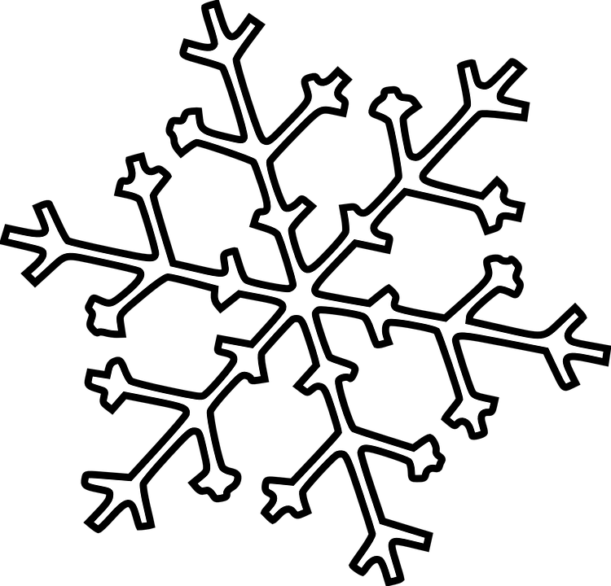 Winter 2022 Newsletter 

**Eagle Ridge Homeowners’ Association**

Website: www.eagleridgenews.org

## *December 2022*

**Highlights of this issue:**

**●2023 Board Meeting Dates**

**●Secondary Gate Code Changes**

**●Snow Removal Contract**

**●Stay Informed: ERHA Website & Emails**

**●Goodbye! Hello! Thank You!**

**●Architectural Control Committee**

**2023 Board Meeting Dates**

Meetings of the Board of Directors will be held on the following Saturdays during 2023: January 28th, April 15th, July 15th and October 14th. All meetings will be held at 9am in the Stillaguamish Conference Room, by Haller Park.

All Lot Owners are welcome to participate and further information will be provided on the Association’s website and emails prior to the meetings.

**Secondary Gate Code Changes**

A separate page will be included with this newsletter which contains your new secondary gate code for the first quarter of 2023. **Only** your secondary code is changed. These new numbers are already valid and your old number will be deactivated within two weeks of the mailing.

**Snow Removal Contract**

ERHA has contracted with Choice Grounds Care for snow removal route for road plowing when a snowfall reaches a “trigger depth” of 2 inches. Choice may also decide to apply ice melt after plowing based on ground temperatures and projected weather conditions. Please keep all roads clear from obstructions during snowstorms, so as to aid in removal of snow.

**ERHA Website**

ERHA Board encourages homeowners in our community to access the website for updated news, happenings and other important information and to add your email to the ERHA email list for news. The email address is erhabusiness.2022@gmail.com.

**Goodbye! Hello! Thank You!**

The ERHA would like to extend thanks to departing Board member, Richard McKinley, who has moved out of ERHA this past fall. At the same time, the ERHA Board would like to welcome its newest member, Jake Nolte, to serve as Vice President. Jake and his family have recently moved into our community and we look forward to his input on the Board. We’re also welcoming back a past Board member to round out the Board as Member-At-Large … and he thought he was retiring! Don Wallace will be rejoining the Board for the next two years.

ERHA would also like to extend a giant thanks to departing Treasurer, Joe Amma, who retired in September from the Board. Joe served the Board with diplomacy and honesty and will be very much missed.

A big thanks to Bruce Aalmo, who repaired the damage at the kiosk of our security gates. Hopefully, the mystery of the moving rocks will come to an end this winter.

**Architectural Control Committee**

All lot owners are reminded that the Covenants (Article X Architectural Control and Article XI Building and Use Restrictions) require that ANY proposed construction (including dwellings, garages and carports, barns and similar outbuildings), other minor outbuildings (for example, tool sheds) and fences and walls, must be submitted to and approved by the Architectural Control Committee before that construction commences. Lot owners should contact any member of the ACC (Ralph Yunker (435-7947), Ken Hawking, Don Wallace or Kristi Neeleman), when planning home and/or lot construction.

**The members of the Board for Eagle Ridge, wishes for all of our community, a happy, safe and kind New Year for 2023.**

