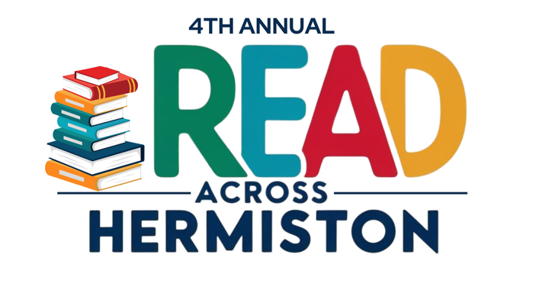

Social Media Post Ideas for Read-a-thon Readers

Here are some ideas for posts on social media, emails, or text message for people to support and donate. Most importantly, share the Fundraising Campaign link!

Fundraising Campaign/Donation Link: https://givebutter.com/KGmSRz
💬 Why do you read? 💬
We all have different reasons – for fun, to escape, to learn, or even to make a difference. For the 4th Annual Read Across Hermiston Read-a-thon, we’re reading to support the Friends of the Hermiston Public Library!
What’s YOUR motivation to read? Share in the comments below and inspire others to join the read-a-thon.
Together, we can make reading even more rewarding!
📚 Ready to make a change? Sign up or donate today: https://givebutter.com/KGmSRz
#ReadForACause #Readathon2025 #InspireThroughBooks
💖 Want to make a real difference? You can help support me in the 4th Annual Read Across Hermiston Read-a-thon! 💖
When you donate, you’re directly supporting Friends of the Hermiston Public Library and helping readers hit their fundraising goals. Plus, it’s a great way to encourage your favorite readers!
🔗 Donate now: https://givebutter.com/KGmSRz
Every donation counts, no matter how big or small. Let’s do this together!
#SponsorAReader #Readathon2025 #BooksForACause
📚 Did you know? 🤔
Reading just 6 minutes a day can reduce stress by 68%! 😲✨ That’s less time than it takes to brew a cup of coffee, and it can help you relax, focus, and improve your mental health.
📚 For the 4th Annual Read Across Hermiston Read-a-thon, we’re reading to support the Friends of the Hermiston Public Library!
Donate today: https://givebutter.com/KGmSRz
#ReadForACause #Readathon2025 #InspireThroughBooks
📚 Did you know? 🤔
Reading just 20 minutes a day can expose you to over 1.8 million words per year! 😲 That’s a lot of knowledge and imagination packed into a small part of your day! ✨
But wait—there’s more! 🌟
- Reading improves focus – The more you read, the better you get at staying focused and engaged, both on and off the page! 🧠
- Boosts creativity – Whether it's fiction or nonfiction, reading opens up new worlds and helps spark your imagination. 💡
- Strengthens empathy – Getting lost in characters’ journeys helps us understand different perspectives, making us more compassionate. 💖
- Expands vocabulary – The more you read, the more words you’ll learn, helping you communicate better and more confidently! 🗣️
📚 For the 4th Annual Read Across Hermiston Read-a-thon, we’re reading to support the Friends of the Hermiston Public Library!
Donate today: https://givebutter.com/KGmSRz
#ReadForACause #Readathon2025 #InspireThroughBooks
📚 Did you know? 🤔
- Libraries are free!
Public libraries offer free access to books, e-books, audiobooks, and even digital resources like language lessons, research databases, and job search tools! 🆓📖
- There are more libraries than McDonald’s!
In the U.S., there are over 17,000 public libraries, while there are only about 14,000 McDonald’s locations. Libraries are literally everywhere! 🍔📚
- Libraries can be your tech hub!
Many libraries offer free access to computers, high-speed internet, and printing services. They're a great resource for job seekers and students! 💻🌐
- Libraries can provide free educational programs.
Many libraries host workshops and events on everything from coding to resume-building, helping individuals of all ages learn new skills. 🎓📚
- Libraries are safe, welcoming spaces.
Libraries are among the safest places for people of all ages and backgrounds, offering a welcoming space for everyone, regardless of background or socio-economic status. 🏛️❤️
- The first public library was founded in 1731.
Benjamin Franklin started the first public library in America—The Library Company of Philadelphia—making books and information accessible to all! 📚🇺🇸
- Libraries help fight illiteracy.
Libraries play a critical role in combating illiteracy and promoting lifelong learning by providing access to books and educational resources. 📖✨
- You can borrow more than just books!
Many libraries let you borrow things like movies, music, art supplies, and even seeds for gardening. 🌱🎬
- Libraries are crucial to mental health.
Studies show that access to books and library programs can significantly improve mental well-being by providing a sense of escape, learning, and community. 🧠💖
📚 Did you know? 🤔
- Reading can make you smarter!
Studies show that reading regularly can improve your intelligence, vocabulary, and cognitive skills. The more you read, the sharper your mind becomes! 🧠✨
- Reading improves your empathy.
Reading fiction, in particular, helps you connect with different perspectives and emotions, making you more empathetic in real life. 💖📖
- Books are brain food!
Reading for just 6 minutes a day can reduce stress by up to 68%—even more than listening to music or going for a walk. 😌📚
- It can improve your sleep.
Reading before bed, especially physical books (not screens), can help you wind down and fall asleep faster. 🛌💤
- Your brain is always working when you read.
Reading stimulates the brain in ways that help improve memory, focus, and analytical thinking. Every time you read, you're actually "exercising" your brain! 🧠💪
- It can make you live longer!
A study found that people who read regularly have a 23% greater chance of living longer than those who don’t! 📚⏳
- Reading makes you more creative.
The more you read, especially fiction, the more you open your mind to new ideas and ways of thinking. It boosts creativity by enhancing imagination. 💡🎨
- Books can be a mini-vacation!
Immersing yourself in a good story can transport you to a different world—reducing stress and providing a sense of escape. 🌎✈️
- You’re never too old to start!
It’s never too late to pick up a book and start reading. Studies show that reading can benefit people of all ages, keeping the brain healthy and engaged. 📖🧓👶

